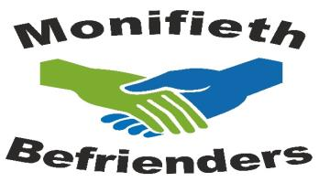
The Health Centre
Victoria Street
Monifieth
DD5 4LX
Tel: 01382 760142
Registered Scottish
Charity
SC030685

E-mail: pauline@monifiethbefriending.co.uk
Website: www.monifiethbefriending.co.uk
Monifieth High School Application form
Please return to me at email address above by Friday 24th April.
CONFIDENTIAL Date: ........................
Name :( Mr, Mrs, Miss. other) ..................................................................
Address: ...........................................................................................
..............................................................Postcode: ..............................
Mobile No: ...................................................
E-mail address: ...................................................................................
Date of Birth .............................................Age: .................................
These questions are to help me get a picture of who you are, so that I can pair you with someone compatible.
1.Please tell me about yourself –family, friends, favourite things, favourite places etc
2. What do you like to do when you are not at school?
3. What subjects are you taking in your sixth year?
4. Why are you taking these subjects?
5. What do you plan to do when you leave school?

6. Please tell me about any volunteering you have done.
7. Befriending is a two-way process. The person you will visit gets friendship and company on a weekly basis. What do you, personally, hope to get out of Befriending?

8. Where did you hear about Monifieth Befrienders?

9.Our young volunteers visit people at home in pairs, so please tell me here one person you would like to visit with. Make sure they know and have applied to be a befriender!!!
Thank you for applying to be a befriender with Monifieth Befrienders. Please use a separate sheet for any additional information you would like to giv
Your Personal information
If you would like to know more about how Monifieth Befrienders uses your personal information, then please contact me further.
Tel: 01382 760142
E-mail: office@monifiethbefriending.co.uk
Website: www.monifiethbefriending.co.uk

