Recalibrating Your DNA!

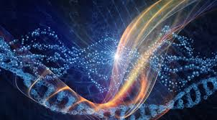

February 15th, 2017
6:00-7:30pm.
Exchange $33

A Workshop and Healing Meditation to assist in clearing cellular memory and activating your DNA!

In this meditation workshop we will be working with the Ascended Masters to transmute lifetimes of negative cellular memory.

We are energy beings, therefore it is so important to clear and balance our energy because it literally affects every area of our lives. Especially now, with the energies on the planet increasing, we are being called to release the old, lower energies and negative patterns in order to make room for the new!

Clear the path and awaken fully to who you really are!

Empower yourself and live your passion. Your passion after all is your path!

This process also awakens you to heal yourself,
others and the planet!

Honor yourself; the amazing Light Being you are!

(Available also as a Private Session for $125)

Presented by;
Birgit "Billie" Weiss, HC CGEM RMT HC
Holistic Health Consultant, Hypnotherapist, Certified Gemstone Energy Medicine
Non-Denominational Minister

