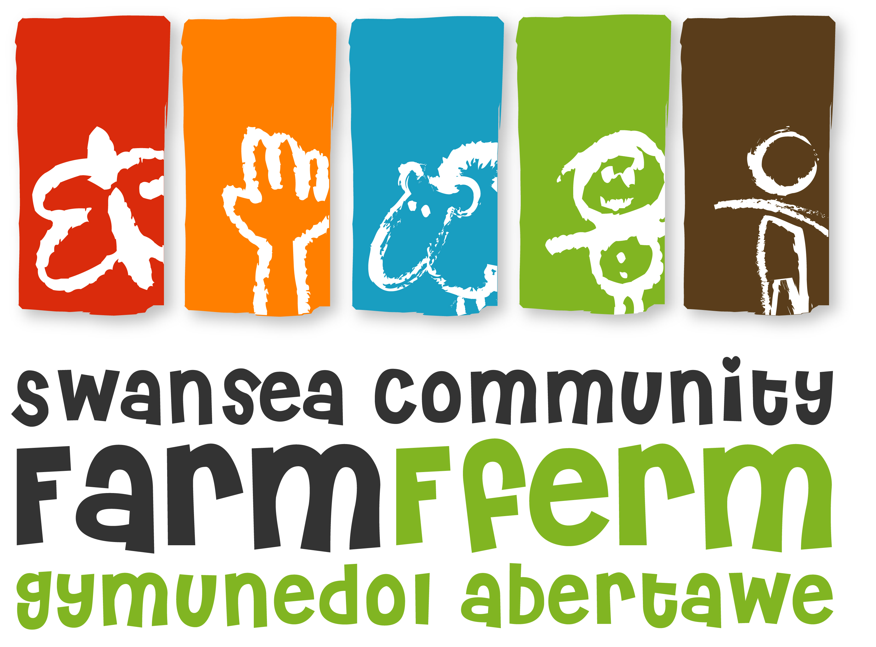Swansea Community Farm
Job Description
Job Title: Animal Wellbeing Worker
(This post is funded by People’s Health Trust using money raised by Health Lottery Wales.)
Responsible To: Wellbeing Officer
Responsible For: Assisting in the planning, delivery and development of the Farm volunteering project, a community-led wellbeing-focussed outdoor volunteering programme. This role has particular responsibility for the Farm livestock and the volunteers who care for them. This involves support and management of new volunteers and existing volunteers and support staff. Carrying out monitoring and evaluation, liaising with other staff, trustees and stakeholders and developing the programme in a beneficiary-led manner. This post includes care of our Farm animals ranging from geese to goats including feeding, cleaning and healthcare.
Pay Scale: SCP 20 £11 473 per year (Equivalent to £20,215, pro rata)
Hours: Contracted to 21 hours a week
This post is a fixed term post until 31st January 2022 (after successful completion of 3 month probation period).
Annual Leave: 28 days p.a. plus statutory bank holidays, pro rata
This post is subject to satisfactory enhanced DBS check before starting the post.

Principal duties and responsibilities
- To take a lead in the animal house, supervising volunteer activities, ensuring proper animal care and taking responsibility for feed, bedding and medicine orders.
- To educate and train volunteers about animals, agriculture and caring for the environment.
- To help run the volunteering project, promote outdoor volunteering and to attract target volunteers (those facing health and wellbeing challenges from deprived areas).
- To deliver twice weekly volunteer days.
- To support volunteers with a wide range of support issues to engage in the Farm.
- To keep track of a small group of target volunteers through data collection, and report back to the Health Lottery on these volunteers’ progress.
- To ensure that paddocks, gates and animal housing are safe and secure.
- In consultation with the Volunteer and Training Manager, undertake annual/monthly/weekly animal husbandry tasks, including taking responsibility for their health, welfare, nutrition and supporting breeding programme following recognised standards, national regulations and best practice
- Undertake basic animal husbandry tasks (e.g. feeding, opening & closing of accommodation, cleaning) and to undertake regular inspections of the animals to ensure that they are all fit and healthy, have access to clean water at all times and are feed when stated

Programme Delivery and Management – To be delivered working alongside the Volunteers as much as is practically possible:
- To be a contact for people seeking information relating to the Farm’s animals.
- To seek feedback from volunteers using participative, fun and consultative techniques.
- To maintain accurate records of work undertaken for use in monitoring and evaluation, to include statistical and qualitative evidence.
- To take responsibility for Health and Safety issues relating to the programme activities as appropriate, including the preparation of activity site checks, risk assessments and toolbox talks.
- Assist in the preparation of the venue and materials required to support group work or work with individual volunteers.
- To promote the project and increase participation of target volunteers.
- To help manage and support sessional staff and existing volunteers supporting the project.
- To attend staff meetings regularly.
- To ensure a high standard of customer care when dealing with the visiting public and whilst delivering activities.
- To adhere to all policies and procedures at Swansea Community Farm, paying particular attention to Child and Vulnerable Person Protection Policy, Health and Safety, Code of Conduct and Equal Opportunities.
- To fulfil all the above duties and any other realistic requests from your line manager and the board of trustees.

Finance
- To assist the Volunteer and Training Manager and Finance Officer in the control of project budgets.
- To assist the Farm team in researching and preparing funding applications for the project and other related activities.
- To ensure efficient handling of money and receipts in accordance with Farm financial procedures.

Working Relationships
The development of effective working relationships through: -
- Co-operation and collaboration with other staff.
- Negotiation with beneficiaries and volunteers to develop their potential.
- Participation in meetings, staff training events for the purpose of the project’s development.
- Developing partnerships with other organisations which will strengthen the Farm and improve its work.

NB: Your Line Manager and the board of trustees have the right to review or vary this Job Description. This post is subject to a 3 month probation period. This job description is as currently applies, but it will be reviewed as required and maybe subject to variation. The post holder maybe required to undertake other tasks that can reasonably be assigned, which are within their capability and grade.

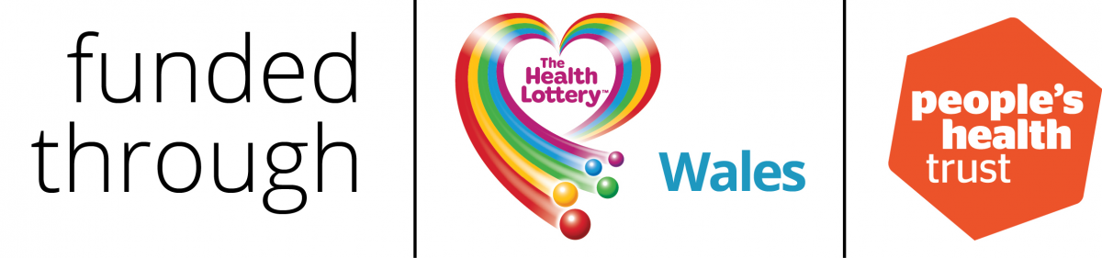

Swansea Community Farm Person Specification
Job Title: Animal Wellbeing Worker

 | Essential | Desirable
Education: | Good general educational attainment or similar demonstrated level of ability.  A suitable qualification or experience in farm animal care, agriculture or similar.  Expertise and/or a qualification in wellbeing-related skills. | Relevant leadership, teaching or management qualification  Qualification or experience in other land-based skills, eg. horticulture, conservation, construction, carpentry or similar.
Experience: | Experience of working with people with health issues to improve health and wellbeing.  Experience of developing programmes for volunteers, training schemes or community involvement.  Practical experience of the care of livestock, poultry and waterfowl and their housing.  Experience of training others in animal care related skills.  Practical experience of lambing, kidding and/or farrowing.  Practical experience of handyperson type skills. | Experience in developing and delivering training, volunteer or wellbeing programmes, including accredited training.  Practical experience in areas such as gardening, construction, woodwork or conservation.  Development and management of projects including initiating new projects, marketing and management of budgets, staff and resources.  Experience of raising animals for human consumption.  Experience of animal behaviour and herding.
Skills and abilities: | Good communication skills, both written and verbal.  Good organisational skills and time management.  Hold a driving licence.  The ability to establish good working relationships with people of all ages and to empower them.  Competent IT skills (word processing, database use, spreadsheets, emails).  The ability to be available to work flexible hours which may include some weekend, evening and holiday work agreed with you in advance. | Welsh speaker.  Hold a trailer licence (B&E)
Values and attitudes: | Candidates should have a commitment to:  - the aims and objectives of Swansea Community Farm  -Organic farming principles.  - A commitment to and interest in wellbeing and environmental issues  - an open and non-judgmental attitude  -a willingness to undertake relevant training | An interest in rare breeds, heritage farming methods and wildlife friendly land management techniques.  Equal Opportunities Policy and anti-oppressive practices
Knowledge | Knowledge of a range of Farm animals and their care needs.  An understanding of how practical outdoor approaches can be beneficial to health and wellbeing management.  A good understanding of Child Protection/Protection of Vulnerable Adult issues.  Practical knowledge and good understanding of Health and Safety issues relevant to Swansea Community Farm | Knowledge of the local area and the needs of the local community.  Practical knowledge and/or qualification in First Aid, Mental Health First Aid, H&S and Food Hygiene.

