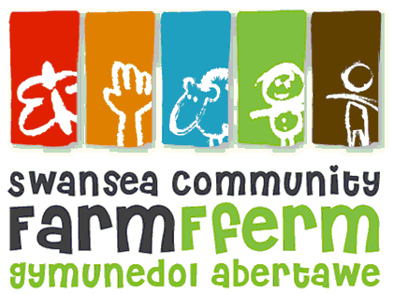
Swansea Community Farm
Equality and Diversity Monitoring Form

Swansea Community Farm aims to ensure that no job applicant nor employee receives less favourable treatment on the grounds of age, disability, gender reassignment, marriage and civil partnership, pregnancy and maternity, race, religion or belief, sex, or sexual orientation.

The following information will be treated as confidential and will be separated on receipt and before consideration of candidates takes place. In order to ensure that these policies are carried out and for no other purpose, all candidates are asked to complete this form. Completion of this form, however, is entirely voluntary.

Development Officer
Position applied for:

Date of birth:

Date:

Gender

Man Woman Intersex Non-binary Prefer not to say

If you prefer to use your own term, please specify here …………………….

Ethnic origin
These categories are based on the Census 2011 categories and recommended by the Commission for Racial Equality.

Asian, Asian British,  Asian / Asian British  Bangladeshi  Chinese  Indian  Pakistani  Other Asian background (specify if you wish): | White  British  English  Gypsy or Irish Traveller  Irish  Scottish  Welsh  Other White background (specify if you wish):
Black, Black British, Black English, Black Scottish, or Black Welsh  African  Caribbean  Other Black background (specify if you wish): | Mixed  White and Asian  White and Black African  White and Black Caribbean  White and Chinese  Other mixed background (specify if you wish):
Prefer not to say

Disability

You’re disabled under the Equality Act 2010 if you have a physical or mental impairment that has a ‘substantial’ and ‘long-term’ negative effect on your ability to do normal daily activities.

Based on this statement, do you consider yourself disabled?

Yes No Prefer not to say

