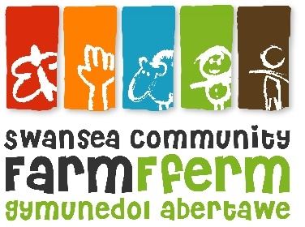

Job Description
Job Title: Development Officer
Responsible To: Volunteer and Training Manager
Responsible For: Supporting the long term sustainability of Swansea Community Farm through developing the fundraising strategy; generating income from Trusts, and other sources; identifying future partners and opportunities, financial planning and budgeting, line management of the finance worker.
Pay Scale: £11,787 per year (Equivalent to £23,573 full time).

This is initially a fixed term role for 12 months with the possibility of extension following review.
Hours: 18.5 hours a week. Flexible working hours are available for this role. Details to be agreed in line with the requirements of the organisation. The postholder may occasionally be required to work weekends and evenings.
Annual Leave: 28 days p.a. plus statutory bank holidays, pro rata
Principal Duties and Responsibilities
- Developing and implementing fundraising plans to support the work of Swansea Community Farm.
- Facilitating the Income Generation subcommittee of staff and trustees.
- Researching grant funding opportunities and writing grant applications to charitable trusts or other bodies awarding grants to charities.
- Identifying and implementing other opportunities to generate income for the Farm e.g. from companies, sponsored events, individuals or other sources.
- Co-ordinating the production of the annual business plan and supporting the development of longer-term farm strategy.
- Working with the Volunteer and Training Manager and farm staff to develop annual organisation and project budgets, and longer-term financial forecasts.
- Producing budgets for grant applications.
- Line Managing the part time Finance Worker
- Maintaining good relationships with funders and supporters and keeping them up to date with the work and the impact of the Farm.
- Keeping accurate and up to date records of fundraising activity, contacts, and outcomes, using existing Farm systems where applicable.
- Analysing and evaluating different income generating activities to inform future planning.
- Overseeing use of the Impact Tracker database (used by project staff to record activities and beneficiary information), ensuing it is up to date and using it to produce reports and information on farm impacts.
- Writing and submitting reports to grant funders – including financial reports - by the deadlines required.
- Ensuring agreed targets and deadlines are met.
- Ensuring all activities comply with the Institute of Fundraising regulations and good practice requirements, including compliance with GDPR.

Working Relationships
- Maintaining good communication and positive relationships with other staff, the Board of Trustees, volunteers, children and young people.
- Participating in working groups, staff training, and meetings as required.
- Helping with farm activities as required.
NB: Your Line Supervisor and management team have the right to review or vary this Job Description. This post is subject to a 3 month probation period. This job description is as currently applies, but it will be reviewed as required and may be subject to variation. The post holder may be required to undertake other tasks that can reasonably be assigned, which are within their capability and grade.

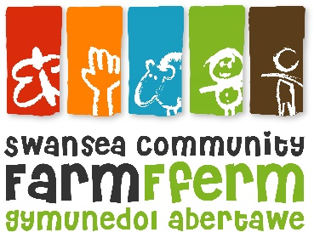
Swansea Community Farm
Person Specification
Job Title: Development Officer

 | Essential | Desirable
Education: | Good general educational attainment to degree level or similar demonstrated level of ability.  Suitable fundraising and management qualifications although experience may be considered in lieu. | Member of the Institute of Fundraising
Experience: | Minimum of two years’ experience of charity fundraising including from trusts and foundations.  Demonstrable track record of generating income from fundraising activities.  Experience of working with budgets and interpreting financial reports  Experience of line managing staff or volunteers. | Experience of fundraising in a small charity.  Experience of generating income from new sources and establishing new relationships.  Experience of producing budgets and financial forecasts.
Skills and abilities: | Excellent communication skills, both written and verbal.  Good strategic thinking skills.  Good research skills and ability to identify suitable funding opportunities.  Excellent numeracy skills and ability to produce, interpret and present financial information.  Good organisational skills and time management  The ability to establish and maintain good relationships with a wide range of people.  A proactive approach and ability to influence others.  A willingness to work some weekends and evenings (with dates agreed in advance)  An ability to work independently and as part of a team.  Excellent IT skills (including use of online resources and databases) | Welsh speaker  Hold a driving licence
Values and attitudes: | Candidates should have a commitment to:  - the aims and objectives of Swansea Community Farm  - the Farm’s Diversity and equality Policy  A willingness to undertake relevant training  A willingness to carry out admin tasks to support their area of work.
Knowledge | Knowledge of Fundraising regulation and good practice.  Knowledge of GDPR requirements. | Knowledge of funding sources and opportunities in Wales and Swansea.

