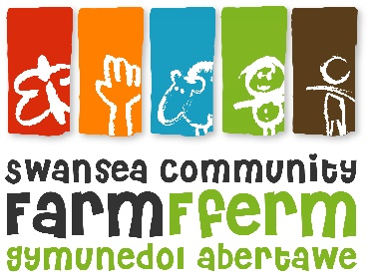
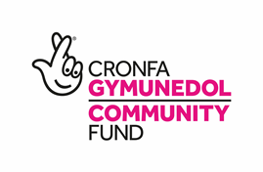
Swansea Community Farm
Job Description

Job Title: Wellbeing Support Worker
Responsible To: Wellbeing Officer
Responsible For: supporting delivery of activities designed to improve wellbeing through practical engagement in the life of a city farm through volunteering, training, educational opportunities. To be achieved through on the ground support for the delivery of our Wellbeing focussed Big Lottery funded Calon Farm for All project to both groups and/or individuals in accordance with the Farm’s Health & Safety guidelines and Child Protection & Vulnerable Adult Policies.
Pay Scale: £7254 per year (equivalent to £17,893 full time)
Hours: 15 hours per week fixed term until 31st March 2024 (with the possibility of additional hours dependent on funding)
Annual Leave: 28 days p.a. plus statutory bank holidays, pro rata
This post is subject to satisfactory enhanced DBS check before starting the post.

Principal duties and responsibilities

Programme delivery – all areas
- To support the direct delivery of activities for Farm volunteers (all ages) and programme participants on Tuesdays and Thursdays.
- To support participants and staff in the preparation of tasks and activities - organising tools/equipment and allocating tasks as appropriate.
- To lead specific activities as required for groups of volunteers and programme participants
- To offer one-to-one support for volunteers and programme participants with additional needs ensuring that their participation in Farm activities is as meaningful, accessible and as positive as possible.
- To help ensure that working practices are in accordance with Farm policies including:
  - Health and Safety
  - Child Protection & Vulnerable Adults
  - Equal opportunities
  - Environment
- To assist the manager and other staff in: assessment and evaluation of current activities; participant progress; related record keeping and the future development of the Farm’s programmes and services.

Animals, Grounds & Buildings – support participants in:
- Care and husbandry of livestock at the Farm, including the day to day welfare of animals and maintenance of high standards of health and hygiene in the animal house.
- Management and maintenance of the Farm grounds (and neighbouring woodland/heathland) in line with nature conservation principles and organic principles of food production.
- Support participant involvement in the above areas through support of the Farm’s Volunteer, Education and Child & Youth Programmes.

Volunteer Programme – support participant engagement in:
- Farm activity programme for adult volunteers of all ages, backgrounds and abilities including weekly work days, practical training, an animal care rota, open days, community activities and supported volunteering.
- Support and servicing of the Volunteer Forum - enabling the project to be beneficiary-led.
- A range of practical training opportunities – both informal and accredited.
- Volunteer induction to the Farm, its programmes and practices.

General responsibilities
- To ensure a high standard of customer care when dealing with the visiting public and delivering activities.
- To fulfil all the above duties and any other realistic requests from your Line Supervisors or the management team, including additional training.

Finance
- To ensure efficient handling of monies and receipts in accordance with Farm financial procedures.

Working Relationships
The development of effective working relationships through: -
- Co-operation and collaboration with other staff.
- Negotiation with beneficiaries and volunteers to develop their potential.
- Participation in working groups, staff training events and meetings for the purpose of the project’s development.

NB: Your Line Supervisor and management team have the right to review or vary this Job Description. This post is subject to a 3 month probation period. This job description is as currently applies, but it will be reviewed as required and maybe subject to variation. The post holder maybe required to undertake other tasks that can reasonably be assigned, which are within their capability and grade.

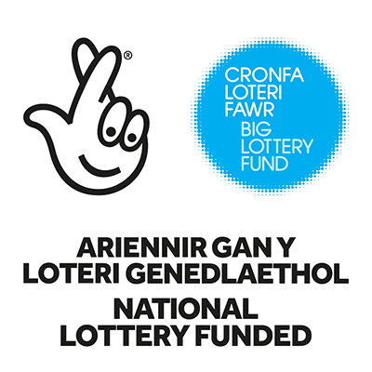

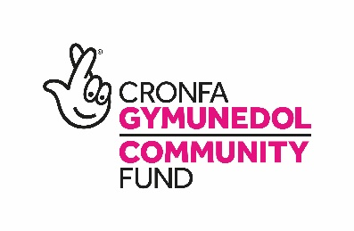

Swansea Community Farm
Person Specification

Job Title: Wellbeing Support Worker
 | Essential | Desirable
Education: | Good general educational attainment or similar demonstrated level of ability.  Suitable qualification although operational experience may be considered in lieu. | Youth Work qualified  Teacher qualified  Volunteer Leader Training  Play Leader Training  Possess a suitable qualification in Horticulture/ Agriculture, Animal Husbandry, Conservation, or similar subject.
Experience: | Experience of project delivery with one or several groups of our target beneficiaries including: children & young people (4-16) young adults 16 - 25 years of age; over 50 years of age; unemployed people; disabled people, people with work limiting health conditions.  Practical experience in at least one of gardening, horticulture, animal husbandry, construction, woodwork or cookery (indoor and out). | Experience of developing programmes for our target beneficiaries in a community setting.  Experience in delivering training programmes, including accredited schemes, to children and adults.  Practical knowledge and good understanding of Health and Safety issues relevant to Swansea Community Farm.  Knowledge and skills surrounding food production, nature conservation, healthy living and sustainability.
Skills and abilities: | Candidates must demonstrate:  - good verbal communication skills  - good organisational skills and time management  - the ability to establish good working relationships with people of all ages and backgrounds  - a willingness to be available to work flexible hours which will include week-end and evening and holiday work from time to time. This will be agreed with you in advance  - an ability to work independently and as part of a team. | Good written communication skills.  Welsh speaker  Basic IT skills ( word processing, spreadsheets, database etc)  Hold a driving licence and be able to drive a standard minibus.
Values and attitudes; | Candidates should have a commitment to:  - the Farms Equal Opportunities Policy and anti-oppressive practices and an appreciation of how the policy affects procedures and practices at the Farm.  - the Rights of the Child  - a commitment to and interest in environmental and wellbeing issues.  - the aims and objectives of Swansea Community Farm  - open and non-judgmental attitudes  - a willingness to undertake relevant training
Knowledge | A good understanding of Child Protection/Protection of Vulnerable Adults issues | Knowledge of the local area  Knowledge of how outdoor practical activities can positively impact wellbeing.  Practical knowledge of First Aid, Food Hygiene and Animal Welfare

