May 15, 2020

ANTON ART CENTER ANNOUNCES VIRTUAL OPENING OF WORLDWIDE ONLINE JURIED ART SHOW FEATURING MORE THAN 500 ARTISTS FROM AROUND THE GLOBE

In response to the COVID-19 Pandemic and resulting closure of physical spaces where artists may show their work, the Anton Art Center launched a global call for artists to submit their work for a juried international online exhibit. A total of 1,524 entries were received from 518 artists (youth, teen and adults) across the globe, representing 30 U.S. states and 44 countries. The Online Juried Art Show will make its world premiere on Friday, May 22 at 12:00pm EST on the Anton Art Center’s website (www.theartcenter.org/exhibits).

Juried by Anton Art Center Executive Director Phil Gilchrist and Exhibition Manager Stephanie Hazzard, entries were received in a wide variety of media in three age groups: youth (age 12 and under), teen (ages 13-17), and adult (ages 18+). Gilchrist selected a number of “Director’s Picks” in each age category, and from those picks both Gilchrist and Hazzard selected first, second, and third-place award winners. The awards did not include a monetary prize, but in a show of solidarity with artists around the world, all entries that met the guidelines will be exhibited. This exhibit will remain on virtual display for at least the remainder of 2020.

“Art has a unique way of connecting people, providing a way to communicate thoughts and feelings across the boundaries of location or language. As an arts organization, one of our core purposes is to help facilitate that connection and provide a platform for artists to share what they’ve created. As we watched art centers, galleries and museums close up before our very eyes, it was clear that we had the ability to help fill an immediate need for exhibit ‘space’ and encourage creativity during a time of uncertainty,” said Gilchrist. “It is safe to say that the response far exceeded our expectations, and frankly took us by surprise. The overwhelming number of entries required additional work to prepare the exhibit for online display, but even working remotely our staff rose to the challenge and we are excited and proud of the show that has emerged.

Hazzard was equally impressed by the response of both the artists and the Anton Art Center staff.

"For a small nonprofit organization, I'm very appreciative of how the Anton Art Center staff managed to quickly and effectively adapt to changes to produce an engaging art opportunity for people around the globe,” said Hazzard. “Due to the tremendous response from artists of all ages, this exhibit is an extraordinary presentation of the human experience through artistic expression unique to these unprecedented times and serves as a shining example of the sincerity of the Anton Art Center's commitment to its mission.

What some of the exhibiting artists had to say:
- "It is great to have a place to show my work right now. Thank you." -Mark Bleshenski, adult artist, Bay City, Michigan, USA (artwork photo attached)
- "Last year, I fell in love with the atmosphere of the Anton Art Center and the people who work there. I found out about the exhibit for teen artists through Instagram and entered some of my new pieces!" -Karlee Szczesniak, teen artist, Age 16, Clinton, Michigan, USA (artwork photo attached)
- "I am a teacher at Arts Academy in the Woods in Fraser, Michigan. I look forward to the exhibit. It's amazing what you are doing." -Brett Guay, Adult artist, Royal Oak, Michigan, USA
- "In this time of crisis and isolation, the role of art becomes more central to our lives. During these dark and gloomy times, I create art with sparks of hope on the horizon. Believing that creativity keeps people connected during a pandemic that keeps us apart." -Parnika Mittal, adult artist, New Delhi, India (artwork photo attached)
- "This is a portrait of a very good friend. I have always felt average throughout my life. I felt like I provided nothing in companionship and was unmemorable. But she looks at me like I’m the most interesting person in the world." -Thy Hoang, teen artist, Age 15, Sterling Heights, Michigan, USA (artwork photo attached)
- "This is a wonderful opportunity for upcoming artists like myself." -Shuja Ulhaq, adult artist, Lahore, Pakistan (artwork photo attached)
For more information about the Anton Art Center, visit www.theartcenter.org or call 586-469-8666. The Anton Art Center is a registered nonprofit organization located in Mount Clemens, Michigan, with a mission to enrich and inspire people of all ages through the arts and a vision to create an open community around creative expression. Connect with us on Facebook, Instagram and Twitter!

###

Online Juried Art Show
Sample Images

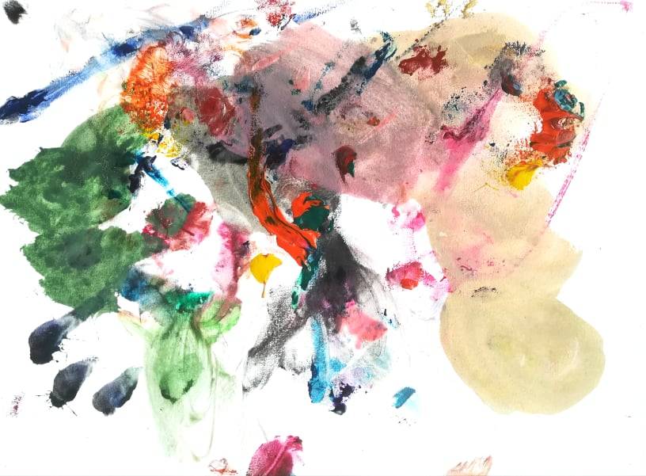  "Colorful Abstraction" Acrylic on paper, 21x29 cm, by Andrey Nikolov, Youth artist, age 2.6, from Sofia, Bulgaria | 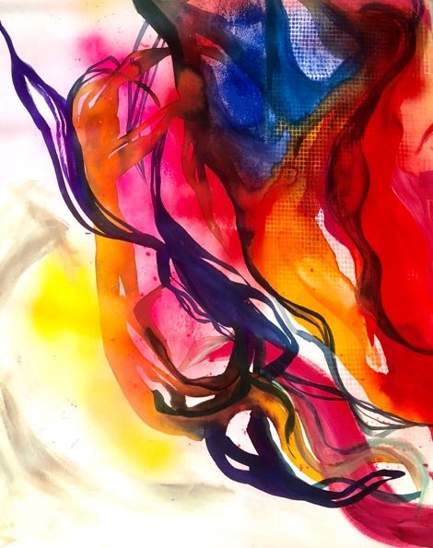  "Chaotic" Acrylic on canvas, 36x30 in., by Parnika Mittal, Adult, New Delhi, India | 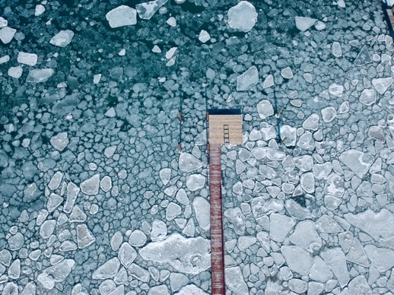  "Ice Flow" Drone Photography, by Jack Kropp, Teen artist, age 13, from Mount Clemens, Michigan, USA
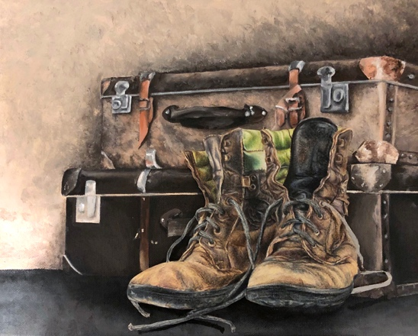  "Autophobia" Acrylic on canvas and colored pencil on paper collage, 11x14 in., by Karlee Szczesniak, Teen artist, age 16, from Clinton, Michigan, USA | 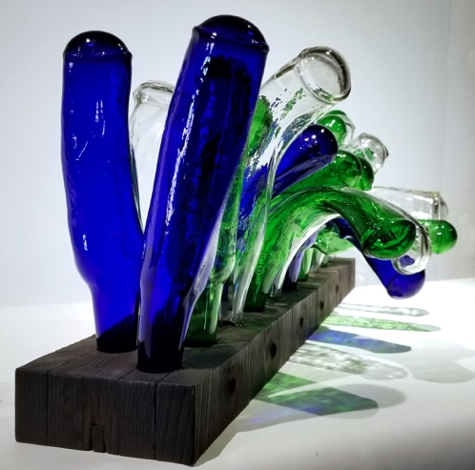  "Maize" Wood, glass bottles, by Mark Bleshenski, Adult artist, from Bay City, Michigan, USA | 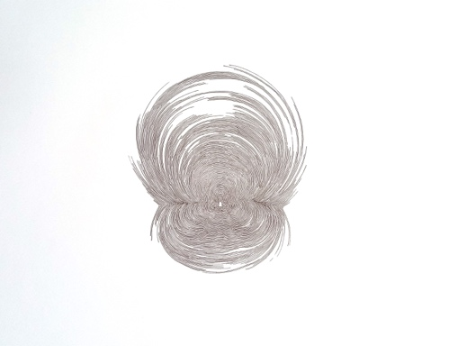  "Conversations with the Universe" Pen, ink on paper, 18x16 in., by Shuja Ulhaq, Adult artist, from Lahore, Pakistan
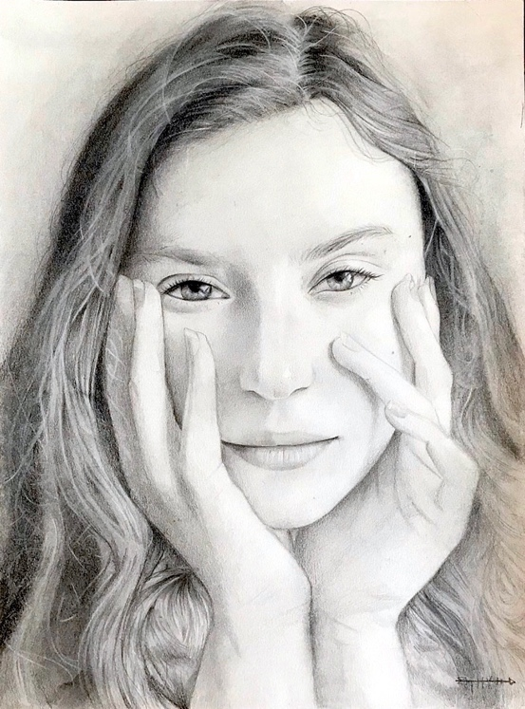  "Feel Special" Graphite on paper, 9x12 in. by Thy Hoang, Teen artist, age 15, from Sterling Heights, Michigan, USA | 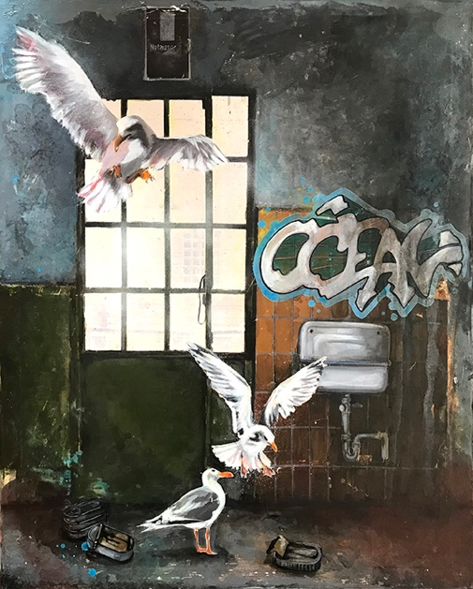  "I Give You the Ocean" Mixed media on canvas, by Beate Arens, Adult artist, from Binissalem, Majorca Baleric Island, Spain | 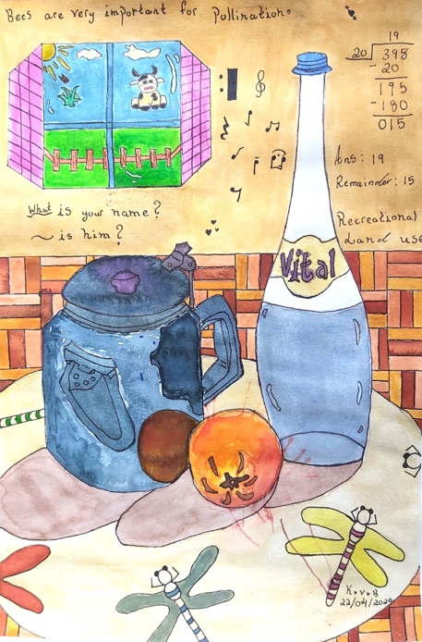  "Confined Study" Mixed media, 25.5x38 cm, by Kohana Vedi Bauhadoor, Youth artist, age 10, from Mauritius

