Contract # N00178-14-D-7825

Marshall Communications Corporation was chosen as a prime contractor under the Naval Sea Systems Command (NAVSEA) SeaPort Enhanced (SeaPort-e) Program. The first Contract # N00178-07-D-5143 was issued in May 2007 and a second, Contract # N00178-14-D-7825, was issued in January 2014.

MARSHALL's Team is structured to have the ability, Subject Matter Experts (SMEs), and qualifications to support the needs of the Seaport-e program in 6 Zones and 22 Functional Areas. The SeaPort-e program makes electronic procurement of engineering, technical, and programmatic support a reality.

Marshall Communications Corporation (MARSHALL) specializes in delivering end-to-end solutions in standards-based, open architecture systems and delivering COTS product solutions that are cost effective and promote quality of service and reliability. MARSHALL is a Small Business.

TASK ORDERS
Seaport-e Task Orders Received:

- N00178-07-D-5143-V701
- N00178-07-D-5143-V702
- N00178-14-D-7825- N6523618F3094

TECHNICAL INSTRUCTIONS
Seaport-e Technical Instructions Issued against Task Orders: For protection of Proprietary Information and/or Non-
Disclosure Agreements (NDA's) please contact Marshall Communications for Seaport-e Technical Instructions Issued against Task Orders.

CAPABILITIES
We fully support the Department of Defense (DOD), including the U.S. Marine Corps, U.S. Navy, non-DOD and other Joint
Agencies technical objectives for the Seaport Enhanced (Seaport-e) program. The technical solution we provide fully encompasses all mandatory requirements including expertise and specific Prime/Subcontractor experience defined in recent relevant work identified in the contracts listed for the corresponding Functional Areas.

MARSHALL pioneered a first-of-its-kind, fully-integrated, DVB-RCS system which was fielded to multiple installations in support of Operation Iraqi Freedom. Designed for the DOD for the Global War of Terror, MARSHALL provided the best highly specialized, bi-directional communications suites available. These advanced technology suites bring to the forefront the latest in standards-based, two-way, high speed data communications via satellite. To date, MARSHALL has been the only integrator awarded four Sole Source contracts to design, integrate, build and deploy a redundant DVB-RCS hub and 40 associated subscriber terminals for CENTCOM.

CONTRACTS
MARSHALL won its first SeaPort-e Contract, #N00178-07-D-5143, in May 2007 and another, Contract # N00178-14-D-
7825, in January 2014.

ZONES
MARSHALL’s depth of resources across large geographic areas allows us to respond quickly and decisively to any
requirements. Seaport-e’s inclusion of Marshall Communications gives us a standing ability to respond by drawing on existing technical resources pre-positioned throughout the Seaport-e Zones. All Zones are applicable to Marshall with the exception of Zone 5.

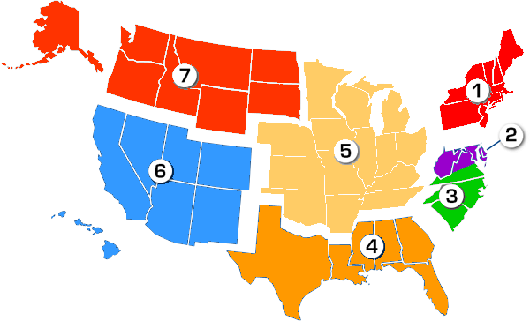
ZONE 1 - Northeast ZONE 2 - National Capital ZONE 3 - Mid Atlantic ZONE 4 - Gulf Coast ZONE 5 - Midwest
ZONE 6 - Southwest ZONE 7 - Northwest

FUNCTIONAL AREAS
MARSHALL's expertise and experience plays a pivotal role in our service to our customers. We enjoy delivering the "Best of
Breed" in systems integration and engineering and giving our customers something extra and unique, which has become an icon for our expertise and representative of our reputation. Our ability to design and implement an end-to-end solution for special application projects sets us apart from the field of others and is a major contributor to our portfolio of services. MARSHALL's Team aligns itself with skilled individuals needed to be able to support 22 Functional Areas.

3.1 | Research & Development Support
3.2 | Engineering, System Engineering and Process Engineering Support
3.3 | Modeling, Simulation, Stimulation, and Analysis Support
3.4 | Prototyping, Pre-Production, Model-Making, and Fabrication Support
3.5 | System Design Documentation and Technical Data Support
3.6 | Software Engineering, Development, Programming, & Network Support
3.7 | Reliability, Maintainability, and Availability (RM&A) Support
3.8 | Human Factor, Performance, and Usability Engineering Support
3.9 | System Safety Engineering Support
3.10 | Configure Management (CM) Support
3.11 | Quality Assurance Support
3.12 | Information System (IS) Development, Information Assurance (IA), and Information Technology (IT) Support
3.13 | Inactive and Disposal Support
3.14 | Interoperability, Test and Evaluation, Trials Support

3.15 | Measurement Facilities, Range, and Instrument Support
3.16 | Logistics Support
3.17 | Supply and Provisioning Support
3.18 | Supply and Provisioning Support / 3.18.1 Technical Training Support / 3.18.2 Professional Development and  Training Support
3.19 | In-Service Engineering, Fleet Introduction, Installation and Checkout Support
3.20 | Program Support
3.21 | Public Affairs and Multimedia Support
3.22 | Functional and Administrative Support

QUALITY ASSURANCE
Since the predominance of our performance is hinged upon our ability to meet and exceed our customer’s expectation, our
Quality Control method is fully integrated into a problem resolution process. Through past performance, we have established a Quality Control method that is simple and one that works. Quality Assurance is of the utmost importance to MARSHALL and our customers. We continually obtain feedback regarding our performance to continuously improve our processes.

Warranty: OEM provided warranty, extended warranty, customized warranty, and maintenance plans, which include software updates and security patches, are available upon request

Product Returns: In accordance with FAR Part 52.212-4, The Government may require repair or replacement of nonconforming supplies or re-performance of nonconforming services at no increase in contract price. The Government must excise its post-acceptance rights — (1) within a reasonable time after the defect was discovered or should have been discovered; and (2) Before any substantial change occurs in the condition of the item, unless the change is due to the defect of the item.

SEAPORT-e CONTACTS
To provide customer feedback or request more information on Seaport-e contracts, please contact one of the POC's listed below.

Director of Business Development
Sean Feigo | sean.feigo@missionsolutionsgroup.com | 571-223-2010

If you are a vendor and are interested in adding your products to our catalog please contact MCC.

"We do more than satellite communications"

