Benefits of Using a Coach
Professional coaching brings many wonderful benefits: fresh perspectives on personal challenges, enhanced decision-making skills, greater interpersonal effectiveness, and increased confidence. And, the list does not end there. Those who undertake coaching also can expect appreciable improvement in productivity, satisfaction with life and work, and the attainment of relevant goals.

Increased Productivity
Professional coaching maximizes potential and, therefore, unlocks latent sources of productivity.
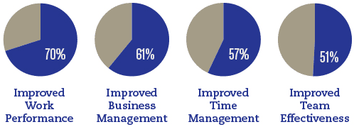

Positive People
Building the self-confidence of employees to face challenges is critical in meeting organizational demands.
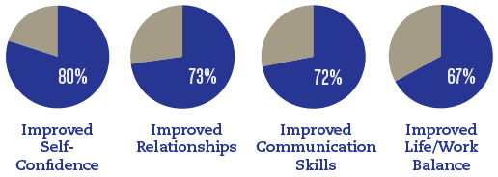

Return on Investment
Coaching generates learning and clarity for forward action with a commitment to measurable outcomes.The vast majority of companies (86%) say they at least made their investment back.

Satisfied Clients
Virtually all companies and individuals who hire a coach are satisfied.

Source: ICF Global Coaching Client Study was commissioned by the ICF but conducted independently by PricewaterhouseCoopers.

