THE FIRST CRYPTO-BANKNOTE WITH AUGMENTED REALITY IN THE WORLD

- Substitute the QR and the id wallet with your personal BHN Wallet

- Print this page and cut the crypto-banknote

- Download the app and scan your crypto-banknote to visualize the Aumented Reality in it.

Once you've scanned it, you'll have access to:
The explorer where you can enter the address of your purse where your
Master Node is and observe the increase in the number of BHN coins.
You will be able to visualize in a video the cause that the BHN team is
supporting at that moment.
And at the same time you can use your crypto-banknote to receive BHN
coins as a quick and easy form of payment (letting the sender/purchaser
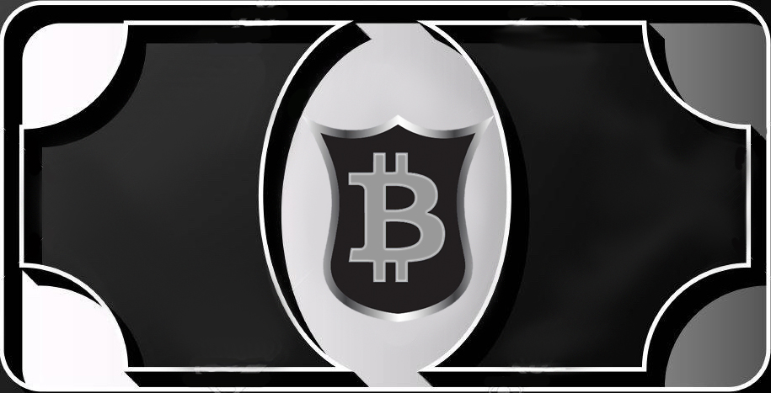
scan your QR code).
B4h2xzJ5KEfEmdfnzouaHiuDmK9mFMa2JC

