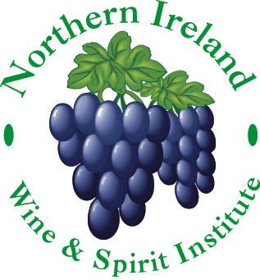
President: Robin Kinahan BA, MW
Vice Presidents: Peter Morris Wilson Dip.WSET
Alastair Bell Dip.WSET
Susan Rees Dip.WSET
Chairman: Tim Hughes
NiwsiChairman@yahoo.co.uk
Vice Chairman: Joe McGlade
Treasurer: Paul Kavanagh
Secretary: Lisa Wilson
NiwsiSecretary@yahoo.co.uk

www.niwsi.co.uk
Xmas Extravaganza & Quiz with Robin Kinahan MW
Tuesday 13th December 2016 – 7:30 p.m. sharp
Direct Wine Shipments, Belfast
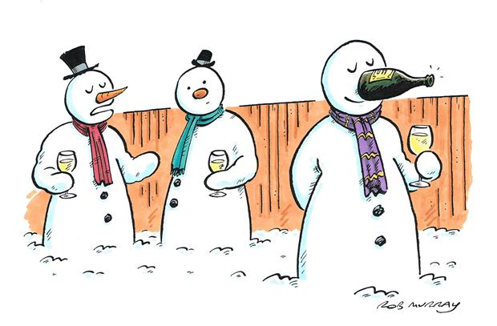
Oh ! The weather outside is frightful
But the wine is so delightful
And since we’ve got a special place to go
Let it flow, let it flow, Let it flow
Now that is a much better version of that song don’t you think?

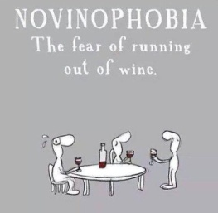
By special request our President Robin Kinahan MW returns for our Xmas event with a cunning quiz of wine facts and fancies (I’ve no idea to be honest as he wouldn’t let me in on the secret!)
But don’t despair as we will be sat in teams so you won’t be alone in making an ejit of yourself!
So bone up on your Bardolino, Beaune and Beaujolais and revise your Rioja, Regent and Refosco
Get ready to put your taste buds to the test for a fun-filled evening of frivolity

Thought for the day:
“It’s Chriiiist-maaas!”
And remember – there is no sanity claus!

Members: Remember to bring your Tasting Glasses

Members: £ 35.00 ** Guests: £ 40.00
** Special Offer - £10 discount if you pay your 2017 membership fee on the night – Total £80 (Includes a fantastic £5 membership discount too!)
Includes a supper with our favourite caterer
Mrs Crumbs

