VIRUNGA MOUNTAINS
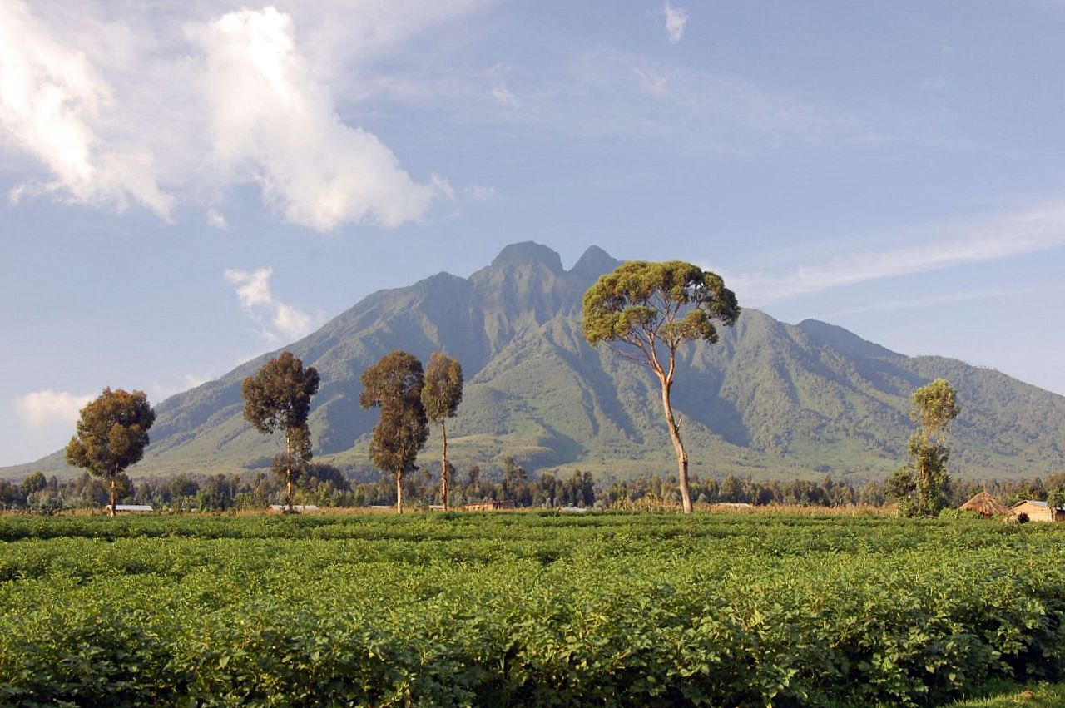
The Virunga massif also popularly known as the Virunga Volcanoes range or the Virunga conservation area is comprised of a number of some of Africa’s unique and finest wildlife attractions. The region ranges from Northwestern Rwanda covering Volcanoes national park, southwestern Uganda covering Mgahinga gorilla national park and eastern Congo covering part of Virunga national park. This region though popularly known for the endangered mountain gorilla safaris that take place in the forested mountains of the three above mentioned national parks and golden monkey tracking, there way many other outstanding authentic experiences that nature lovers and adventurous tourists can enjoy while on an African safari in the Virunga Mountains. These range from forest walks, Volcano hiking, birding among others. Lets however explore more on hiking the various volcanoes the region has since its one of the less known but very interesting activity.

The Virunga massif has a total of eight Volcanoes that are evenly distributed in the three countries. They include Mountain Karisimbi which lies on the Rwanda – DRC border, Mount Mikeno in DRC, Mount Muhabura which lies on the Rwanda – Uganda border, Mount Bisoke which lies on the Rwanda DRC border, Mountain Sabyinyo which lies on the Rwanda-Uganda and DRC border, mount Gahinga which lies on the Rwanda – Uganda border, Mount Nyiragongo and Mount Nyamuragira in DRC. All these Volcanoes are very open for tourists interested in Volcano hiking and offer very remarkable experiences.

MOUNTAIN SABINYO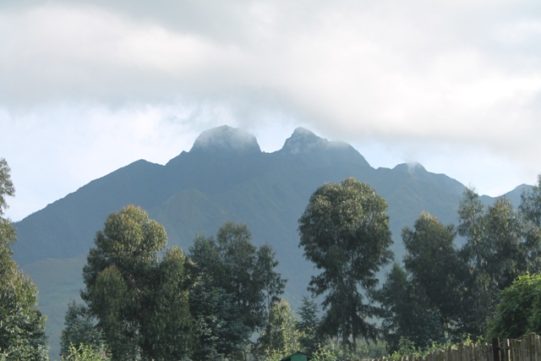

Mount Sabinyo, 3645m, (wrongly spelled “sabyinyo”) offers one of the best climbing experiences in Uganda. A dormant volcano, Mt Sabinyo is one of the numerous rolling volcanoes that make up the magnificent Virunga mountain range that spans along the borders of Rwanda, Uganda and the Democratic Republic of Congo. While the other volcanoes either lie in one of the countries or are shared between two countries, Mt. Sabinyo lies at the meeting point of the all the three borders. It is more like the axis of the Virunga range and offers the best views across the Virunga’s, you could call it a 360-degree experience!

In Uganda, Mt Sabinyo is located within Mgahinga Gorilla National Park in the southwestern corner of the country.
“Sabinyo” is a local term which means “old man’s teeth” in reference to the mt. Sabinyo’s distinct summit with peaks which look like an old man’s spaced teeth.

Hiking Mount Sabinyo
Due to the extremely rugged nature of the terrain along the Sabinyo’s slopes that has many craters with sharp ridges, the mountain cannot be trekked in the other two countries except in Uganda where they have managed to work out a safe though challenging trail that includes improvising handmade ladders to assist climbers at very steep sections. Like all the other Virunga volcanoes except the highest, Karisimbi that requires 2 days, Mt. Sabinyo is a one day hike and the round trek is 8 hours, 4 hours to the summit and 4 hours back, however depending on the pace, weather, etc…
Hiking activity sets off from the park office after meeting with and briefing by the ranger guide. Walking sticks are provided for free meanwhile the porters are available for hire.
You go through vegetation ranges from the bamboo zone between 2400 – 2800m, this is also habitat for the Golden Monkeys which you are chanced at seeing. Other big wildlife in the park includes Buffaloes, Elephants and Gorillas but are rarely seen on the trail. Between 2800 – 3200m is a beautiful forest patch of Hagenia Hypericum, over 3200 is that Sub-alpine zone that has fewer trees. This is also territory of the famous Rwenzori Turaco, a stunning bird which is also endemic to the Albertine rift region.
At the summit you hike to each of the three summits and get the chance to be at the meeting point of all the countries, and enjoy the best views of all!

What you need to carry for the Sabinyo Hike
- Rain gear, i.e. rain coat
- Hiking shoes
- Stocking hat for warmth
- Garden gloves for cold weather at the top
- Long-sleeved shirt and trouser to protect from itchy plants e.g. stinging nettles
- Lunch and snacks

In Uganda, Mt Sabinyo is located within Mgahinga Gorilla National Park in the southwestern corner of the country.
“Sabinyo” is a local term which means “old man’s teeth” in reference to the mt. Sabinyo’s distinct summit with peaks which look like an old man’s spaced teeth.

Hiking Mount Sabinyo
Due to the extremely rugged nature of the terrain along the Sabinyo’s slopes that has many craters with sharp ridges, the mountain cannot be trekked in the other two countries except in Uganda where they have managed to work out a safe though challenging trail that includes improvising handmade ladders to assist climbers at very steep sections. Like all the other Virunga volcanoes except the highest, Karisimbi that requires 2 days, Mt. Sabinyo is a one day hike and the round trek is 8 hours, 4 hours to the summit and 4 hours back, however depending on the pace, weather, etc…
Hiking activity sets off from the park office after meeting with and briefing by the ranger guide. Walking sticks are provided for free meanwhile the porters are available for hire.
You go through vegetation ranges from the bamboo zone between 2400 – 2800m, this is also habitat for the Golden Monkeys which you are chanced at seeing. Other big wildlife in the park includes Buffaloes, Elephants and Gorillas but are rarely seen on the trail. Between 2800 – 3200m is a beautiful forest patch of Hagenia Hypericum, over 3200 is that Sub-alpine zone that has fewer trees. This is also territory of the famous Rwenzori Turaco, a stunning bird which is also endemic to the Albertine rift region.
At the summit you hike to each of the three summits and get the chance to be at the meeting point of all the countries, and enjoy the best views of all!

3 Day Sabinyo hiking tour itinerary
Day 1 – Pick up from the hotel in Kampala and set off on an 8 hour long journey to southwestern Uganda. Overnight in Kisoro town
Day 2 – Have early breakfast and travel to Mgahinga Gorilla National Park, a 40 minutes drive from Kisoro. Meet the rangers and start the hike at 7.30am. Carry packed lunch and at least 2 litres of drinking water. Return to the evening and transfer back to Kisoro for the overnight.
Day 3 – After breakfast, check out and return to Kampala.

What you need to carry for the Sabinyo Hike
- Rain gear, i.e. rain coat
- Hiking shoes
- Stocking hat for warmth
- Garden gloves for cold weather at the top
- Long-sleeved shirt and trouser to protect from itchy plants e.g. stinging nettles
- Lunch and snacks

MOUNTAIN MOROTo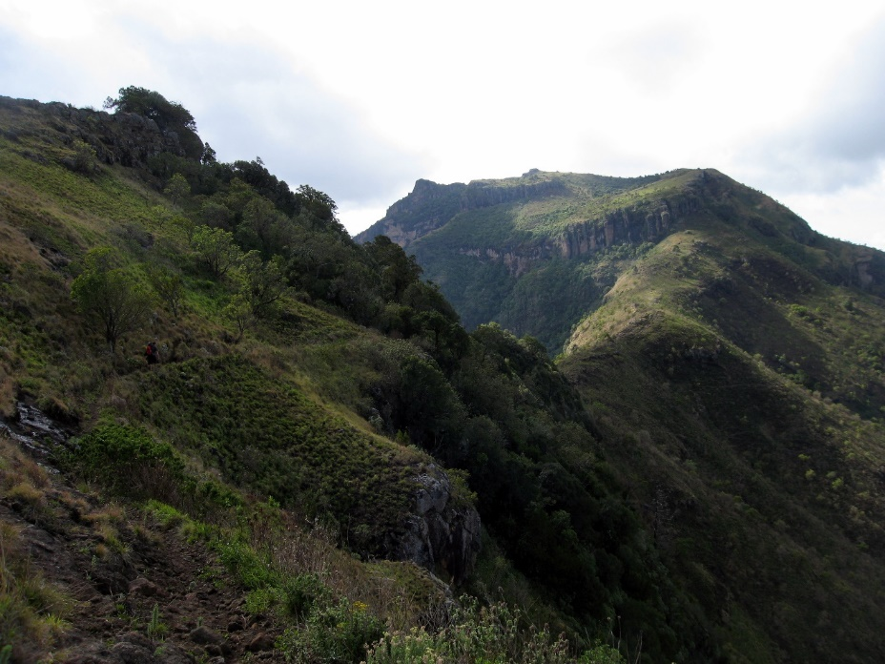

Mount Moroto is (3,083 m or 10,115 ft.) high, the mountain is adjacent to the town of Moroto, Northern Region of Uganda. Mount Moroto is one of a chain of volcanoes along Uganda’s international border with Kenya that begins with Mount Elgon in the south and includes Mount Kadam and Mount Morungole. The region around Mount Moroto is a forest reserve protecting a range of habitats from arid thorn savanna to dry montane forest.
Mountain climbing
The nature reserve that encloses Mount Moroto measures 483 square kilometers (119,000 acres) and contains over 220 bird species, monkeys and wild cats. Climbing trails exist and mountain guides are available

Hiking Mountain Muhabura/Muhavura

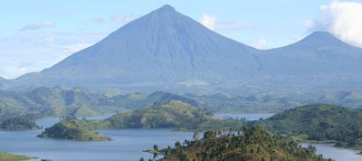
Uganda is simply is the most beautiful country in East Africa and thats why its called the “pearl of Africa”. It has alot of hills and beautiful scenery
Muhabura-The Guide in the local language, Kinyarwanda, is an extinct volcano in the Virunga Mountains on the border between Rwanda and Uganda—it lies partly in Volcanoes National Park, Rwanda and partly in Mgahinga Gorilla National Park, Uganda.
For climbers, you should fear not! There is a mountain in Kisoro district to take a hike and is also easily accessible by car. Mount Muhabura is the country’s 3rd tallest mountain at around 4,127 meters. Muhabura provides hikers with a challenging ascent with its own rewards that include fantastic views of the surrounding countryside as well as wildlife including birds, Primates and Buffalos. Though most travelers hike the mountain after a gorilla tour in Mgahinga National Park, independent hikes are also possible.
Getting There
Its about 8 hours from Kampala to Kisoro where this mountain is housed. You can choose to hire a car or use public means.
When You Arrive
You will be spotted soon enough after reaching by Uganda wildlife authority guides who will come running out to you. You will be taken to the visitor center and assisted as requested. After paying for the activity, you will be given a guide to take you up to the peak of Mt. Muhabura and if you have a back packs then request for a porter who will help you carry your luggage. Enjoy the scenic views of DRC, Rwanda as well as Uganda. The hike is a bit steep and so demanding.
The name Muhabura means sentinel in Kinyarwanda (the local dialect) .The hike will typically take a full day. The Park fees for the climb are currently USD$ 75 per person which includes the park guide. The trek begins at around 7.00am from at park headquarters in Kinigi, from where visitors will have to drive / be driven to the base of the volcano.
Mount Muhabura may not be as glamorous as other better-known tourist stops, but it certainly offers outdoor enthusiasts a fun, day long activity that’s near Kisoro and, best of all, it’s pretty darn cheap.

GAHINGA MOUNTAIN
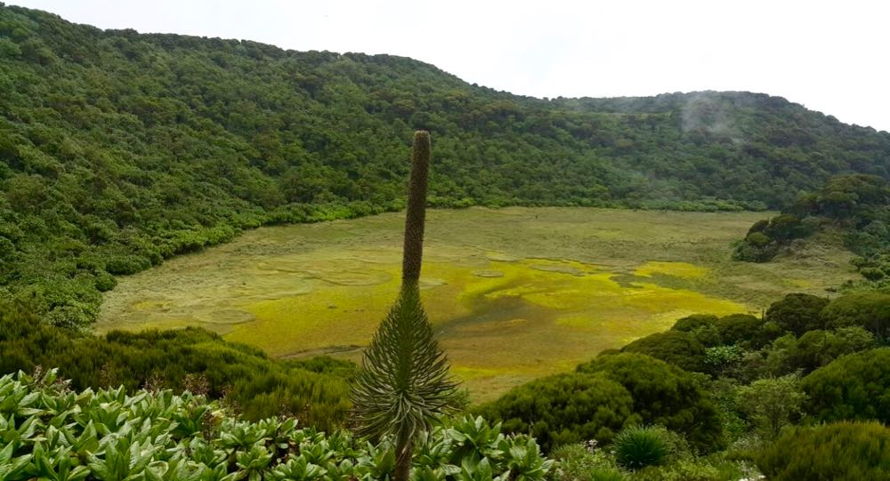
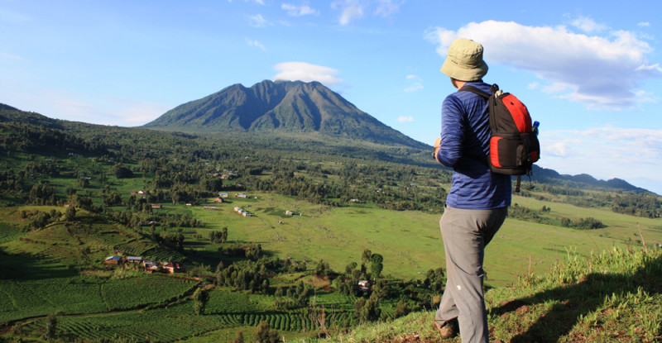
Mgahinga National Park derives its name from this volcanic mountain. This dormant/extinct volcano lies on the border between Uganda and Rwanda. Mount Gahinga lies in between Sabinyo and Muhavura and rises up to 3,474 meters.
The word Gahinga comes from the local Kinyarwanda/Rufumbira dialect meaning “a small pile of stones”. Mount Gahinga has a swampy caldera on its peak believed to be as wide as180 meters.
The vegetation across the mountain can be described as afro-montane with bamboo composing the main vegetation. Like Muhabura and Sabyinyo, the bamboo forests on Mount Gahinga are a habitat of the endangered mountain gorillas that live within the park. There are several other species of animals and birds that form part of the Mount Gahinga ecosystem. The golden monkeys are notable to these.
An ascent of Mt. Gahinga climbs through bamboo forest to reach a lush swamp which lies in the crater at the summit. The round trip from Ntebeko takes around 6 hours.

CLIMBING MOUNT SPEKE

The ascent of Mount Speke (by David Orlandi, February 2012)
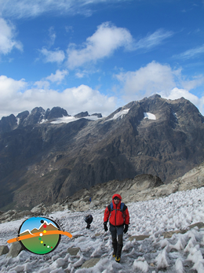The ascent to Mount Speke up to Vittorio Emanuele Peak (4.890 meters), without a solid alpine preparation is not to be considered an easy climb. If you are climbing in good weather conditions, it is a trail at a high altitude, with some points a bit exposed with rocks and grass, which often require the use of hands. Particularly, there are a couple of points where alot of attention is needed. The first one not far from Bujuku Hut (the starting point for the day) is a 20 meters long rocky ramp, slightly stepped, which is blocked on top by the roots of a tree. Practically, it is necessary to climb the roots of the tree without falling, as it could be so dangerous. In case of rain, to be on a safe side and during the descent it is advisable to use the rope. The second critical point is rock crossing of 3rd degree or more which is quite exposed. The advice for those who are not much of experts is to use the rope in the ascent as well as in the descent, using a certain projection of rock just on top of the crossing point. It is dangerous to fall from this point. At the highest point of the trekking is where the glacier begins or what remains of the glacier. It is easy to cross all of it and we did not use crampons or rope. We did not see any crevasses. However it is always advisable to bring with you the crampons and ropes up to this point since conditions can change. After the glacier, there is a short walk through a small rocky surface leading to the peak. In case of rain or snow, this trail can be very challenging as the difficulties will be increased. In those circumstances the use of the rope in the critical points should be a must for everyone. Even other parts of the trail should be considered with attention as it is very messy and could be slippery.

tororo RocK
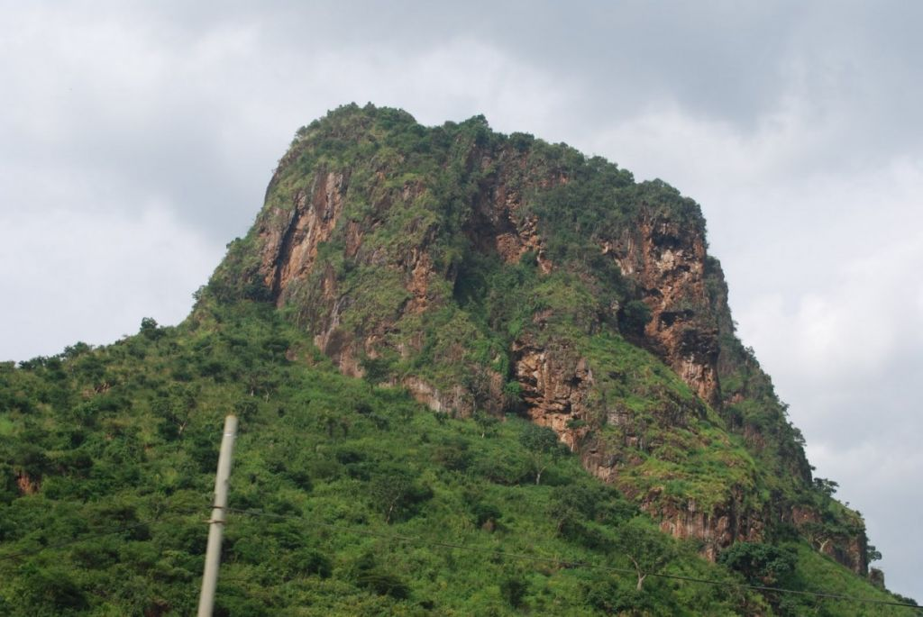

lies 5km, southeast of the Tororo town center, which is situated 230km (140miles), east of Kampala, Uganda’s capital city and business center. This steep volcano which rises to about 1800m above sea level and can be seen for miles before reaching it. The rock is a distinguished feature among the residents of Tororo and in fact, it is a prominent landmark in Uganda.
The rock is a major tourist attraction in Uganda and on the rock’s slopes, there are several ancestral caves and various rock paintings.
From the top of Tororo rock, you will enjoy panoramic view of Mountain Elgon, Tororo town & Lake Victoria. Several telecommunication masts belonging to Uganda voice & Data companies like MTN, UTL, Airtel & Warid are scattered on the hilltop. Climbing takes about 1hour and guides are available at Rock Classic Hotel
Getting There:
Tororo Town lies 3hours drive away from Kampala. Minibus-taxis and buses run from Kampala via Jinja and Iganga town, connecting to Tororo town, and the border town of Malaba on the Kenya Uganda Border. Taxis operating the Tororo route are common in the old Kampala taxi park.

