Stephanie Stebich
Director of the American Art Museum
Begins with a confession - I always loved the Corcoran
What did they do well ? Always looking- at what they did well, it was much loved.
300 works came our way from the Corcoran.
We think there are a lot of similarities between the Corcoran and SAAM -
I got a model of the building.. it is in my office.

American Voices
Trends - Lonnie Bunch III is the director. A fools Errand, creating the African American History Museum in the age of Bush, Obama & Trump.
Our job is to make sure we are not only visited, venerated and valued but that we have Impact and relevance. What are we doing today that is important in the lives of our citizens.

SAAM- The National Portrait Gallery & the Renwick
Renwick is based on the Louve. The National Portrait and American Art Museum was the old patent office. These are the largest of the Smithsonian art museums – with the largest budget and collections

Where will American Art Take you?
Electronic superhighway - 51 states – 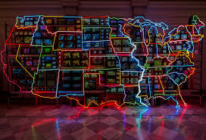

Albert Bierstadt - Among the Sierra Nevada - the American landscape is the root of our artists. A German artist who was one of the explorer artists. All expirations included artists. Once they found out the beauty of American landscape it changed perception of America.

Large landscapes are the showstoppers.

Alma Thomas (1891-1978) we have over 78 of her works
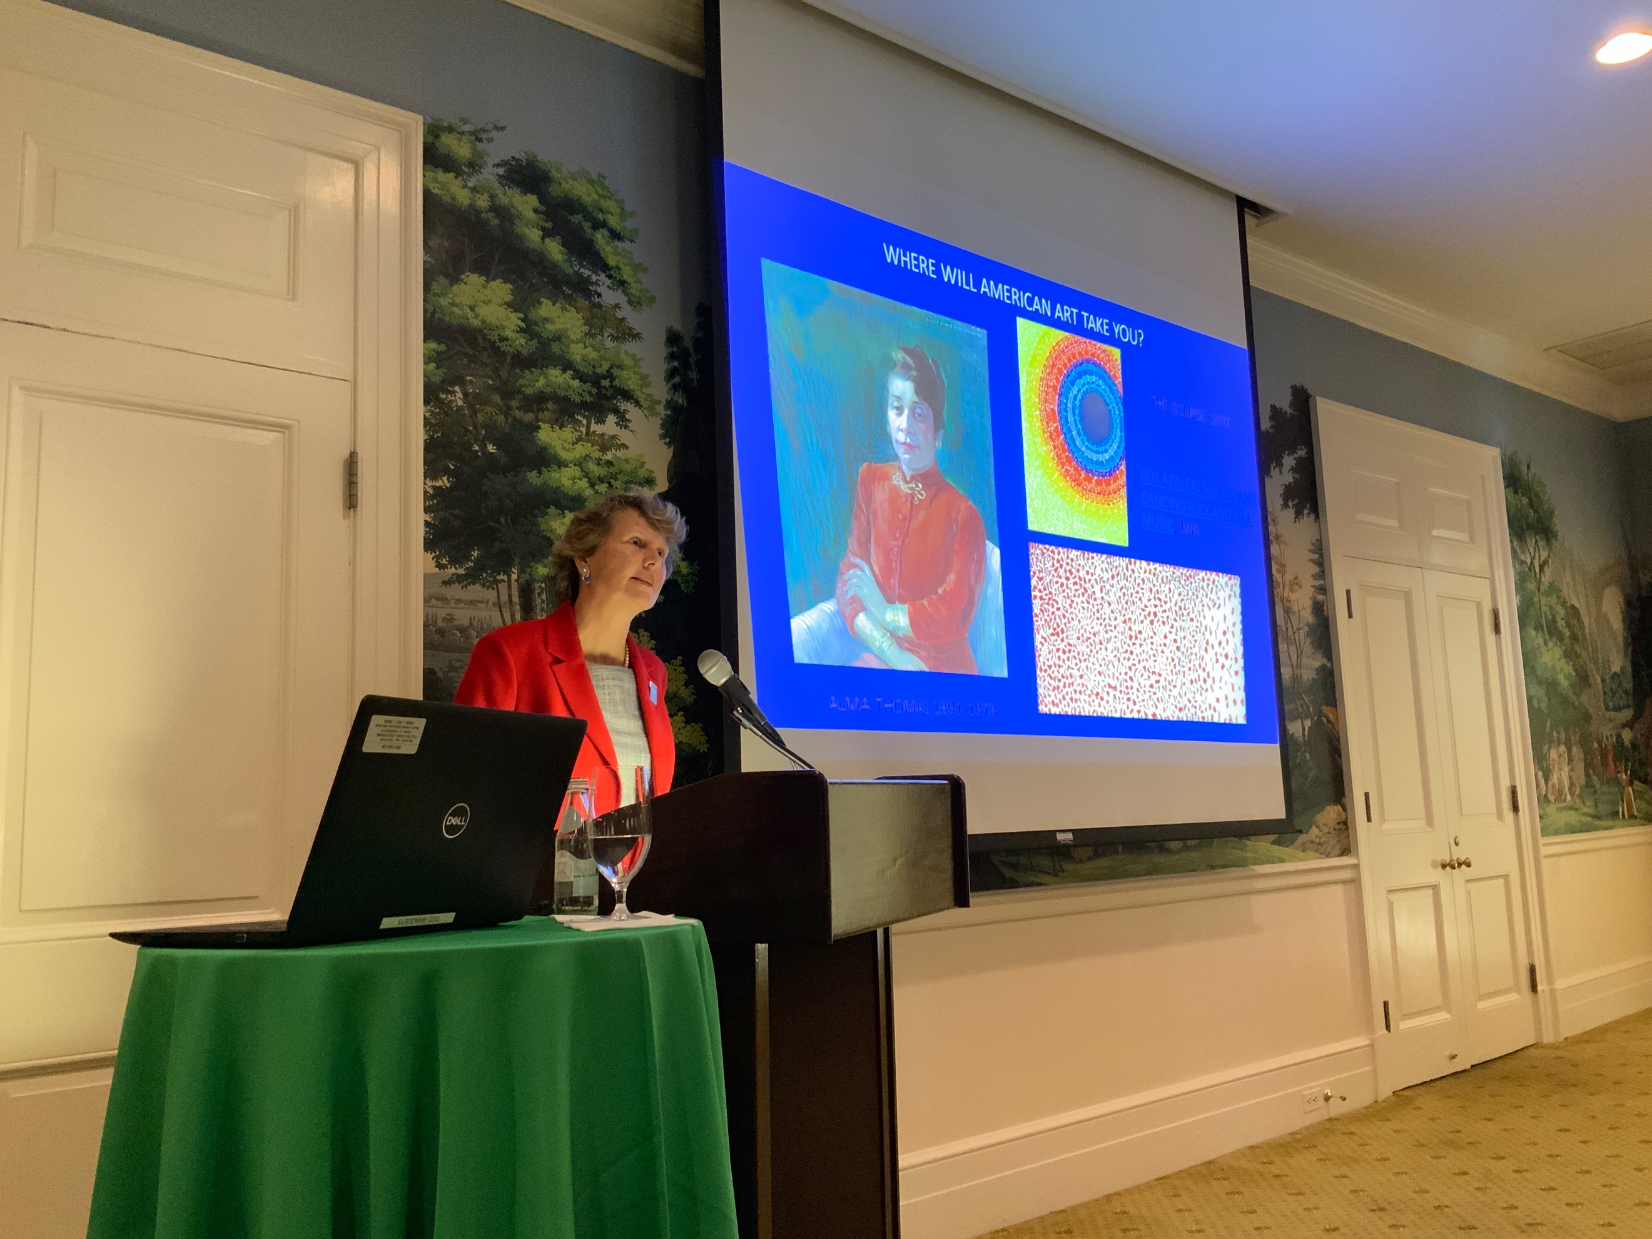

Washington Color School
Morris Lewis & Martin Puryear - their first exposition in the Corcoran

SAAM has 13 curators. Recent purchases include
William Wiley - over 4 dozen pieces
Barbara Chase Verbot - knitted skirts, Zanzibar West
Seth Gould - Coffer
Miguel Luciano - Puerto Rican American. Plantain.. Pure Plantanium
Radiator - Doho sup
Active policy of buying - mid tier career artists

Good news – is that people are coming.
Visitor Count SAAM
FY18
2/1 Million Visits compared to FY18 1.2
Open 364 days a year til 7 am.
Renwick
FY18 - 795,00 < FY17 371,000 Visit
Over 50% are repeat visitors
Bring a child... they will become lifelong art lovers

Peggy Guggenheim -
Sara Roby - gave her entire collection to SAAM
A Pittsburgh heiress
She hated Jackson Pollack (called him a “dripper”
So she collected art.
Edwards Hopper -
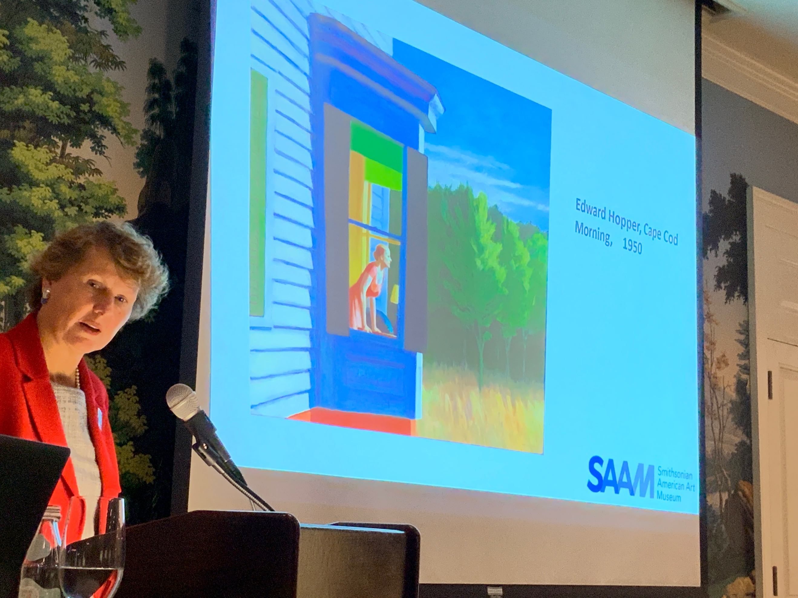

She advocated for women artists

Adopting new technology
Scan on art - that you can use your mobile phone to get info.

No Spectators - The Art of Burning Man - March 30-Sept 16, 2018
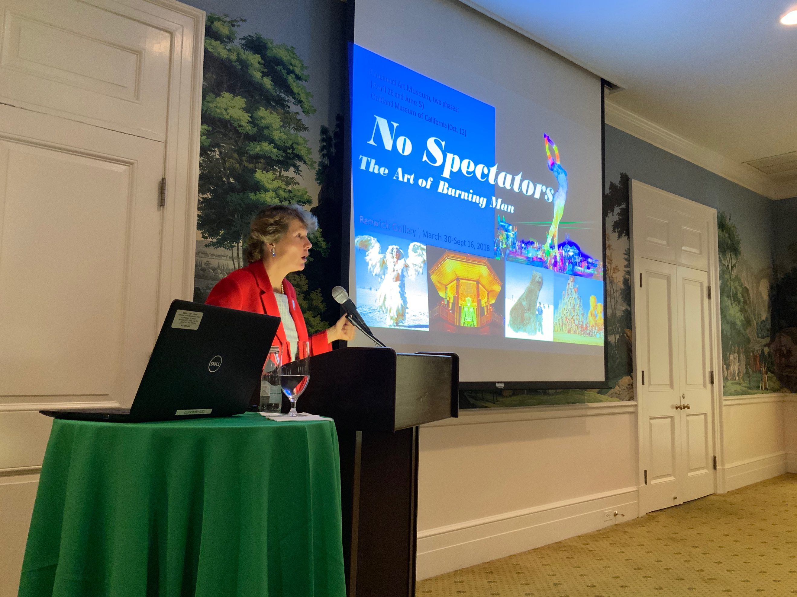
- That’s me next to the bear made out of 10,000 pennies

What SAAM has going on:
Bill Traylor - Art of Bill Traylor - publishing
Dance parties
SAAM Fellows - Art Bites - ted talks by the fellows on the Collection
Education K-12 - We teach American Art to American kids abroad - my staff teaches class online. Paid by the Dept of Defense
Collecting with other Smithsonian - Joint acquisitions – a new trend.
American Women’s History Initiative
Maya Lin - Sculptor and Architectural Designer
5 year launch to expositions, catalogs and retrospectives
Muriel Siebert- Financier
Vera Rubin - Astronomer
We are looking to amplify women’s voices
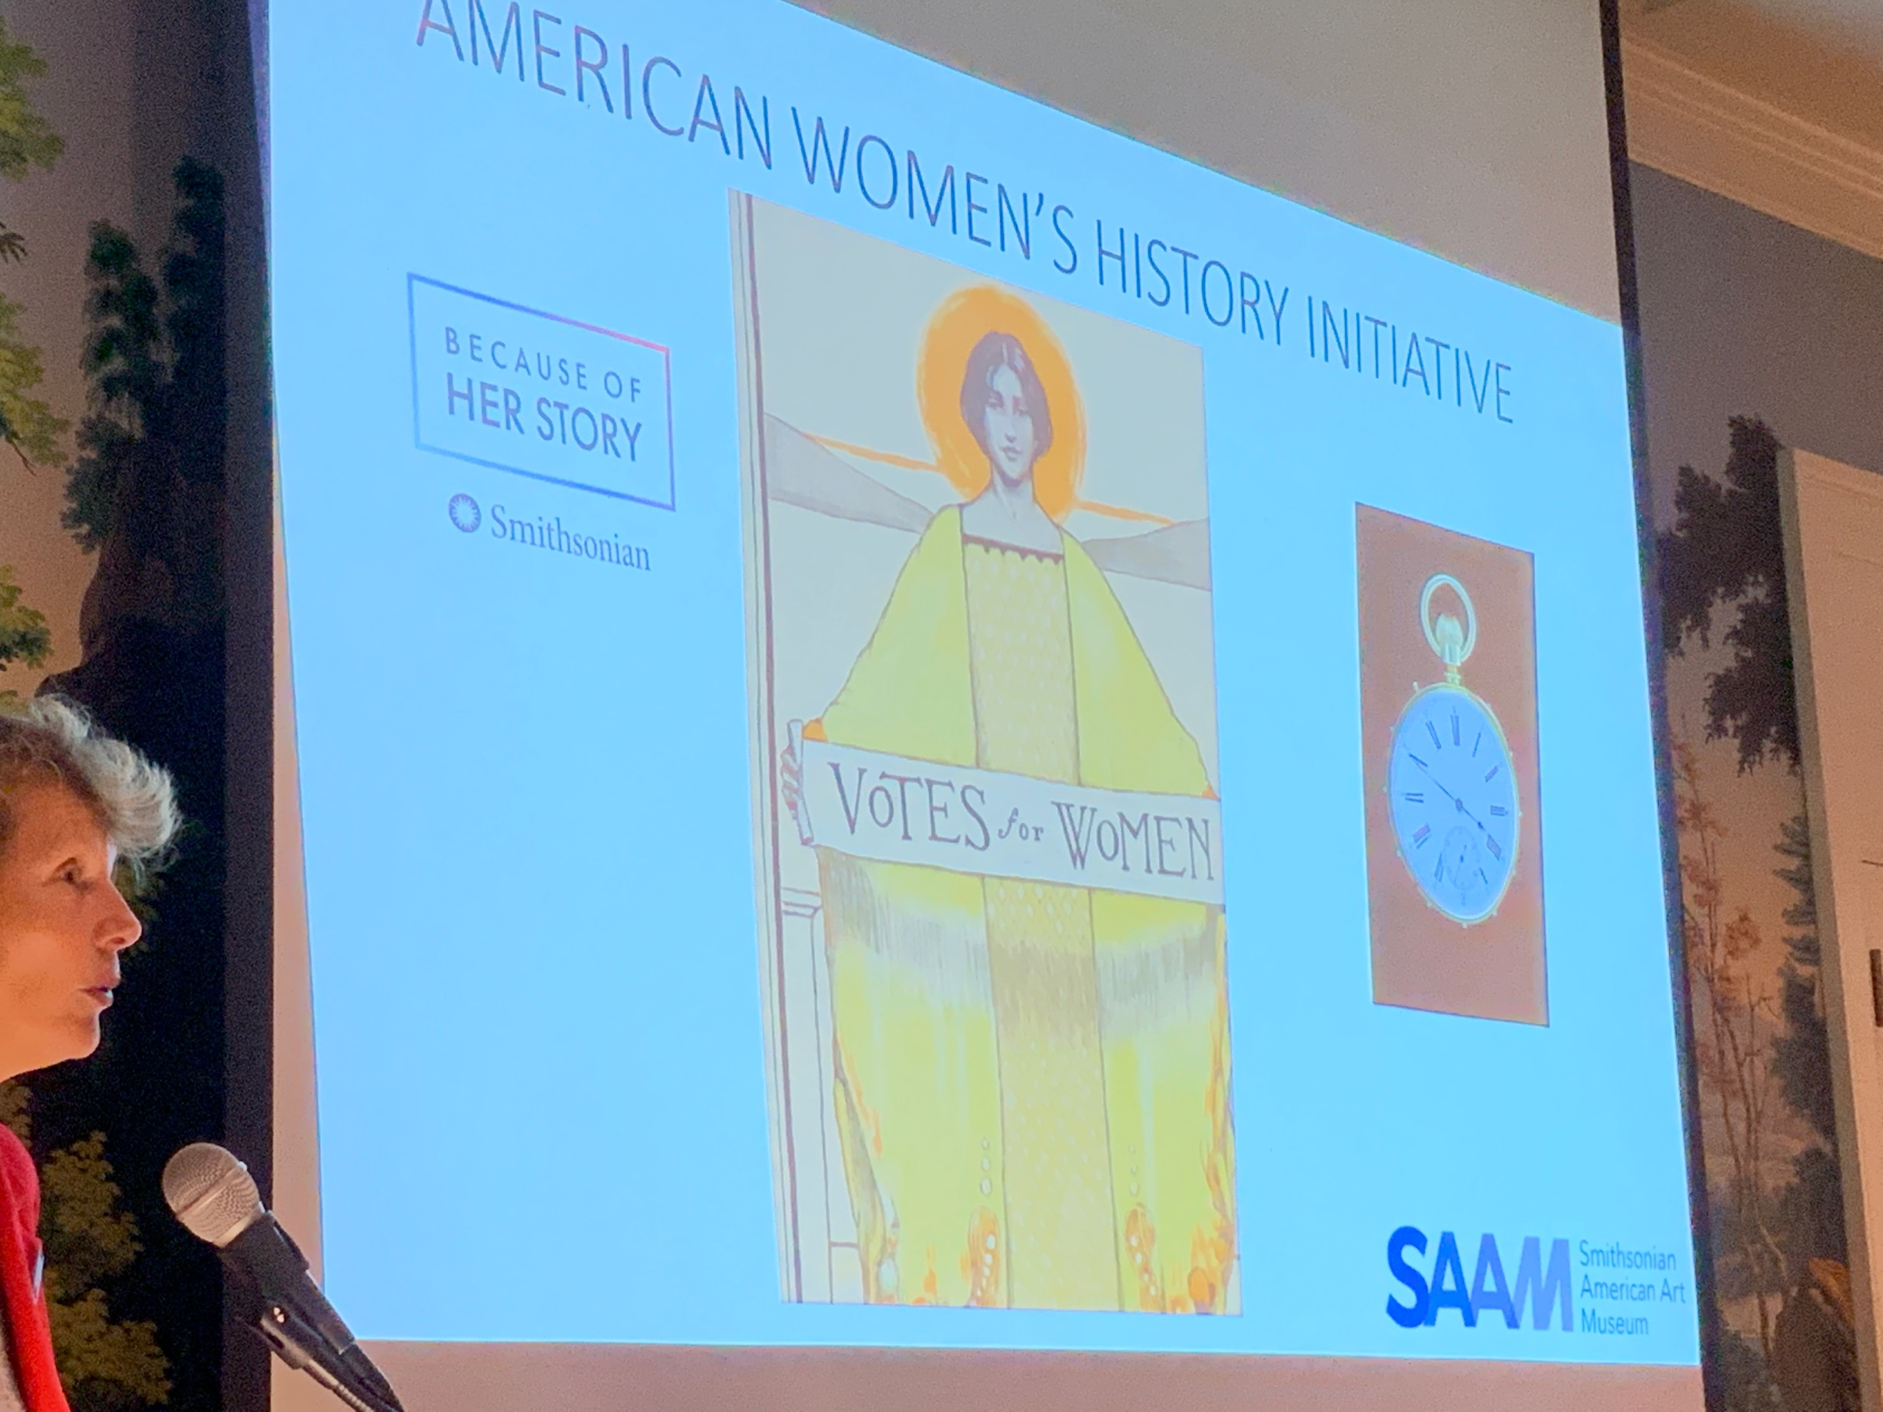
Helen Keller’s Watch - retrofitted so she can
We have an upcoming work = in the American History Museum - Girlhood
New book is coming out... 100 works, created by women

Women’s Initiative
There is a portal - you can get on and find out more about things and get their emails.
Here is the link: https://womenshistory.si.edu/

