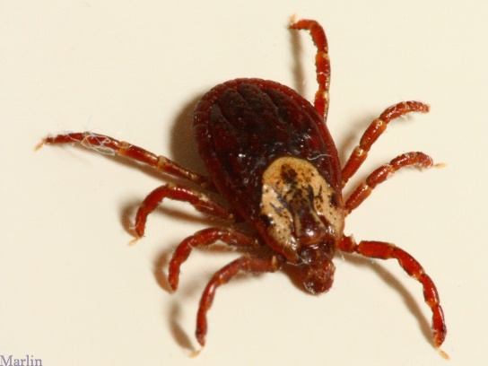

Updated June 2017
Ticks are small spiderlike arachnids that bite to fasten themselves onto the skin and feed on blood. Ticks live in the fur and feathers of many birds and animals. Tick bites occur most often during early spring to late summer and in areas where there are many wild animals and birds. While most ticks don't carry diseases, and most tick bites don't cause serious health problems, it is important to understand the signs and symptoms of tick-borne illnesses. Ticks should be removed properly from humans and pets as soon as possible. Removing the tick's body helps to avoid diseases the tick may pass on during feeding. Once removed, it is important to assess for tick-borne illnesses. These include Lyme Disease, Rocky Mountain Spotted Fever, Anaplasmosis, Babesiosis and Tularemia.

What Are Ticks?

Ticks are arachnids, which is a relative of the spider. They are obligate blood feeders (blood is all they feed on), and they typically stay attached to their host for days or a week to complete feeding (in contrast, mosquitoes are quick-in/quick-out blood feeders). Ticks also carry a wide variety of disease-causing germs and they transmit these agents while bloodfeeding. There are many different types of ticks including: deer ticks, american dog ticks, gulf coast ticks, and rocky mountain wood ticks - to name a few. For more details on the types of ticks, see the resources section below.

Ten Essential Tick Facts

Adapted from University of Rhode Island TickEncounter Resource Center, Thomas Mather. With permission.
- All ticks crawl up (think protection from the ground up).
- All ticks (including deer ticks) come in small (larvae), medium (nymphs) and large (adult female/male) sizes.
- Ticks can be active even in the winter.
- Ticks carry a variety of disease-causing microbes.
- Only deer ticks transmit Lyme disease bacteria.
- It is unclear if deer ticks must be attached for longer than 24 hours to pass on the Lyme disease infection. Other tick-borne disease organisms can be transmitted in less than 24 hours.
- Some ticks can be hard to see or feel - deer tick nymphs look like a poppy seed on your skin.
- The easiest and safest way to remove a tick is with a pointy tweezer.
- Tick repellent clothing with permethrin is best for preventing tick bites.
- Tick bites and tick-borne diseases are preventable.

Tick Repellent Clothing

DEET-containing products were thought to be a good option for preventing tick bites. However, recent tests have shown that although DEET is an excellent repellent for mosquitoes, black flies and gnats, it's only effective at repelling ticks for brief time periods after being applied and then must be re-applied. A better option for repelling ticks are "Clothing Only Repellents" such as those containing Permethrin (found in Permanone® Products, Sawyer Clothing-Only Repellent® and Repel®). These products contain about 0.5% Permethin, much less than the amount used to treat head lice on children or Scabies mite infestations of the skin. In the case of tick repellents, using more of the active ingredient than this is unnecessary, and can even lead to chemical overexposure.
You can purchase tick repellent clothes containing permethrin (easiest and most cost-effective) or use sprays and soaking kits to treat your own clothes with permethrin tick repellent. Commercially treated clothing remains tick repellent through 70 wash cycles while treat-at-home sprays and kits provide effective repellency for up to 6 washings. Whichever method you choose, wearing tick repellent clothing makes tick bite protection and disease prevention as easy as getting dressed in the morning!

