**POSTERIOR STABILISATION THERAPIST INFORATION**

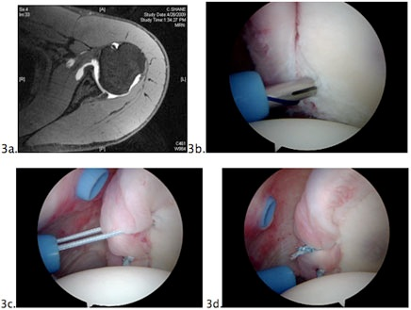

Contact:

Email: info@manchestershoulderdoc.com

NHS - Sarah Clowes 01612766822

* Posterior stabilisation involves reapposition of the posterior labrum to glenoid using bone anchors.
* To allow healing to be effective do not push for IR in forward flexion for 6-8 weeks**.**

**AIMS OF PHYSIOTHERAPY**

* Increase gleno-humeral and scapula stability
* Posture training
* Achieve full range of movement
* Strengthen rotator cuff
* Improve scapula control and postural awareness
* Restoring proprioception with closed chain exercises

EARLY STAGE: Weeks 1-3

|  |  |
| --- | --- |
| **Aims** | **Treatment Guidelines** |
| **Minimise pain & swelling** | * Analgesia - usually codeine and Paracetamol should suffice * Ice if needed |
| **Protection of Repair** | * Polysling (with ER brace in some cases - refer to op note) |
| **Maintain ROM other joints** | * Shoulder girdle, elbow, wrist and hand exercises * Initiate scapula setting * Postural awareness * pendular exercises |
| **Function** | * Teach axillary hygiene |
| **Other** | * Remove stitches at 2 weeks |

MIDDLE STAGE: Weeks 3-6

**Review with Consultant at 6 weeks unless clinically necessary earlier**

|  |  |
| --- | --- |
| **Aims** | **Treatment Guidelines** |
| **Minimise pain & swelling** | * Analgesia * Ice |
| **Protection of Repair** | * Sling removed at 4 weeks |
| **Increase ROM** | * Increase ROM as tolerated. Avoid FF in IR beyond 90 degrees |
| **Function** | * Strictly no gym activities |

LATE STAGE: 6 weeks onwards

|  |  |
| --- | --- |
| **Aims** | **Treatment Guidelines** |
| **Increase ROM** | * Gradually increase range of movement * Hydrotherapy |
| **Increase muscle control** | * Functional Gleno-humeral and scapula stability exercises * Rotator cuff strengthening |
| **Proprioception & core stability** | * Core stability and proprioceptive exercises * Open and closed chain exercises |

Return to Functional Activities

Following timelines are the earliest for these activities to be commenced. Of course the times are approximate and will vary with individuals.

* **Using computer** 3 weeks
* **Driving** 6-8 weeks
* **Swimming** Breaststroke – 10 - 12 weeks

Freestyle - 4-6 months

* **Golf** 4-6 months
* **Contact sports** 6 months onwards
* **Return to work** Dependent upon the patient’s occupation.
* **Gym** Can start graded bench press and push ups after 3 months