An Garda Síochána
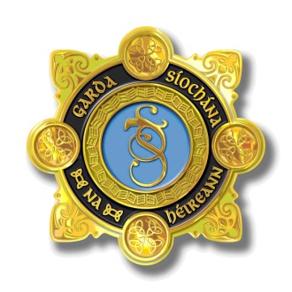
An Garda Siochana
Community Policing Unit
Garda Station
Roscommon Town
Co Roscommon

An Garda Siochana
Stáisiún an Gharda Síochána
Roscomain
Co Roscomain

Teileafón/Tel: (090)6638335
Facs/Fax: (090)6638383

Bí linn/Join us
Láithreán Gréasain/Web Site: www.garda.ie
Ríomh-phoist:/Email:
john.l.oconnor@garda.ie

9th June 2020

______________________________________________________________________________________

Dear Principal,

I am pleased to inform you that following feedback from schools, the Annual Garda Poster Competition will take place despite the obvious obstacles that exist.

A number of schools have decided that it was not practical to take part and this is understandable. We will hopefully be back to some sort of normal in 2021.

The competition will again be organised in conjunction with Roscommon County Council.
The closing date for entries is Friday 19th June 2020.

The school will arrange for all entries to be delivered by post or by hand to Roscommon Garda Station for my attention. For practical reasons, all posters should be A4 Size. Please ensure that the pupils, name, class and school is clearly wrote on the back of the poster.

We would hope that teachers would encourage their pupils to make a special effort in what has proven to be a worthwhile exercise.
In the past, the successful entries have been those that have had an original road safety message and they were presented in a clear and colourful manner.

Prizes will be awarded to the best entries in each school. The number of prizes for each school has yet to be decided, as they may have to be hand delivered individually to each pupils home.

There will also be three overall winners and they will be presented in person in line with Covid-19 Government regulations. Venue and date TBC.
The overall winner will receive a family pass for Zipit, Lough Key, Forest Park.
This prize is kindly sponsored by Roscommon County Council.

Please find a list of rules attached.

Any enquiries to;

Garda John O’Connor, Roscommon – john.l.oconnor@garda.ie (090) 6638300.

Regards,

John

