Researches on Christian Archaeology,
Late Antiquity and Early Middle Ages
International conference of PhD students
Rome, 5th-7th February 2018
PARTECIPATION FORM - poster*
Name and Surname | Nationality |  |  | Institution
First year of PhD |  | Date of PhD discussion
Topic of PhD thesis
Research Tutor |  |  | General subject
Poster title
Abstract (maximum 250 words)
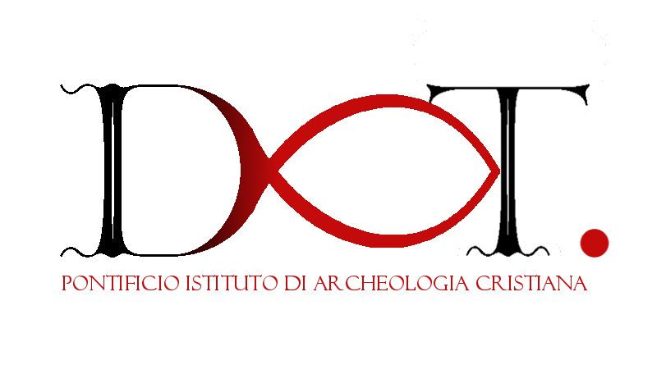
* Poster have to be vertical and 70 x 100 cm. We ask you to use the following textsize: Heading 70-100 pt; Subtitle: 50-60 pt; Title of the paragraphs: 30-40 pt; normal text: 18-24 pt. Text does not have to be longer than 700 words and have more than five pictures.

