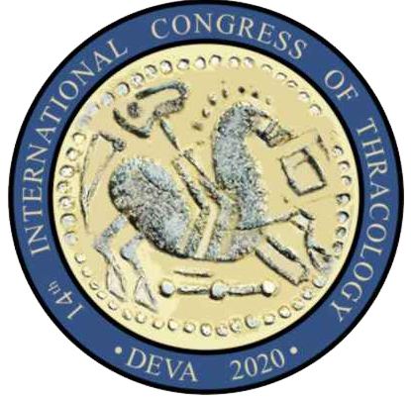
THRACing the Past
From Bronze Communities to Iron Kingdoms

Registration Form
14th International Congress of Thracology
Deva, Romania, 6th-10th of May 2020

Family Name
First Name
Title (Prof./Dr.)
Street
No.
Zip-Code
Town
Country
E-mail
Institution

Poster
Lecture
Title
Please give a brief description of the topic of your poster or lecture (max. 100 words).

Are you interested in joining the post-Congress tour to the Dacian Fortresses of the Orăştie Mountains and Hunedoara Castle (1 day)?
Yes
No

Please mention if you wish to apply for a grant:
Yes
No

e-mail: thracology2020deva@gmail.com

