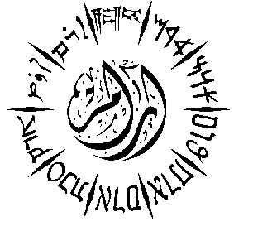
Aram Society for Syro-Mesopotamian Studies
The Oriental Institute, University of Oxford, Pusey Lane, Oxford OX1 2LE-UK
Tel: 01865-514041 Fax: 01865-516824 Email: aram@orinst.ox.ac.uk or
aram@aramsociety.org www.aramsociety.org or www.aramsociety.com
Charity Number UK: 1011775

Aram Forty Sixth International Conference:

Arabs before Islam
17^{h} – 19th July 2017
The Oriental Institute, University of Oxford

Registration Form
Please complete in block capitals:
Title: (Prof. Dr. Mr. Mrs. Ms. Rev. ).....................................................................................................
Name:.....................................................................................................................................................
Address:..................................................................................................................................................
................................................................................................................................................................
City:...................................................................Postcode:......................................................................
Country:.............................................................Tel:..............................................................................
Email ......................................................................................................................................................
Mobile Phone: Country Code……………………….. Number:…………………………………….
You will receive regular SMS messages during the conference to aid your understanding of the program and its activities.
I am speaker:
If Yes, please give the title of your paper:……………………………………………………………..
…………………………………………………………………………………………………………
…………………………………………………………………………………………………………
The Name of your academic institution: ………………………………………………………..…….
Please attach your CV if you are a new speaker
The Advisory Committee of the Conference cannot accept your proposal without an abstract, which should reach us before mid-March 2017.
Your abstract should be around 300 words, and it should contain the main sources of your research as well as the main points of your talk.
I am not a speaker but I wish to attend:
I am a student: (Name of your University & Department)…………………………………..….
…………………………………………………………………………………………………………
Please, send this form either by email to aram@orinst.ox.ac.uk or by post to:
The Aram Society, the Oriental Institute, University of Oxford, Pusey Lane, Oxford OX1 2LE, United Kingdom.

