Religious Interactions in the Hellenistic World

International Conference

The Ioannou Centre for Classical and Byzantine Studies - Oxford,
Lecture Theatre 18-19 March 2017

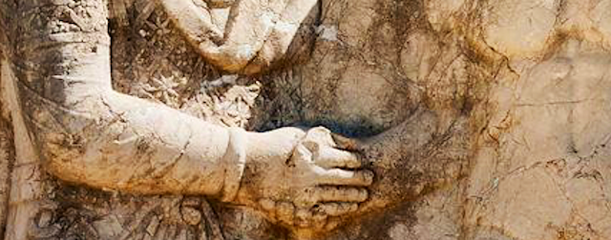

Organisers: Dr Sofia Kravaritou & Dr Maria Stamatopoulou

Info: sofia.kravaritou@classics.ox.ac.uk; maria.stamatopoulou@classics.ox.ac.uk

Sponsors: Marie-Curie Fellowship, John Fell Fund, The Craven Committee, Society for the Promotion of Hellenic Studies

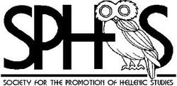

Religious Interactions in the Hellenistic World
The Ioannou Centre for Classical and Byzantine Studies - Oxford, Lecture Theatre18-19 March 2017

Connecting people or promoting diversity? Endorsing diplomatic affinities among empires and local communities by forging social bonds between ethnically and culturally diverse people, or instigating social conflicts based on varied group identities within major urban centres? What was the driving force in communicating and sharing heterogeneous cult practices and beliefs among the populations of the Hellenistic World? The conference will discuss how and whether religious interactions helped achieve a successful operation of institutions and whether they contributed to the cohesion of the peoples in the Hellenistic empires. The area covered stretches from Sicily and Italy to Bactria.
The issues that will be addressed include: the role of cult practices and religious beliefs in the emergence and development of the socio-political and cultural interface of the Hellenistic World; how and whether rulers promoted religious interactions in order to achieve social cohesion; what were the major effects of the social policies and initiatives related to cult affairs that were implemented by non-royal social agents; the development of shared cult practices among ethnically and culturally diverse agents and cult participants as a key factor in acculturation processes in metropoleis and smaller communities; the evolution of religious institutions and sacred spaces both in local and regional socio-cultural contexts; the role of interconnectivity and communication networks; religious diversity and modes of exchange between Greek and non-Greek traditions of religious practice and thought; the nature and motivation behind the wide distribution of certain deities and cult practices; the role of private groups and associations; one’s gods and the gods of the others ̶ perception of self and the ‘other’ as a medium of self-representation within the Hellenistic cosmos.
Attendance – Info
- Attendance is free for all Oxford university members, staff and students. In order to have a sense of numbers, and ensure that we adhere to Fire Regulation restrictions we would appreciate it if you could contact us to inform us if you are planning to attend.
- Non-Oxford University members will have to register using the online store (link and dates to follow). Attendance costs: £ 8 (covers tea and coffee for the two days).
- We are able to provide a few bursaries for students in Greek History and Archaeology from other UK universities; they may cover (part or all) travel expenses, registration fee. Interested students are requested to contact Sofia Kravaritou (email: sofia.kravaritou@classics.ox.ac.uk).

Provisional programme

Saturday, 18 March

9:15 Welcome and introduction

9:30 Manuela Mari (Cassino)
Local and 'national' cults in Macedonian kings' letters
and diagrammata.

10:00 Rolf Strootman (Utrecht)
The Marriage of Antiochos and Nanaia: Seleukid participation in local cults and the globalization of Hellenistic religions

10:30 Discussion and Coffee

11:30 Frances Reynolds (Oxford)
Continuity and change at Hellenistic Esagil

12:00 Vito Messina (Turin)
Religious interactions at Seleucia on the Tigris:
the archaeological evidence

12:30 Discussion and lunch

14:00 Laurianne Martinez-Seve (Lille)
Cults and religious practices at Ai Khanoum (Bactria)

14:30 Julietta Steinhauer (UCL)
The social dynamics of religious associations in Western Asia Minor

15:00 Discussion and Coffee

16:00 Kyriakos Savvopoulos (Oxford)
(Alexandria) title tbc

16:30 Tessa Rajak (Reading)
The Alexandrian torah translation and the paradoxes of acculturation

17:00 Discussion

17:30 Drinks Reception

19:00 Dinner for speakers and chairs

Sunday, 19 March

09:00 Christy Konstantakopoulou (London)
The social dynamics of dedication in the third-century Delian inventories

09:30 Christina Williamson (Groninger)
Panhellenic politics. Festivals as multi-scalar tools of cohesion in the post-classical world

10:00 Corinne Bonnet (Toulouse)
Does Hellenism rhyme with Imperialism? Greek and Phoenician religious networks in the Hellenistic middle ground

10:30 Discussion and Coffee

11:30 Milena Melfi (Oxford)
Gods and civic communities in the late Hellenistic period: Towards the creation of an uninterrupted religious history

12:00 Sofia Kravaritou (Oxford)
The new Thessalian mystery cult and its transcultural background

12:30 Discussion and lunch

14:00 Ilias Arnaoutoglou (Athens)
Hellenistic Athenian private cult associations. A privileged space of religious interactions?

14:30 Stella Skaltsa (Copenhagen)
Rhodes: a melting port? Associations and religious interactions

15:00 Discussion and coffee

16:00 Massimo Osanna (Naples)
(Pompeii ) title tbc

16:30 Chris de Lisle (Oxford)
The Priest-Kings of Hellenistic Sicily. Negotiating between the Local and the
Global

17:00 Discussion

17:30 Final discussion/concluding remarks

19:00 Dinner for speakers and chairs

