Application Form

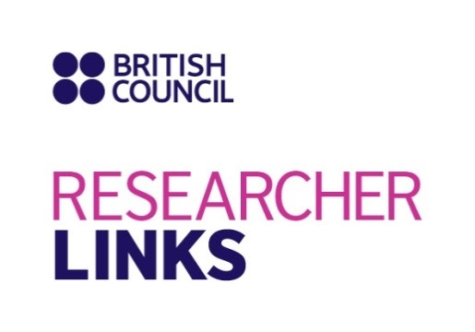

Workshop Title: Plato's Communities: Citizenship and Diversity
UK coordinator: Gábor Betegh (University of Cambridge)
Brazil coordinator: Gabriele Cornelli (Universidade de Brasília)
Discipline: Ancient Philosophy
Dates and venue: September 19-21, 2017

The full application below must be completed and submitted by the March 30, 2017 to archai.unb@gmail.com.

1. Applicant
Name and title
Gender (for statistical purposes. This will not affect choice of participants)
Position and institution
Postal address
Email
Phone number
Brief CV (academic career, publications, markers of esteem, and any other relevant information) – no more than ½ page of A4

Abstract - Please give a summary of your area of research, and provide a brief description of the topic of your presentation

3. Please describe your motivation for attending the workshop and how the workshop matches your professional development needs
4. Please describe the expected impact of your participation on your personal and professional development, including your ability to work internationally

5. Please indicate how you will disseminate the outcomes of the workshops and the new knowledge/skills you have acquired

6. Workshops will take place in English as standard. Please indicate your ability to work and communicate in English (Note, translators may be provided if necessary)
Native speaker |  | Good
Excellent |  | Need support

7. Please use this space to give any additional information that you feel is relevant for the application.

