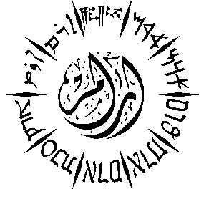
Aram Society for Syro-Mesopotamian Studies
The Oriental Institute, University of Oxford, Pusey Lane, Oxford OX1 2LE
Tel: 01865-514041 aram@orinst.ox.ac.uk www.aramsociety.org
Charity Number UK: 1011775

Aram Fifty First International Conference

The Gnostics of the Ancient Near East

15th-17th July, 2019
(The Oriental Institute, the University of Oxford)

Registration Form
Please complete in block capitals:
Title: (Prof. Dr. Mr. Mrs. Ms. Rev. ).....................................................................................................
Name:.....................................................................................................................................................
Address:..................................................................................................................................................
................................................................................................................................................................
City:...................................................................Postcode:......................................................................
Country:.............................................................Tel:..............................................................................
Email ......................................................................................................................................................
Mobile Phone: Country Code………………………..Number:……………………………………….
You will receive regular SMS messages during the conference to aid your understanding of the program and its activities.
I am speaker:
If Yes, please give the title of your paper:……………………………………………………………..
…………………………………………………………………………………………………………
…………………………………………………………………………………………………………
The Name of your academic institution:………………………………………………………..…….
Please attach your CV if you are a new speaker
The Academic Committee of the Conference cannot finalise your proposal without an abstract, which should reach us before November 2018. Not all papers which appear on the first draft of our programme will be accepted, for the Scientific Committee can only confirm your participation in the conference after reading your abstract. Your abstract should be around 300 words, and it should contain the main sources of your research as well as the main points of your talk.
I am not a speaker but I wish to attend:
I am a student: (Name of your University & Department)…………………………………..….
…………………………………………………………………………………………………………

Please, send this form either by email to aram@orinst.ox.ac.uk or by post to the above address of ARAM

