cid:image003.png@01D44F61.9D857C20

UK and Ireland Regional Chapter

Yorkshire and Midlands Regional Networking Event - open to all

**How can businesses and academia address the problem of plastic waste?**

**Date: 3rd April 2019**

**Location: Sheffield Business School, Cantor Building, Room 9234**

**Agenda**

**12:30** Arrival, buffet lunch and networking

**1:15** Welcome and outline of day

**1:30** Keynote speakers - 30 minutes per session including Q and A.

* ***Dr Anne Kildunne,*** Plastics Collaboratory, University of Hull,

The Plastics Collaboratory at the University of Hull comprises more than 25 staff across a range of academic disciplines working to address to address the problem of plastic waste and propose new solutions.  A major new research project funded by the EPSRC aims to use the Circular Economy model to identify gaps and leaks in the plastics circular economy and work with a wide range of stakeholders to develop practical solutions.

* **2:00 *Professor Elizabeth Kirk*,** Professor of International Environment Law, Nottingham Trent University

Do we need a new treaty to tackle plastics in our oceans?  “Marine Plastics and International Law: Time for a Treaty?”

* **2:30** ***Nicholas Hunt,*** Environmental Manager, University of Loughborough,

The alternatives to plastics and are they really better or just creating other problems

* + compostable and biodegradable plastic alternatives
  + Examples of materials used instead of plastics
  + The carbon footprint impact of the alternatives

The real challenge with plastics

* + Different plastic types
  + Recycling plastic
  + Plastic litter
* The single use plastics we do need to avoid

Summary of what needs to be done to win with plastics.."

**3:00** Refreshments to take to break out rooms

**3:15** Discussion in break out rooms (depending on numbers attending)

**4:00** Final plenary - 4:30 finish

**Register your interest and reserve a place**

<https://store.winchester.ac.uk/conferences-and-events/public-events-and-workshops/prme/prme-yorkshire-and-midlands-regional-networking-event>

**The aim of this event is to help us all gain a better understanding of the problem with plastic, and to develop ways to counter this global challenge, either in class with our students, through our research or in our engagement with businesses.**

[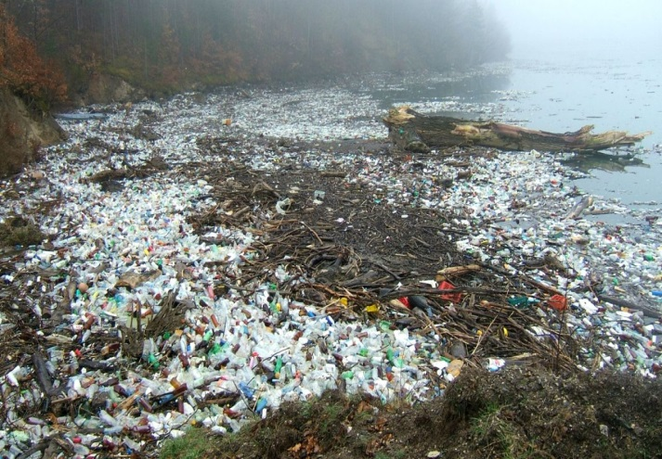](https://www.google.com/url?sa=i&rct=j&q=&esrc=s&source=images&cd=&cad=rja&uact=8&ved=2ahUKEwjGt_nlraTgAhXABGMBHV2zBbMQjRx6BAgBEAU&url=https://friendsoftheearth.uk/plastics&psig=AOvVaw0-mkgDXTjiuWMtfOZqF43t&ust=1549447915863027)

[**https://friendsoftheearth.uk/plastics**](https://friendsoftheearth.uk/plastics)

**Topics for discussion in break-out sessions - these are negotiable and may change according to what participants want on the day.**

* What are the implications for universities in terms of teaching, research and good practice?
* How can we address the plastic problem in our teaching and/.or research and engage our students and other stakeholders?
* How can businesses help us with this?

How to find us

<https://www.shu.ac.uk/visit-us/how-to-find-us/city-campus-map>

**Facts about Plastic and why it is a growing problem**

In 1950, the world’s population of 2.5 billion produced 1.5 million tons of plastic; in 2016, a global population of more than 7 billion people produced over 320 million tons of plastic. This is set to double by 2034.

Every day approximately 8 million pieces of plastic pollution find their way into our oceans.

<https://www.sas.org.uk/our-work/plastic-pollution/plastic-pollution-facts-figures/>

Only about 9% of plastic produced has been recycled, 12% has been burned and the remaining 79% has ended up in landfills or the environment.

Discarded plastic is harming the marine environment and impacting on low income communities living by polluted rivers.

Here are some more facts about plastic:

* Over the last ten years we have produced more plastic than during the whole of the last century.
* 50 percent of the plastic we use, we use just once and throw away.
* Enough plastic is thrown away each year to circle the earth four times.
* We currently recover only 5% of the plastics we produce.
* Plastic accounts for around 10 percent of the total waste we generate.
* The production of plastic uses around eight percent of the world's oil production (bioplastics are not a good solution as they require food source crops).
* Plastic in the ocean breaks down into such small segments that pieces of plastic from a one liter bottle could end up on every mile of beach throughout the world.
* Annually approximately 500 billion plastic bags are used worldwide. More than one million bags are used every minute.
* <https://www.ecowatch.com/22-facts-about-plastic-pollution-and-10-things-we-can-do-about-it-1881885971.html>