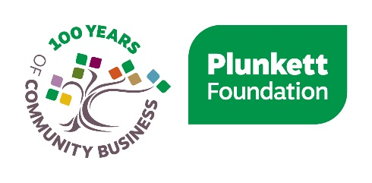

Peer Networking Project: Woodland Social Enterprise Networking Group
Code of Conduct

The group has been established for those involved with woodland social enterprises to share ideas and ask questions on a safe and interactive platform.
As this is a closed Facebook group, this means that anyone can see the group and who is in it, but only members are able to post and see posts. If you are a member of the group, you will be able to invite anyone to join, but only approved admin users can accept new members.
To prevent spam users, admin will use discretion when approving new members.
As well as seeing posts from fellow MLWW Groups and WSEs, Plunkett Foundation will inform you of services and activities that you may find useful.
The opinions and views expressed within the group are of the authors and do not necessarily represent those of Plunkett Foundation, MLWW Partners or The National Lottery Community Fund. Any advice received via the group is for general information purposes only. Further action should not be taken relying on direct information only.
Appropriate professional advice should be gained before acting upon this.

Moderation of the group
This group will be both monitored and moderated by administrators, who are members of staff or volunteers of Plunkett Foundation. We will be unable to monitor the group 24/7, however urgent actions such as the removal of unacceptable posts will be removed as soon as possible.
We encourage all members to self- moderate and be aware of their posts, replies and the feelings of other members of the group.
Anyone assumed not to be a legitimate user of the group may be removed without consultation. This group is intended to act as a networking platform for community shop groups.
Moderation will cover the following topics, however we will review each incident on a case by case basis.

Abusive posting
Negative posts, intended as trolls/flames, aimed at other members of the community shop networking group will not be accepted. Any abusive messages directly/indirectly aimed at other members will be deleted immediately. Persistent use of negative comments or views directly towards another member of the group will be viewed as abuse by moderators. Initial use will be met with a warning. If this continues to occur, then the guilty member will be issued with a permanent ban from the group. We would like all our members to respect the views of others even if you feel their opinion is incorrect.

Language used
All uses of foul language, including swearing and aggression, towards other members of the group will not be tolerated.

References to content
As this group is intended to act as a peer networking platform, we encourage all members to refer to either their own website or partner websites when discussing woodland community projects news, events etc.
Therefore, please feel free to share links when necessary so other members can find out more. However, this group is not intended as a mass spam/marketing platform.

Advertising/spam
This is a peer networking group for Facebook users involved with woodland communities. Therefore, any mass advertising (spam) will not be tolerated. This would be surrounding a topic which is not directly involved with the woodland network, such as the promotion of personal business outside the network.
This will be dealt with on a case by case basis by administrators of the group.
If you have any questions or concerns about this, please direct message one of the lead moderators (highlighted in the group description on Facebook).

Use of images
It is of the responsibility of individual group members to obtain permission before posting images to the network. If you have any questions about this please contact one of the group administrators.
As a member of the network, your Facebook profile will be available to view by other members of the group. Therefore, you may want to change your privacy settings if you are using a personal Facebook account. For more information on this, please visit the Privacy Settings information here.
Plunkett Foundation does not accept responsibility for images which are external to the organisation. All information shared should be treated confidentially, unless otherwise stated.
If you have any concerns about images or videos hosted on the networking group, please contact a lead administrator.

-------------------------------------

