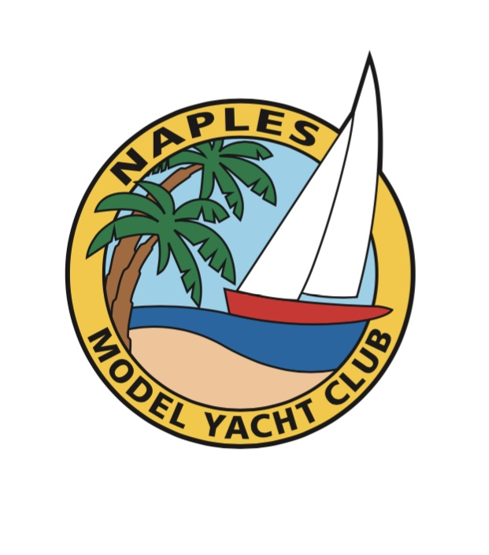


Naples New Year EC-12 Regatta

Regatta 2 of the Florida EC-12 Association 2018-2019 Series

January 12 & 13, 2019

Hosted by

Naples Model Yacht Club

AMYA Sanctioned Club No. 108

Rules: The regatta will be governed by the ‘rules’ as defined in the Racing rules of sailing, as

modified by Appendix E.

Eligibility: The regatta is open to all skippers with boats registered with the EC-12 Class

Schedule: Registration 8:30 AM Saturday

Skippers meetings 9:00 AM Saturday, 9:00 AM Sunday
Saturday races begin at 9:30 AM, No races will start after 4:00 PM.
Sunday races begin at 9:30 AM, No races will start after 12:30 PM.

The RD will extend the racing hours if needed due to weather delays or other unforeseen circumstances.

Location: North Collier Regional Park

15000 Livingston Road, Naples, FL 34109 Detailed directions will be provided, if necessary.

Sailing Instructions: The standard Sailing instructions for the Florida EC-12 Association are posted at: http://www.floridaec12.com/regattas.html

A copy will also be available at the regatta.

Entry: Eligible boats may be entered by completing an Online Entry and submitting by Jan 2 2019 with an entry fee of $32.00, guests $8. Entry fee includes coffee, doughnuts, and drinks on Saturday and Sunday, plus lunch on Saturday

Scoring: The regatta will be scored under the AMYA Heat Management System (P&R/EORS) using the Low Point Scoring method of RRS Appendix A. To start the regatta, skippers will be placed in either the A- or B-fleet based on the National Seeding List. No seeding heats. A boat's worst score will be excluded if 6 -11 races are sailed. A Second worst score will be excluded if 12 or more races are sailed.

Prizes: Prizes will be awarded based on the number of entries received by the entry deadline:
3 prizes for 19 entries or less; 4 prizes for 20-26 entries; 5 prizes for 27 or more entries.

Please Enter Online By Going to:

http://www.floridaec12.com/regattas.html

or

https://www.theamya.org/regatta/nextYear/race_date.php

and Click the "Online Entry" Button

If you are unable to do online entry, send an e-mail to Richard Hedderick.

DickHedderick@gmail.com

Entries must be received by January 2 2019.

Saturday group dinner Dutch at a reasonable area restaurant.

Hotel Information and Directions

You may search online for a Hotel in either in Naples or Bonita Springs. Here are several modest priced hotels just off I-75. Local phone numbers are included as this may yield a better rate.

Hotel Located off Exit 101 of I-75

Comfort Inn Super 8

3860 Tollgate Blvd. 3880 Tollgate Plaza

Naples, FL 34114. Naples, FL 34114

Phone: (239) 353-7500. Phone (239) 300-2558

Hotel Located off Exit 107 of I-75

Best Western Naples Plaza

6400 Dudley Drive

Naples, FL 34105

Phone: (239) 643-6655

Hotel Located off Exit 116 of I-75

Days Inn

27991 Oakland Drive

Bonita Springs, FL 34135

Phone: (239) 949-9400

