Brockmans Gin “grapefruit zest is best” for the perfect G&T

It you thought G&T was the simplest of cocktails, it’s time to re-think. Brockmans Gin is English and brimming with botanicals from around the world, made distinctive with berry notes and citrus flavours which gave rise to the tagline ‘a gin like no other’.

Summer evenings beckon and G&T is the perfect choice for a sundowner. Making G&T perfect isn’t hard, but there are some rules than mean the ubiquitous ‘ice and a slice’ isn’t quite good enough. In the interests of research – or so they tell us – the people at Brockmans tried no fewer than 100 different recipes for G&T and finally came up with the ‘perfect serve’. The secret: a twist of pink grapefruit zest which draws out all of the 11 botanicals in this very special gin.
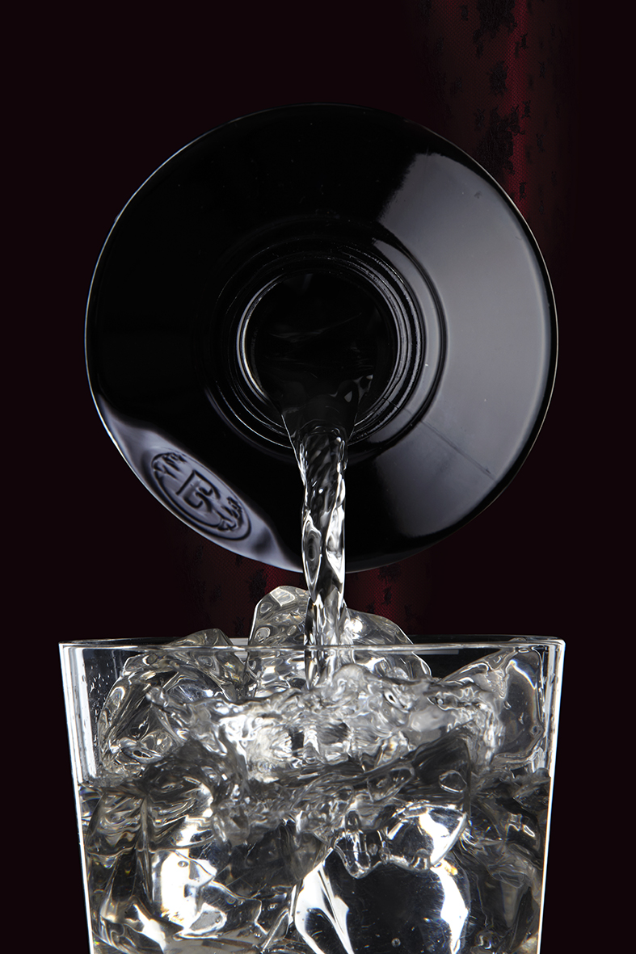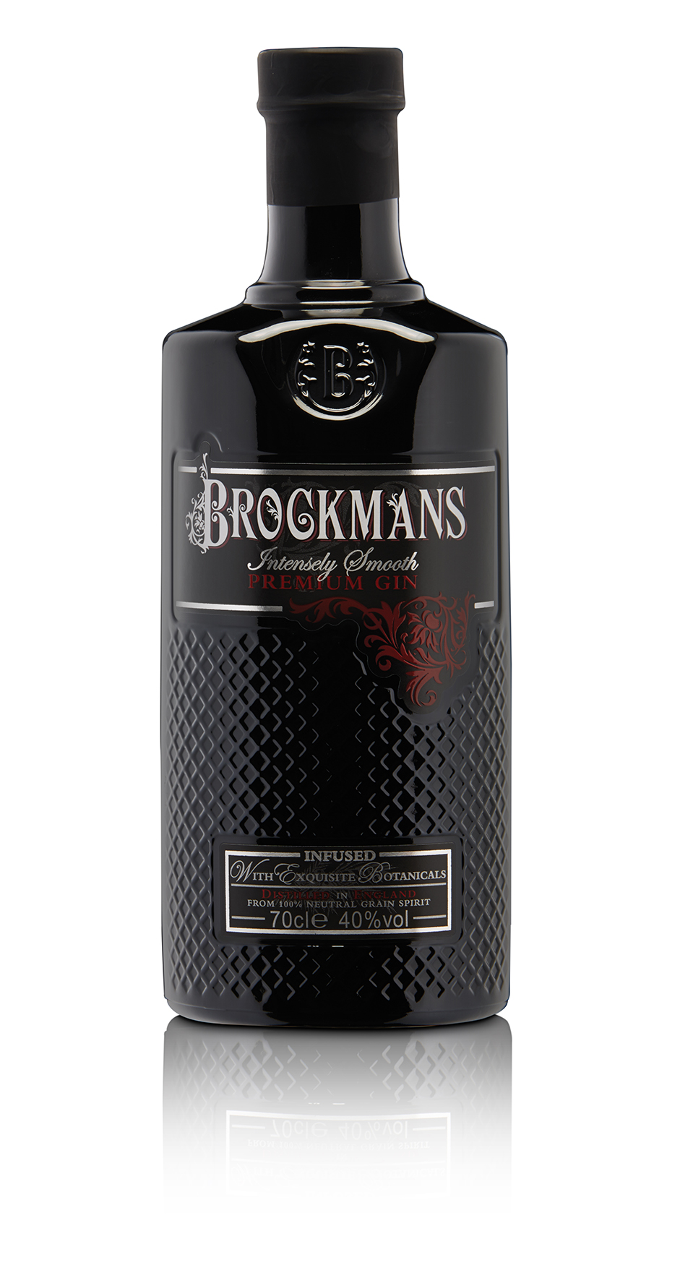
Brockmans Gin & Tonic with a Pink Grapefruit Twist
- Select and chill wide glasses – with a stem if it’s a very hot evening
- Chill good quality tonic water as this helps preserve the efferevescence
- Pour Brockmans Gin over large ice cubes in the chilled glasses - small ice cubes melt too quickly
- Add the chilled tonic water carefully either by pouring over a spoon or by pouring gently to again help preserve the sparkle
- Stir very gently
- Add a twist of pink grapefruit peel or other flavouring of your choice.
- Finish with a garnish of fresh blueberries for the visual appeal they bring.

To achieve the perfect G&T recipe, Brockmans Gin worked with a number of barmen, mixologists and a taste expert & perfumer, Alexandre Schmitt, who works all over the world within the drinks industry. The perfect addition of a twist of grapefruit peel rather than the flesh works because the balance of bitterness and acidity within pink grapefruit peel combines well with each of the botanicals within Brockmans Gin. It also lifts out some of the further notes within Brockmans Gin such as the tanginess of coriander and juniper. This then contrasts well with the dry citrus delivery of good quality tonic water.

Brockmans Gin is made in England and has an ABV of 40%. It is priced at around £32.99 a bottle and available from top bars, restaurants and hotels as well as specialist drinks retailers including on-line retailers.

www.brockmansgin.com
Ends
Notes to Editors
For images or a sample of Brockmans Gin please contact
Jo Jacobius
Brockmans Press Office
jo@axiom-uk.com
Tel: 020 8347 8206 or 07850338998

Rel 72

