LESSON PLAN

School Level : Elementary School
Class : 6th grade
Subject : Mathematics
Times : 2 x 50 minutes

- Core Competence
1. Accept and carry out the teachings of the religion s/he adheres to.
2. Having honest, disciplined, responsible, polite, caring, and confident behavior in interacting with family, friends and teachers.
3. Understanding factual knowledge by observing [hearing, seeing, reading] and asking based on curiosity about himself, God's creatures and activities, and the objects s/he encounters at home and school.
4. Presenting factual knowledge in clear and logical and systematic language, in an aesthetic work in a movement that reflects healthy children, and in actions that reflect the child's faithful and noble behavior.

C. Learning Objectives
- Identify the steps in adding fraction without or with regrouping
- Add fraction without or with regrouping
- Solve routine and non routine problems involving addition of fraction.
- Create problems (with reosonable answer) involving addition of fraction.

- Subject Matter
- Add fraction with or without regrouping

- Learning Approaches/ Method
Learning Approaches : Scientific
Strategy : Problem Based Learning
Teknique : Example Non Example
Method : Assignments, observations, FAQs, Discussions

- Learning Activity

Activity | Activity | Time
Opening | 1. The class opens with greetings and continues with a prayer led by one of the students.  2. The teacher prepares the students' physical and psychological conditions, and checks the attendance of students.  3. Students are facilitated to ask questions of importance to initiate each activity with prayer.  4. Students are asked to check their neatness and class cleanliness as a reflection of environmental care.  5. Students pay attention to the teacher's explanation of the objectives, benefits, and learning activities to be carried out. | 5 minutes
Core | - Teacher start the class with flashing addition cards.  *I will flash some addition cards and you are going to give me the answer as fast as you can, are you ready?  4 + 5  3 + 4  6 + 7  9 + 2  3 + 5  - Teacher invite the students to sing a song related to the topic.  Adding fractions, adding fractions  So easy, so easy!  Add the numerators,  Copy the denominator  Then simplify,simplify!  - Teacher give the student questions  - Andi has 1 pie and then his mother give him ¾ more pie. How much the pie that Andi have right now?  - Teacher explain about the method of fraction using number line and draw a mathematical model based on the question.  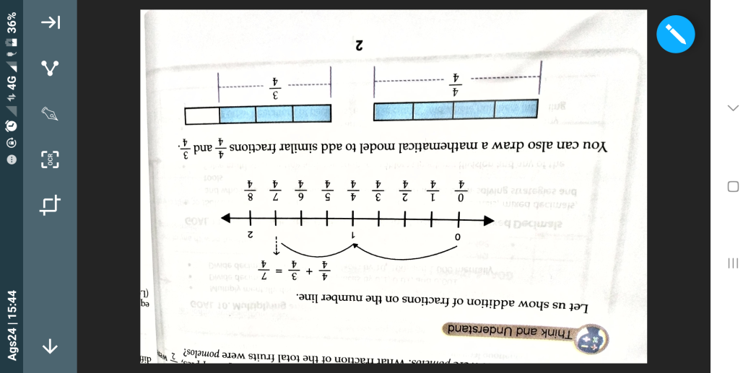  - Teacher give a chance to student to ask questions.  - Teacher explain how to simplify the fraction.  When the answer is improper fraction, simplify your answer into mixed numbers. You should follow the following:  - divide the numerator by the denominator;  - the answer will be the whole number;  - the remainder will be the numerator; and  - copy the denominator.  When simplifying the answer into lowest term:  - find the Greatest Common Factor (GCF); and  - divide both numerator and denominator by its GCF.  - The teacher give an example to be solve by the students.  - $\frac{2}{5}+ \frac{1}{5}=$ $\frac{3}{5}$  - $\frac{4}{8}+ \frac{3}{8}=$ $\frac{7}{8}$  - $\frac{3}{10}+ \frac{3}{10}=\frac{6}{10}$ : $\frac{3}{5}$ = $\frac{2}{3}$  - Teacher continue to the next topic if the studens already understand.  - Teacher explain the meaning of LCM/LCD  - Students do exercise  Find the sum. Add the following fraction then simplify your answer.  - $\frac{2}{7}+ \frac{3}{14}$ =  - $\frac{3}{4}+ \frac{1}{5}=$  - $\frac{3}{4}+ \frac{3}{8}=$  - $\frac{1}{4}+ \frac{4}{6}=$  - Problem solving  John and Jun harvested palay. John harvested $\frac{3}{4}$ kilograms of rice palay and Junn harvested $\frac{1}{2}$ kilograms of rice palay. How many kilograms of rice palay did John and Jun harvested respectively? | 40 minutes
Closing | - Students with the teacher together do the refrection for the topic that they’ve done:  - What do you learn today?  - How was the learning?  - Teacher says thank you and goodbye

- REFERENCES
- Student ourself, Family environment, and School environtment.
- Math for Life, grade 6th. 2017. P. 2-3
- A piece of paper, number line, activity worksheet, chart how to add fractions, chart for the motivation

Reflection:

Notes:
1. Problem :……….
2. New idea :………..
3. Special Moment :………….

Bayambang, August 2018

_______________________
Nurul Alia
SEA Teacher Student

_______________________
Ms. Lilibeth L. Mateo
Supervising Instructor

______________________________
Mr. Mike Kelvin Nicole N. Buted
Principal

