Beginner 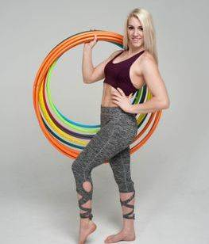
Introduction:
-Welcome
-What hoop to use
-Hoop posture
-Warm Ups and Cool Downs

Lesson One:
- Waist Hooping
- Turning and Walking
- Passing
- Lift up to hand hooping

Lesson Two:
- Waist to Neck and Neck hooping
- Weave & weave to jump through
- The Vortex up and down
- Waist Breaks
- Step Through

Lesson Three:
- Leg Hooping
- The Helicopter
- Neck to Half Chest Hooping
- Kick up
- Basic Hand Spin and Open Palm Spin

Lesson Four:
- Beginning Chest Hooping
- Escalator Up
- Hip Hooping
- Tossing and catching

Lesson Five:
- Planes and how to control your hoop
- Thinking about Transitions
- Creating your own combos and finding your ‘flow’

Lesson Six:
Combos!
- Combo 1
- Combo 2
- Combo 3
- Combo 4
- Combo 5

Intermediate
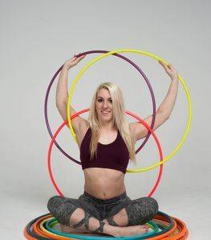
Lesson One:
- Arm Duck outs
- Shoulder Duck outs
- Chest hooping without arms
- Shoulder hooping

Lesson Two:
- Vertical Waist hooping and breaks
- Knee hooping up to waist
- Vortex from knees
- Jump through to Vortex to waist and to hands

Lesson Three:
- Intro to Isolations
- Two handed isolations
- Isolation Barrel roll, two handed and one handed
- Smear and Spinning smear

Lesson Four:
- Introduction to chest rolls
- One side chest rolls
- Full chest rolls
- Cat eyes isolation
- Escalator up and down

Lesson Five:
- Introduction to shoulder rolls
- One sided back roll
- Full back roll
- Horizontal chest hooping
- Barrel rolls

Lesson Six:
- Combos and transitions

Multi-hooping
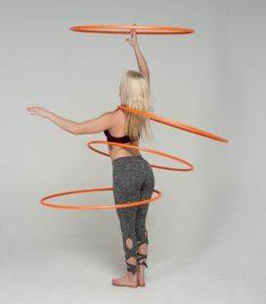

Lesson One:
Two Hoops off-body
- Elbow and hand
- Wrists and hand
- Same time, split time, different directions
- Hand spins and anti-spins

Lesson Two:
Two Hoops on-body
- Hand hooping while knee, waist, chest, neck, and wrist hooping
- Splitting waist hoops
- Knees and waist
- Waist and chest

Lesson Three:
Three Hoops

Lesson Four:
Four Hoops

Lesson Five:
Five Hoops

Lesson Six:
Extra
- Hoop wings
- Hoop globe

