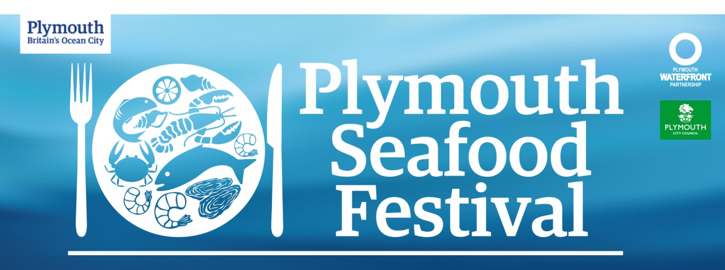

A Taste of the Waterfront

Following the success of last years Plymouth Seafood Festival, held on the The Barbican and Sutton Harbour, for its 7th year we are complementing it with a new event – A Taste of the Waterfront. A ten day event leading up to the popular weekend and following the Plymouth Seafood Festival, with a purpose to bring a greater collaboration with the Waterfront area BID businesses and drive footfall to the destination.

The Seafood Festival, on Saturday 15th and Sunday 16th September, is developing in to an event that engages and encourages its visitors to interact with not only the traders on the two days, but also with the surrounding businesses on the Waterfront. Last years event saw visitor numbers increase to 20,000, and we want you to see a tangible benefit from this event as a platform.

From the 13th to 23rd of September, each day there will be a focus and promotion on our social media accounts (Facebook, Twitter, Instagram), as well as the Visit Plymouth site, of a promotion or deal that one Waterfront business is providing. This promotional activity would be valid for the ten days and on the weekend of the Seafood Festival with daily highlights.

This event is dedicated to the Waterfront businesses and it provides you with another cost saving marketing tool as it is free for any Waterfront BID business to sign up.

- To publicise the Waterfront BID area businesses
- To bring unique offers to residents and visitors
- To strengthen our area as a destination
The objectives of the event

To be a part of this event all you will need to do is tell us about a promotion or deal that you would like to offer for the event. This could involve –
- Discounted deals / special offers
- Dining experiences
- Tasting menus
- Tours
- Family activities
- Workshops

How you can be involved

- An opportunity for free marketing and promotion
- Brand visibility
- Associate your business with a successful and growing event

What will this do for you?

Application Form

Business Name –
Contact Name –
Contact Email –
Contact No –
Address –
Website –
Social Media Links –

Details

Please provide in as much detail the offer / promotion that you would like to host that can run for the full duration or individual dates. Please include prices, any restrictions, booking contact details, marketing information, dates and times.)

Offer / Promotion

