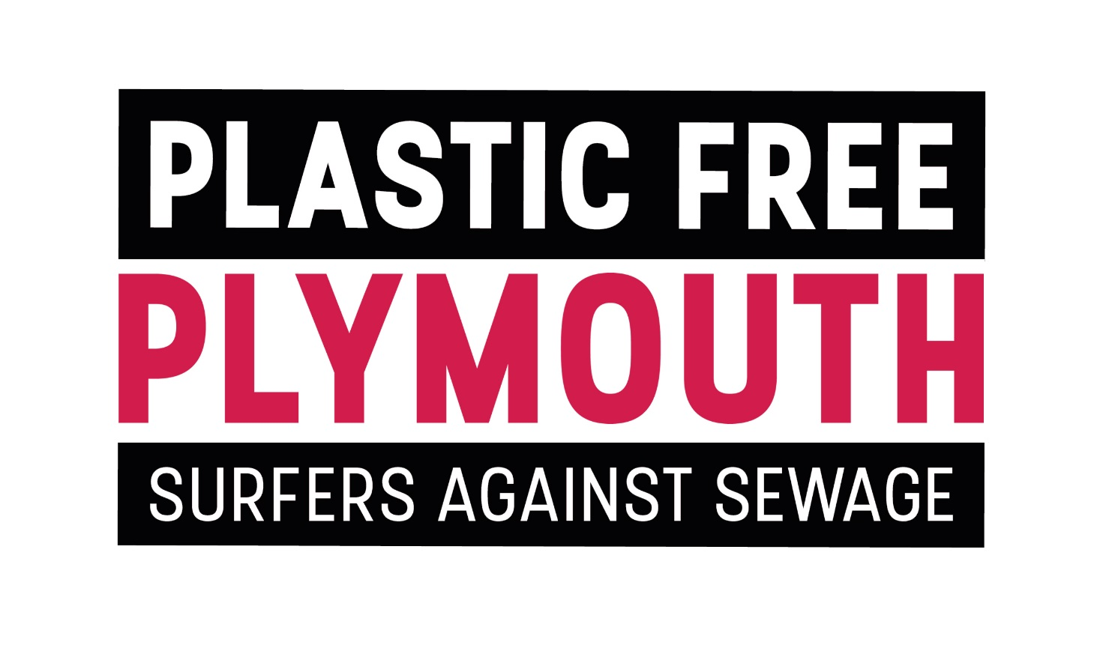
PLASTIC FREE PLYMOUTH PLEDGE
We would welcome your support for this first step………..

Name :
Organisation :
Contact email :
(We accept that our email will be retained for the purpose of developing Plymouth’s Plastic Free Plymouth Sound Action Plan and its associated events and understand that we can request its removal at any point
Please tick.)
The three Single-Use-Plastic items we have removed or replaced are :
1.
2.
3.
The additional action we are seeking to take is :
1.
2.
3.

