Self Embodiment Reflexology Workshop with Laurie Clark (laurielynnclark.com)

Overview: Explore Reflexology, Breath, Music, Sound and Embodied Movement
Experience reflexology therapy on hands and/or feet and take time to navigate and notice connections in life-supporting ways. Embody and expand your awareness through connection with self in an interactive, ongoing action/reflection workshop. Engage in a journey of self discovery through navigation exercises involving reflexology, breath work, movement, journal writing and quiet contemplation of the body’s somatic release process. Share in restorative communication to encourage support for oneself as we empathize with other women’s journeys in a safe, inclusive, non-judgmental and confidential environment.

"Body Mind Centering (BMC) is an ongoing experiential journey into the alive and changing territory of the body. In BMC, we are the material, our body and minds the medium of our exploration. An important aspect of our journey in the body-mind centering is discovering the relationship between the smallest level of movement in the body - aligning the inner cellular movement with the external expression of movement through space. The finer the alignment, the more efficiently we can function to accomplish our intentions." (Reference: Sensing, Feeling, and Action. The Experiential Anatomy of Body-mind Centering, by Bonnie Bainbridge Cohen)

The Awakening Body:
"The body itself wants to release and as soon as you invite that release in your feet it begins to happen elsewhere. Working with the feet beautifully instigates this process because all the meridians of the body run through the feet. So by working with the feet, you are reaching the whole body." (Reference: The Awakening Body, Somatic Meditation. Reginald A. Ray)

Reflexology and the Therapeutic Experience:
(Reference: Total Reflexology by Martine Faure Alderson, D.O)
The foot is a reflection of the human body in its entirety. Reflexology can successfully restore the circulatory, nervous, immune, digestive, hormonal and structural systems to normal functioning. reflexology is now recognized and even recommended by professors in the field of medicine. If homeostasis is no longer possible, Total Reflexology Therapy does bring comfort to patients with serious illnesses.
The gentle, calm and steady pressure of the practitioners thumb and index finger on the zone to be treated is a circular Helicoidal movement which mimics the DNA. There are no specific contraindications to Reflexology Treatment, however it is wise to be cautious with cases involving degenerative diseases that contribute to the deterioration of the physical body such as internal hemorrhaging or those of a immunodepressant component such as cancer, aids, bronchial obstructions, viral and bacterial pneumonia.
Reflexology helps to deprogram the mechanisms and habits that have been rooted in the body since childhood. Part of the practitioner's job is to assist the patient locate why and how past traumas buried away in memory have created his/her particular physical disorders and to show the patient why it is crucial to reprogram and reframe past events/ trauma into a resolution in positive terms.

The ART of Breathing:
Every morning and evening practice abdominal breathing . Take a very deep breath and when exhaling pay very special attention to the lower abdomen while visualizing a softness in the navel area. Ensure the breath is pushed out on the exhale with mouth open and eyes closed. Repeat several times slowly and with concentration. Water is the best Medicine: Drink frequently and in small amounts.
(Reference: Total Reflexology by Martine Faure Alderson, D.O)

Definitions:
Somatization: Through somatization, the body's cells are informing the brain as well as the brain informing the cells. When the body is experienced from within, the body and mind are not separated but are experienced as a whole. Somatics also names a field of study - the study of the body through the personal experiential perspective. (BMC/ Cohen)
Somatic Meditation: develops a meditative consciousness that is accessed through the spontaneous feelings, sensations, visceral intuitions and felt senses of the body itself. The body wants to show us what it wants us to know - awareness.
Somatic Terminology: felt senses/ intuitions/ visceral impressions/ somatic memories.
"When using the term SOMA (or body)- I intend to refer interoceptively, to the field of experience that opens up when we descend beneath the surface of conceptual thinking into the still depths of our body."
(Ref.: The Awakening Body/ Reginald Ray.)

REFLECTIVE observation notes on body sensations: linking extremely subtle experiencing of the mind to the body.
[Reference: Mindfulness Integrated CBT (Cognitive Behavioural Therapy). Well Being and PErsonal Growth, by Bruno A Cayoun.]

Four characteristics of body sensations: i. Mass ii. Motion iii.Temperature iv. Fluidity.

Four Elemental Sensations associated with characeristics of four body sensations:

Fire: Sensation of Temperature refers to temperature of the body (coldest- neutral- hottest) and outside the body such as climate. (IE: fever/ chills/ cold sweats)
Water: Sensation of Fluidity. Lack of fluidity is characterized by rigidity or constriction. (most diffused- neutral- most constricted. (muscle tension cramps/ stomach knots/ throat constriction)
Air: Sensation of Motion. Refers to gas within the body. (most still- neutral - most movement)
Earth: Sensations of Mass. Lightest experience - neutral- Heaviest experience. (IE: when sadness or grief is revealed as heaviness/ feeling bed ridden.)

Interoceptive Exercise:
Practice the Body Scan and on the diagrams below mark the areas of stress in your body with descriptions on the elemental sensations you perceive.
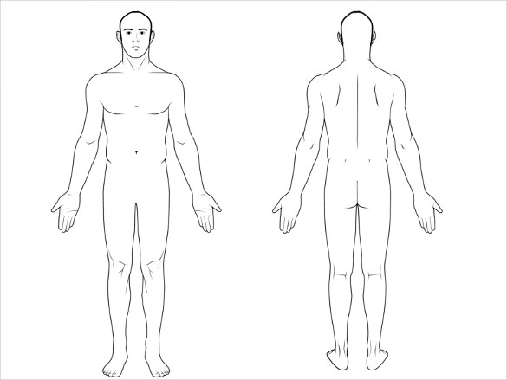
Definition of interoceptive : of, relating to, or being stimuli arising within the body and especially in the viscera (The visceral layer of the membrane covers the organs (the viscera)) and fascia (A fascia from Latin: "band") is a band or sheet of connective tissue, primarily collagen, beneath the skin that attaches, stabilizes, encloses, and separates muscles and other internal organs.

