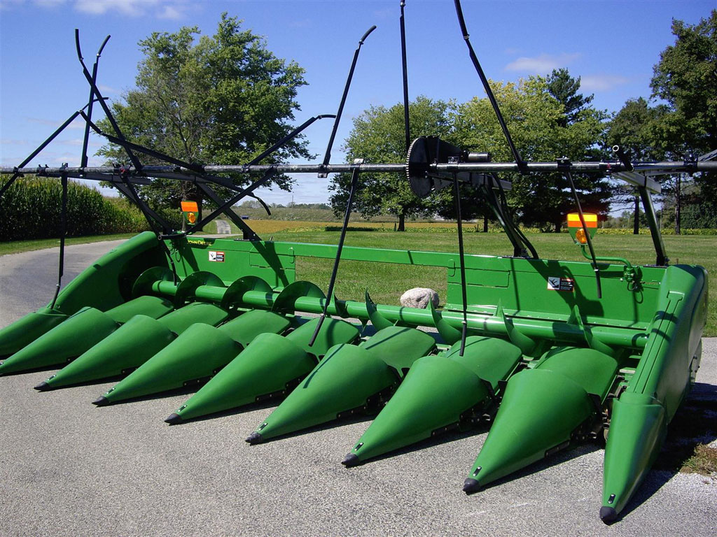

Reel Type | Basic Price
4-row | $3450
6-row 30" | $3775
6-row Wide | $4350
8-row 30" | $4550
8-row Wide | $4750
12-row | $6850
16-row | $8575

