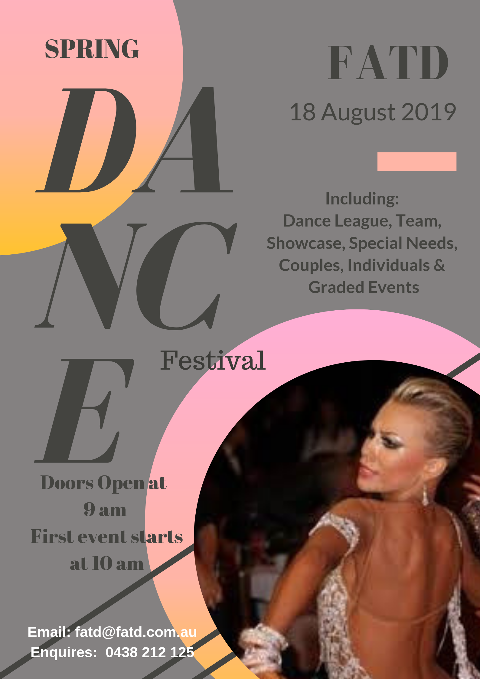

Federal Association of Teachers of Dancing
Spring Festival Sunday 18th August 2019

Competitors Juvenile/Junior $20.00 Entries close 9th August 2019
Competitors Adults/Masters $30.00 Enter online with P5000 and details to
fatd@fatd.com.au
Spectators only: $15.00

Competition Rules & Conditions of Entry

GENERAL

The Festival is registered with DSA including the DSA Elevation system.
The Organisers reserve the right to alter or cancel any event on the program.
Couples may be asked to dance up a level. Pre-event entries are encouraged to assist in organisation of events on the day. Students may NOT dance in 2 different age groups or levels, unless stated by the organiser.

DRESS CODE

DSA Dress Code applies to all age groups. Recreational is STREET WEAR ONLY.

NUMBERS

A minimum of $5.00 will be required & refunded upon its return. CHANGE WILL NOT BE GIVEN

E.g. if you provide $10, you will receive $10 when the number is returned.

VIDEO

We encourage you to take photos and videos and share them on our Facebook site.

SOCIAL/NOVELTY EVENTS

Individual competitors may be partnered by another social dancer or by a dancer registered with

DSA. Competitors may not compete in two different age categories

PEOPLE WITH DISABLITIES EVENTS

These events are specifically for competitors who are physically or mentally challenged. They

may be partnered by their Professional Teacher, Amateur Coach, or any other dancer, registered

or non-registered.

RECREATIONAL EVENTS

Restricted Syllabus apply to all Recreational Events. Recreational couples may compete in both

couples and individual, but NOT with the same partner in individual events. Participation in a

Recreational Division event is restricted to people registered in the Recreational Division.

AMATEUR/GRADED EVENTS

DSA Rules apply to all events, you may dance one level up. Competitors in Masters Events may

dance down an age category but may not dance up. e.g.: Masters 2 may dance Masters 1 but

not dance Masters 3.
TEACHER / STUDENT EVENTS
A teacher is any registered DS member who has an accreditation. A student may be a registered
Amateur or recreational competitor. Amateur rules apply to all participants. Adjudicators will
only assess the student, there for the student must wear the back number.
PRO / AM EVENTS
The Professional must be registered with DSA. A student must be a registered Amateur Competitor. The couple is being assessed so the man will wear the back number. The professional cannot have multiple partners in the same event.

Federal Association of Teachers of Dancing
Spring Festival
Sunday 18TH August 2019
Couples or Individuals that are NOT Registered with Dancesport.
These events are classified as novelty events.
Individual Event | NOT REGISTERED with Dancesport
Juvenile | 1. Waltz - Q Step | 2. Cha - Jive | 3. Merrilyn - E3Step
Junior | 4. Waltz - Q Step | 5. Sam - Jive | 6. Merrilyn - G Tap
Adult | 7. Waltz - Q Step | 8. Sam - Cha | 9. Charmaine - G Tap
Masters | 10. Waltz - Q Step | 11. Cha - Jive | 12. Charmaine - E3Step
Solo Juvenile/Junior | 13. Waltz | 14. Cha
Solo Adult / Masters | 15. Waltz | 16. Cha
Note: Depending on the numbers of competitors events may be split into separate Male/ Female events. This will be announced on the day.

Couples | NOT REGISTERED with Dancesport
Juvenile | 17. Waltz Q/step | 18. Cha - Jive | 19. Merrilyn - E3Step
Junior | 20. Waltz - Q/Step | 21. Sam - Jive | 22. Merrilyn - G Tap
Adult | 23. Waltz - Q/Step | 24. Sam - Cha | 25. Charmaine - G Tap
Masters | 26. Waltz - Q/Step | 27. Cha - Jive | 28. Charmaine - E3Step

Special Needs (Individual Events) | NOT REGISTERED with Dancesport
Open | 29. Waltz | 30. Cha | 31. Merrilyn
Open | 32. Q/step | 33. Jive | 34. E3Step

Team Events | NOT REGISTERED with Dancesport
Progressive Teams | Any Age | Max 6 Couples | 35. Cha - RBD - GT
Showcase | Any Age |  | 36. Showcase

Registered Events
Recreational Events – Couples
Juvenile | Open | 37. Waltz - Q/Step | 38. Cha - Jive | 39. Merrilyn - G Tap
Junior | Open | 40. Waltz - Q/Step | 41. Cha - Jive | 42. Merrilyn - T/ette
Adult/Masters | Open | 43. Waltz - Q/Step | 44. Cha - Jive | 45. Merrilyn - T/ette
Recreational Events - Individual Male
Juvenile | Open | 46. Waltz - Q/Step | 47. Cha - Jive | 48. Merrilyn - GTap
Junior | Open | 49. Waltz - Q/Step | 50. Cha - Jive | 51. Merrilyn - T/ette
Adult/Masters | Open | 52. Waltz - Q/Step | 53. Cha - Jive | 54. Merrilyn - T/ette
Recreational Events - Individual Female
Juvenile | Open | 55. Waltz - Q/Step | 56. Cha - Jive | 57. Merrilyn - GTap
Junior | Open | 58. Waltz - Q/Step | 59. Cha - Jive | 60. Merrilyn - T/ette
Adult/Masters | Open | 61. Waltz - Q/Step | 62. Cha - Jive | 63. Merrilyn - T/ette
Teacher / Student Events
Juvenile/Junior | Open | 64. Waltz - Tango -  Q/ Step | 65. Cha - Rum - Jive | 66. TW/Waltz - Mer - La Bom
U21/Adult | Open | 67. Waltz - F/trot - Q/Step | 68. Sam - Cha - Jive | 69. TW/Waltz - Car - T/Terrifc - BB
Masters | Open 3 Dance | 70. Waltz - F/trot - Tango | 71. Sam - Cha - Jive | 72. LW/Waltz - BB - T/Terrific

Federal Association of Teachers of Dancing
Spring Festival
Sunday 18th August 2019
Juvenile Graded Events

 | C Grade |  |  | 73. Waltz - Q/step |  | 74. Cha - Jive |  | 75. Char - T/ette
 | B & C Grade |  |  | 76. Waltz - F/Trot - Q/step |  | 77. Sam - Cha - Jive |  | 78. S/Waltz - Char -  T/ette
 | Open |  |  | 79. Waltz -Tango - F/trot - Q/step |  | 80. Sam - Cha - Rum - Jive |  | 81. S/Waltz - La Bom -  Char - T/ette
Junior Graded Events

 | C Grade |  |  | 82. Waltz - Q/step |  | 83. Cha - Jive |  | 84. TL/Waltz - Char
 | B & C Grade |  |  | 85. Waltz - F/trot -  Q/ Step |  | 86. Sam - Cha - Jive |  | 87. TL/Waltz - Char -  La Bom
 | Open |  |  | 88. Waltz -Tango - F/trot - Q/Step |  | 89. Sam - Cha - Rum - Jive |  | 90. TL/Waltz - Char -Car - La Bom
U21/Adult Graded Events

 | C Grade |  |  | 91. Waltz - F/trot - Q/step |  | 92. Sam - Cha - Rum |  | 93. S/Waltz - Car - La Bom
 | B & C Grade |  |  | 94. Waltz - Tango -F/trot - Q/step |  | 95. Sam - Cha - Rum - Jive |  | 96. S/Waltz - Car - T/Waltz - La Bom
 | Open |  |  | 97. Waltz - Tango - V/W - F/trot - Q/step |  | 98. Sam - Cha - Rum - P/D - Jive |  | 99. S/Waltz - Car - La Bom - TW/Waltz - TT
Masters Graded Events

Masters 8 Dance | Open |  |  | 100. Waltz - Tango - F/trot - Q/Step - T/Waltz - Car - T/Terrific - L/Waltz
Masters 1 | C Grade |  |  | 101.Waltz - F/trot - Q/step |  | 102. Sam - Rum - Cha |  | 103. L/Waltz - Car -  La Bom
 | B & C Grade |  |  | 104. Waltz - Tango - F/trot - Q/Step |  | 105. Sam - Cha - Rum - Jive |  | 106. L/Waltz - Car - La Bom - T/Waltz
 | Open |  |  | 107. Waltz - Tango - V/W - F/trot - Q/Step |  | 108. Sam - Cha - Rum - P/D - Jive |  | 109. L/Waltz - Car - La Bom - Exc - T/W
Masters 2 & 3 | B & C Grade |  |  | 110. Waltz - Tango - F/Trot |  | 111. Sam - Rum - Cha |  | 112. L/Waltz - Car -  La Bom
 | Open |  |  | 113. Waltz - Tango - V/W - F/trot - Q/Step |  | 114. Sam - Cha - Rum - PD - Jive |  | 115. L/Waltz - Car - La Bom - Exc - T/Waltz
Pro/Am Events

Juvenile/Junior |  | Open | 116. Waltz - Tango - Q/Step |  | 117. Cha - Rum - Jive |  | 118. TL/Waltz - Mer -  La Bom
U21/Adult |  | Open | 119. Waltz -Tango F/trot - Q/Step |  | 120. Cha - Sam - Rum- Paso - Jive |  | 121. T/Waltz - Car - T/T - BB - S/Waltz
Masters |  | Open 3 Dance | 122. Waltz - F/Trot- Tango |  | 123. Cha – Sam- Rum |  | 124. L/Waltz - BB - T/T
Masters |  | Open 4 Dance | 125. Waltz -Tango -F/trot - Q/Step |  | 126. Sam - Cha - Rum - Jive |  | 127. L/Waltz - BB - Car - La Bom

Federal Association of Teachers of Dancing
Spring Festival
Sunday 18th August 2019
** Final Entries: Friday, 9th August 2019 **
Register on www.p5000 This entry form MUST be sent to: fatd@fatd.com.au

This is to ensure your details are correct and tickets can be sent to you.
Name: _________________________________________ CID NO: ________________________________
Name: _________________________________________ CID NO: ________________________________
Phone: ___________________________________Email:________________________________________
Studio:

No. of tickets |  | Cost per ticket | Total
 | Juvenile/Junior Competitor | @ $20.00 |  | $
 | Adult/Master Competitor | @ $30.00 |  | $
 | Spectator Only | @ $15.00 |  | $
 | Processing Fee | @ $3.00 |  | $ 3.00
 |  |  |  | $

Event Numbers

Payment Method
Please circle: Visa/ Mastercard Direct Debit Cheque/Money order

Credit Cardholder Name:-___________________________________________

Card Number: _______/_______/_______/_______ Expiry: ____/____CCV____________

Signature: _____________________________________________

Direct Debit
Account Name: Federal Association of Teachers of Dancing Ltd
BSB: 082 367 Account Number: 509136584
*Please use full name as reference on all direct deposits.

Cheques & Money Orders payable to: FATD
Ticket order forms to: Email fatd@fatd.com.au or FATD, PO Box 7223, Greenway, ACT 290
Enquires PH: 0438 212 125
Only Spectators tickets can be brought at the door on the day.

------------------------------ Detach here for studio registrations ------------------------------
Federal Association of Teachers of Dancing
Spring Festival Sunday 18TH August 2019
Unregistered Events Form / Individual or Schools
Studio: _____________________________________________________________
Name Event Numbers
Name:
Name:
Name:
Name:
Name:
Name:
Name:
Name:
Name:
Name:
Name:
Name:
Name:
Name:
Name:
Name:
Name:

Payment Method
Please circle: Visa/ Mastercard Direct Debit Cheque/Money order

Credit Cardholder Name: ___________________________________________

Card Number: _______/_______/_______/_______ Expiry: ____/____CCV____________

Signature: _____________________________________________

Direct Debit
Account Name: Federal Association of Teachers of Dancing Ltd
BSB: 082 367 Account Number: 509136584
*Please use full name as reference on all direct deposits.

Cheques & Money Orders payable to: FATD
Ticket order forms to: Email fatd@fatd.com.au or FATD, PO Box 7223, Greenway, ACT 290
Enquires PH: 0438 212 125
Only Spectators tickets can be brought at the door on the day.

