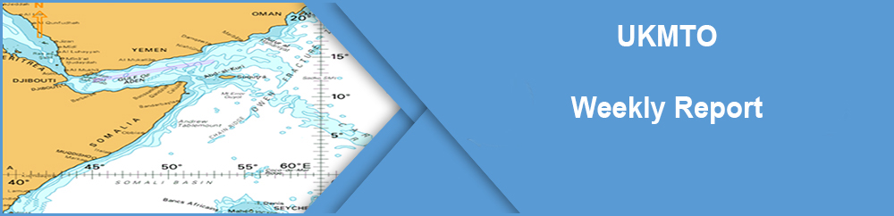

**30 Jun - 6 Jul 2018**

In This Issue

Command Overview

This week UKMTO has issued two Advisories (see page 3) and no Warnings.

1. The Maritime Shipping Industry’s publication ‘Best Management Practises to Deter Piracy and Enhance Maritime Security in the Red Sea, Gulf of Aden, Indian Ocean and Arabian Sea’ (BMP5), was released last month. Superseding BMP4, BMP5 includes additional guidance on how to best mitigate against a broader range of maritime threat including piracy, conflict spill over into the maritime domain and terrorism.

2. In addition to BMP5, an association of Shipping Industry organizations simultaneously launched a new Maritime Global Security website including their new publication the ‘Global Counter Piracy Guidance for Companies, Masters and Seafarers’ which covers the threat to shipping worldwide. Both publications can be viewed on the new website at [www.maritimeglobalsecurity.org](http://www.maritimeglobalsecurity.org)

ATTACKED, BOARDED OR HI-JACKED

**(1) Attacked**

**One incidents reported, see advisory 002/Jul/2018 for further details.**

**(2) Boarded**

**No incidents to report.**

**(3) Hijacked**

**No incidents to report.**

VESSELS & PERSONS UNDER PIRATE CONTROL

|  |  |  |  |
| --- | --- | --- | --- |
| **Details of Vessel** | **No. Vessels held** | **No. Souls held** | **Date Taken** |
| Merchant Vessels | 0 |  |  |
| Fishing Vessels | 0 |  |  |
| Dhows | 0 | 4 | 26/03/15 |
| Total | 0 | 4 |

FUTURE EVENTS

|  |  |  |
| --- | --- | --- |
| **Date** | **Event** | **Location** |
| 13-14 Nov 18 (tbc) | SHADE | Bahrain |
| 22 Nov 18 (tbc) | MIEVOM | Dubai |

LIAISON AND VISITS

30 Jun - Meeting with VADM Scott Stearny, Commander NAVCENT, 5th Fleet & CMF.

6 Jul - Visit of Capt John Craig RN, DUKMCC.

Should anyone wish to visit our office in Dubai or arrange a briefing from UKMTO please contact Lt Chris Long E-mail: [dubai-oic@ukmto.org](mailto:dubai-oic@ukmto.org)

ALTERNATIVE SOURCES OF INFORMATION

[www.ukmto.org](http://www.ukmto.org)

[MSCHOA](http://www.mschoa.org/)

[Combined Maritime Forces (CMF)](http://combinedmaritimeforces.com/)

[Middle East Navigation Aids Service (MENAS)](http://www.menas.org/)

[United Kingdom Hydrographic Office](http://www.ukho.gov.uk/security)

[IMB Live Piracy Reports](https://icc-ccs.org/piracy-reporting-centre/live-piracy-report)

[www.marad.dot.gov/MSCI](http://www.marad.dot.gov/MSCI)

[NATO Maritime Command (MARCOM)](http://www.mc.nato.int/)

[www.maritimeglobalsecurity.org](http://www.maritimeglobalsecurity.org)

SHIPS BRIEFED

|  |  |  |
| --- | --- | --- |
| **Date** | **Location** | **Vessel** |
| 02/07/2018 | JEBEL ALI | FPMC 17 |
| 02/07/2018 | JEBEL ALI | MSC ILONA |
| 02/07/2018 | JEBEL ALI | MAERSK KITHIRA |
| 03/07/2018 | JEBEL ALI | FAIRCHEM SWORD |
| 03/07/2018 | JEBEL ALI | MAERSK MESSINA |
| 04/07/2018 | JEBEL ALI | MAERSK GIRONDE |
| 04/07/2018 | JEBEL ALI | HYUNDAI VICTORY |
| 04/07/2018 | JEBEL ALI | CMA CGM COCHIN |
| 05/07/2018 | JEBEL ALI | UACC HARMONY |
| 05/07/2018 | JEBEL ALI | PACIFIC MARTINA |
| 06/07/2018 | JEBEL ALI | BUBYAN |
| 06/07/2018 | JEBEL ALI | MAERSK SENANG |
| 06/07/2018 | JEBEL ALI | CT ACE |
|  |  |  |
|  |  |  |
|  |  |  |
|  |  |  |
|  |  |  |
|  |  |  |
|  |  |  |
|  |  |  |
|  |  |  |
|  |  |  |
|  |  |  |
|  |  |  |
|  |  |  |
|  |  |  |
|  |  |  |
|  |  |  |
|  |  |  |

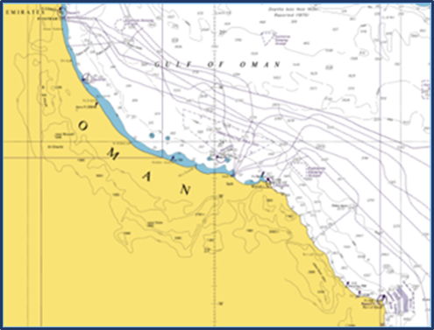WARNINGS

**No Warnings issued.**

ADVISORIES

4 Jul

**001/JUL/2018**

**Category:** Suspicious Approach

**Description:** On 04 JUL 2018 at approximately 09.50UTC a Merchant Vessel in position: 24 02 02N 059 55 38E reported being approached at speed by 2 white hulled small craft with 4 POB. The closest point of approach on the Merchant Vessel was 500m. The crew and vessel are safe

**002/JUL/2018**

**Category:** Attack

**Description:** Time late report received: on 04 JUL 2018 at approximately 05.02UTC an MV in position: 13 33.2N 042 40.1E (Approx. 5 miles south of Hanish Islands) reported being approached at speed by 3, white and blue hulled skiffs. Each skiff had 7/8 POB. The skiffs fired at the MV, embarked AST returned fire. The crew and vessel are SAFE.

4 Jul

Notes

For further information or queries regarding any UKMTO Warnings, Advisories or Notices ring: 0044 2392 222060. THESE ADVISORIES are not classified as a Maritime Security Events and have not been verified by UKMTO. This information is provided to inform maritime situational awareness for mariners operating in the region. UKMTO is not responsible for the accuracy of this reporting.