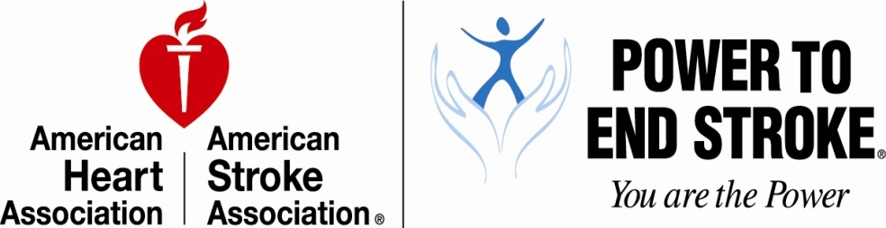
Media Contact:
Claire Kinzy
214-712-1330
claire.kinzy@heart.org
Twitter: @AHAdallas
http://www.powertoendstroke.org/

***MEDIA ALERT***MEDIA ALERT***MEDIA ALERT***
Power Sunday with Kirk Franklin

WHAT: The American Heart Association is proud to partner with Grammy award-winning artists Kirk Franklin to celebrate Power Sunday at St. John Church in Grand Prairie on Sunday, May 27 at 11:00 a.m.

WHEN/WHERE: St. John Church @ 11:00 a.m. on Sunday, May 27
1701 West Jefferson, Grand Prairie, TX 75051
(972) 264-1483 – main church number

WHY: Each May, the American Heart Association designates one Sunday as Power Sunday. By partnering with local churches, the AHA hopes to raise awareness of the risk for stroke and how to prevent it, particularly within the African-American communities.

- African-Americans have almost twice the risk of first-ever strokes compared to Caucasians.
- African-Americans have higher death rates for stroke compared to Caucasians.
- The prevalence of high blood pressure in African-Americans in the United States is the highest in the world.

This involvement with the faith-based community is part of our Power To End Stroke Movement and is designed to help local at-risk communities understand their risk for stroke and how to prevent it. Power Sunday is celebrated nationwide, with over 5,000 churches participating every year. The congregants are encouraged to wear purple signifying stroke risk and awareness in their community. Check out what’s happening at Power Sunday:
- Join us and the congregation of St. John Church (Grand Prairie campus) wearing your best purple attire to raise awareness about stroke.
- Hear Kirk Franklin’s moving testimony about our physical health and spiritual health and the importance of living a heart healthy life-style
- AHA staff will be on hand to educate attendees about stroke prevention and recognizing the warning signs of stroke.
- Free soul food cookbooks to the first 75 people that join our healthy mobile network by texting MYHEART to 50555.

The first National Power Sunday church service was conducted by Yolanda King, daughter of Dr. Martin Luther King Jr. in remembrance of her mother, Coretta Scott King, and others who have survived or died of stroke. The church service was held on Sunday, May 6, 2007 in Atlanta, Georgia as part of the “Igniting the Power” weekend and 1st Annual Power Awards. Today, more than 74 Power Sundays have been conducted across the United States in more than 5,000 churches.

Grammy Award-winning gospel recording artist Kirk Franklin joined the PTES movement in 2009. “To all my sisters and brothers in this Family of Faith, we have a serious health issue that is claiming the lives of our loved ones every day. It’s called stroke, and it’s time to make a declaration to stand up and do something about it.” - Kirk Franklin in support of Power To End Stroke

MORE: Stroke is the No. 4 cause of death and the leading cause of disability in the United States. One out of every six people worldwide has a stroke making it the second leading cause of death in the world behind heart disease. That means that every 40 seconds, someone has a stroke – and if a stroke doesn’t kill, it may cause physical or mental disability.

WARNING SIGNS OF STROKE (Not all of these warning signs occur in every stroke):
- SUDDEN numbness or weakness of the face, arm or leg, especially on one side of the body.
- SUDDEN confusion, trouble speaking or understanding.
- SUDDEN trouble seeing in one or both eyes.
- SUDDEN trouble walking, dizziness, loss of balance or coordination.
- SUDDEN severe headache with no known cause.
ABOUT POWER TO END STROKE
Power To End Stroke (PTES) is an education and awareness campaign that embraces and celebrates the culture, energy, creatifity and lifestyles of Americans. It unites people to help make an impact on the high incidence of stroke within their communities. PTES was created in 2006 by the American Heart Association/American Stroke Association to help reach the ASA mission to reduce stroke and risk of stroke by 20% in 2020. Download the Power Sunday Toolkit here.

ABOUT AMERICAN STROKE ASSOCIATION
Created in 1997, the American Stroke Association is dedicated to prevention, diagnosis and treatment to save lives from stroke — America’s No. 4 killer and a leading cause of serious disability. We fund scientific research, help people better understand and avoid stroke, encourage government support, guide healthcare professionals and provide information to enhance the quality of life for stroke survivors. To learn more, call 1-888-4-STROKE or browse strokeassociation.org.
ABOUT AMERICAN HEART ASSOCIATION
The American Heart Association is devoted to saving people from heart disease and stroke – America’s No. 1 and No. 3 killers. We team with millions of volunteers to fund innovative research, fight for stronger public health policies, and provide lifesaving tools and information to prevent and treat these diseases. The Dallas-based association is the nation’s oldest and largest voluntary organization dedicated to fighting heart disease and stroke. To learn more or join us, call 1-800-AHA-USA1 or any of our offices around the country, or visit www.heart.org.

###

