Wondering what to do to reduce wasted produce at your allotment?
How about donating it to the Food Hub.
Sutton Lane Allotment Association have been doing just that for the last two seasons and have ended up donating at least 18 different types of fruit and vegetables and more than 150kg of fresh goodies that have gone to local charities and community groups.
This is a simple guide for you to use if you want to do it too:
- Get the agreement of the Allotment Committee.
The Sutton Lane Allotment Association discussed the food collection proposal at the AGM in 2017. We had a useful discussion about how it would work and decided that if the initiative was to be sustainable it had to be really simple: a weekly collection through the season at a designated time from a central collection point on the site. If you’ve missed the AGM then taking it to an Allotment Committee meeting will probably suffice. You don’t want to have to miss a whole delicious season!
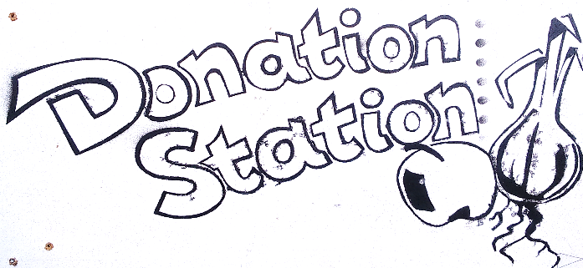
- Set up a Donation Station.
I would love to say that we came up with the name ‘Donation Station’ because it’s such a great one but actually we stole it from a blog on the website Foodshare. We did however come up with the logo design which we are happy to share.
Our Donation Station is basically a log store (for a bit of shelter from the weather) with the Donation Station sign screwed on the top. But your Donation Station could just be a large, lidded bin in a shady place or something like that.
- Communicate the scheme to allotment holders.
We just put up signs on the noticeboards and allotment entry points. Our signs encourage people to deposit anything that they no longer need (seeds, plant pots, hoses, produce) at the Donation Station and say that other allotment holders are welcome to have first pick. They also give a date that produce collections for the Food Hub are beginning that year (in 2018 we began in the second week of June) and the day/time of the collection (Sunday at 5pm in our case). Your allotment commitee might organise a regular e-newsletter that you could communicate through too.
- Organise the collections.
At Sutton Lane Allotments I usually do the pick-up from the allotment on a Sunday and deliver it to the Food Hub but if I’m not around another allotment friend does it. It’s no big deal and gets me down to our own allotment to pick more frequently so less gets wasted!
- Feedback.
At the end of the season I prepare another notice to put up giving a bit of feedback from the Food Hub about how much lovely produce we collected and where it went. This gives everyone a nice warm glow to get us through the winter until we start all over again
And that’s basically it!
Nicola Craddock
Any questions? nicolaframesu@yahoo.co.uk

