I was in the University of California at Santa Cruz in 1989-90.I completed a postgraduate program and was awarded a Certificate in Theater Arts in June 1990. The slug is the UCSC mascot…and the redwood forests around the campus were full of them.

My main focus was leaning wayang golek, the traditional Puppet Theater of West Java with Professor Kathy Foley. She gave me weekly private lessons for a year and a half. (I returned to UCSC for another half year in 1992.)

Kathy taught me all about the traditional theater of Sunda, its social context, the structure of the shows, the roles of the "dalang" (the narrator/ puppeteer) and the clowns, how to move and dance the puppets, the unity of music movement and text, and encouraged me to learn not only how to animate the puppets but to take Javanese dancing lessons as well. "To dance the puppets you must dance yourself" Kathy told me. I participated therefore in her class of Javanese dance.

A photo of Kathy below.
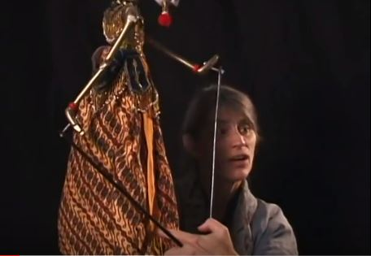

She gave me lots of articles to read about Indonesian theater, including her PhD dissertation and I had to write a summarizing paper. I had to make cards with the pictures of about dozens of puppet heads of characters from the Ramayana and Mahabharatha and had to memorize them by heart!! I spent weekends with my flash cards! Now, 20 years later I still remember a dozen.

Kathy was the student of one of the most famous dalangs in Indonesia, Asep Sunandar Sunarya. And now she was teaching me!!!
I followed her around in Santa Cruz whenever Kathy herself was invited to perform wayang to learn by watching her. I still remember my utter surprise when, in the mini-van driving to the place where soon she was to play, at the beginning of my studies I asked her " What are you performing today?".Kathy answered: "I haven't yet decided". I could not believe my ears. "WHAT?" Kathy of course knew. She and Undang (Undang Sumarna the gamelan orchestra director and master Drummer) always prepared a few sentences with the basic structure of the show but little more. Kathy was teaching me that in wayang there is no need for rehearsals. Since there are sound codes between the puppeteer and the master drummer and between him and the rest of the orchestra the dalang can decide on the spot what music she/he needs.

Below a photo of Asep.

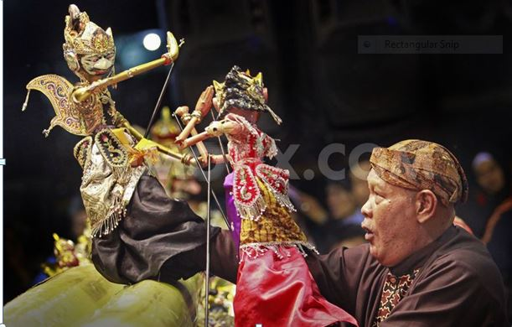

I studied the Sundanese music that accompanies the puppet shows with Undang Sumarna and played with the UCSC gamelan.(beginners' level). For the mood songs that are part of the wayang performance I took private lessons with Pak Nano S. These were amazing lessons. Just imitate him sing the mood songs. No questions about what they mean....Kathy gave me later the "explanations".

In the course of the program I was, together with Kathy, an assistant to Dalang I Nyoman Sedana when he came to UCSC to perform wayang kulit
( Javanese Shadow Theater). My own end of the program work was a performance of Sundanese wayang golek together with the UCSC gamelan ( advanced level) directed by Undang Sumarna. I was the dalang and had the honor to have my teacher Kathy sit next to me as my assistant. At least I could be sure of grabbing the right puppets.

What I learned at UCSC, mainly with Kathy, has been until today one of the greatest influences in my artistic career. As a performer of Puppet Theater I find wayang influences in the show I created in 1994 and which is one of my big achievements, the story of Louis Braille, the inventor of the alphabet for the blind and which is an international success until today with more than 3000 shows in France alone (about a third of which I performed myself in French and the rest I passed on to an actress living in France whom I directed). I realized later (since I did not set myself consciously to design it that way) that the whole setting was similar to the one in wayang: my stage is a narrow sand box where I plant my rod puppets, the rest of them around and behind me at arm's length, me sitting crossed leg next to this playing area, the minimal scenery, simple lighting. The dalang sits crossed legged on the floor, all the puppets visible and to his sides, the "stage" a narrow banana log...Just as the clowns -which come from another world-can break the epic frame in wayang, I have a figure, Charles Barbier, a captain from the French Army who was very important in the plot, he is the one that inspires Braille with his own invention, and I let him appear on stage suddenly and his clowning gives place to laughter.

What I learned about Indonesian wayang gave me the basis to understand other traditional theaters of Asia and teach a basic course to students here in Israel. I was also the first one to expose Israeli children here to the Ramayana with my puppet show " Hanuman's Jump" which I prepared at UCSC under Kathy's direction.
In the early 90's no child here had ever seen a show about the Indian epics.

