Happy Halloween Southbridge Community:

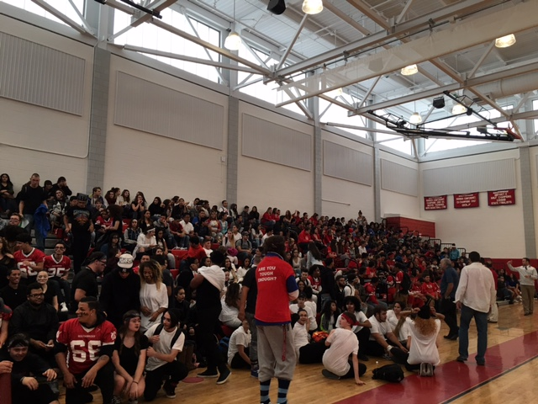
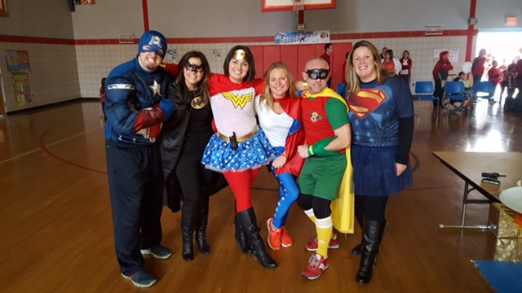
Last week was certainly fun filled and exciting as we celebrated Homecoming, and had a Superhero PBIS assembly at the West Street School. The Homecoming Pep Rally was fantastic. Kudos to the students and staff who planned the event. If you want to see the Staff Dance Routine, please see it on my Twitter Page, @DrJessHuizenga. The Homecoming Game at McMahon Field Friday night was so much fun. It was great to see so many staff and students there, as well as many graduates of Southbridge High School. Even Mr. Danby’s Grandfather, a Southbridge Graduate from long ago, attended. Despite a tough loss, it was a wonderful time, and I enjoyed crowing the King and Queen with Dr. Townsel. (See pictures of our King and Queen Below). Saturday night we had the Homecoming Dance, which from all accounts was a huge success.

Math curriculum development work continued this weekend at the MHS. I want to thank all the staff who have committed to doing this work. I’m extremely pleased with the work being done, and have no doubt it will make a big difference in the learning outcomes for our students.

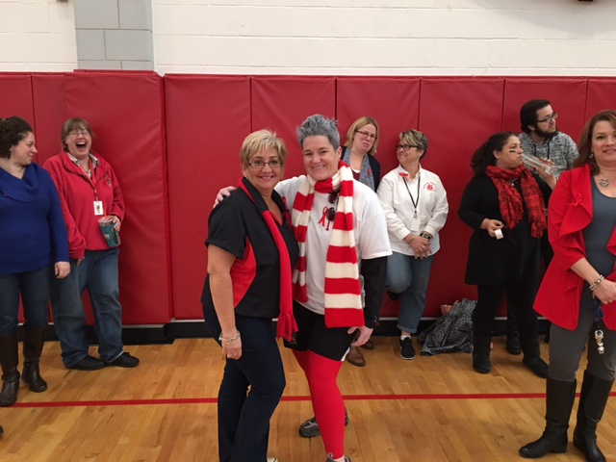
The DESE Special Education Coordinated review took place at all schools last week. Thanks to all who participated and gave feedback. This review will help us focus on areas of improvement within the SPED department. I was invited to give a presentation to the State Board of Education on the Turnaround progress to date in Southbridge. The Board was incredibly impressed at the progress being made in the district, and I want to thank all of you for the commitment and perseverance you have shown as we have undertaken a tremendous amount of change in a short period of time. The partnership with AeroVenture Institute is underway with the recent selection of 26 HS students. These students will take an aviation science course, gain 2 college credits and attain hours toward flight licensure.

We have a few events taking place this week. On Thursday 11/3, Administrators will be conducting building walk-throughs. Principals will provide feedback to staff. Also, our next District Professional Development ½ day is Fri, 11/4. There will be a number of targeted training sessions taking place. Please be sure to sign-in to ensure you receive Professional Development Points. This is the Link to 11/4 PD schedule: 11/4 PD Schedule
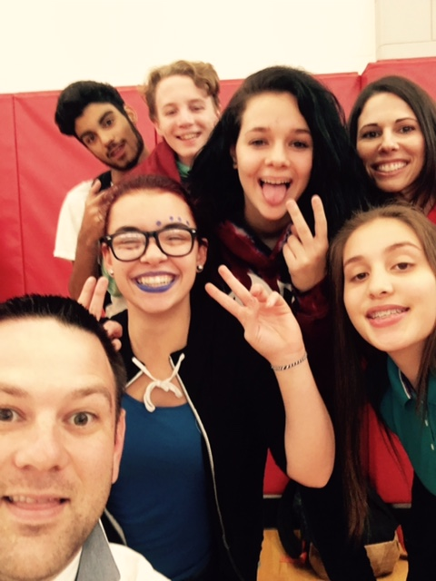
Professional development for middle and high school humanities teachers with the Institute for Learning (University of Pittsburgh) begins this Saturday, 11/5. This PD will focus on the following: Deepen understanding of CCSS, including instructional shifts in ELA/Literacy, Practice analyzing student work to assess mastery of those standards, identify rigorous texts that will push students’ development, create high quality writing tasks (tied to the standards--do things like comprehend complex texts and use evidence to support arguments; are evaluated using a pre-established rubric; require students to develop higher order thinking skills).

Did you know that we have a Dual Language Steering Committee? The group meets monthly to develop a plan for starting K-1 dual language immersion program to begin next school year. If you have ideas or experience with this type of program, please contact Kelly Cooney, ELL Director.
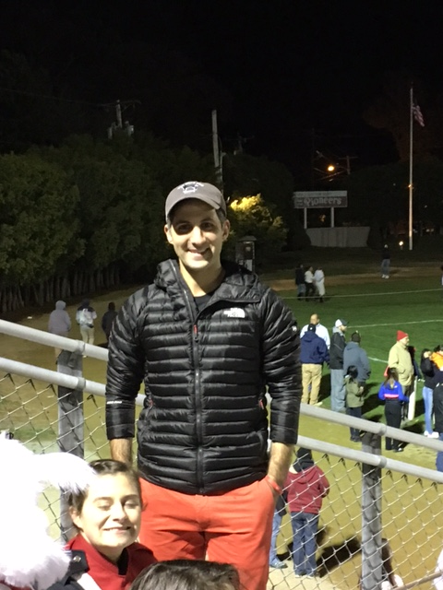
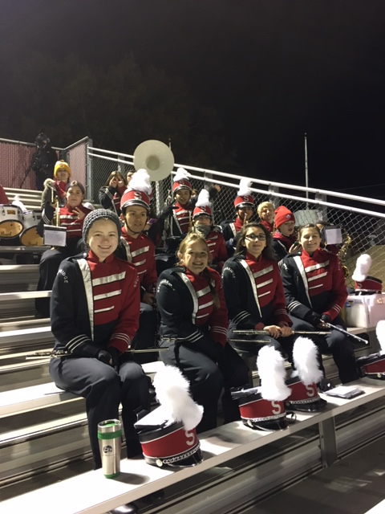
I want to begin highlighting staff members who are shining lights in our district. This week’s highlight is Dr. Arthur Thovmasian. Dr. Thovmasian joined our Pioneer Family this year and has been such a positive addition to the High School Faculty. He stepped into an established Band program and continues to raise the bar, working tirelessly with the kids to improve week after week. Even though we have one of the smaller bands in the area, our kids recently won first place in the Worcester Columbus Day Parade on October 9th. Whether it is competing in competitions, playing at community events or supporting the Southbridge High School football team Dr. Thovmasian has dedicated himself to Southbridge High School by giving countless hours to support our students, and has even developed a 5-year plan to create a world class fine arts program. Thank you Dr. T. for all you do! Staff Members, if you know of a colleague that deserves a district-wide shout out for going above and beyond for our kids, nominate someone to be highlighted in our district newsletter and on our website.

This Friday is the final home Football game of the season and is Senior Night where we will recognize our Senior Football players and cheerleaders. Please join us if you can. Also, I’d be remiss if I didn’t send a big “Congratulations” to the High School Girls Volleyball team for making the playoffs. Go Pioneers!

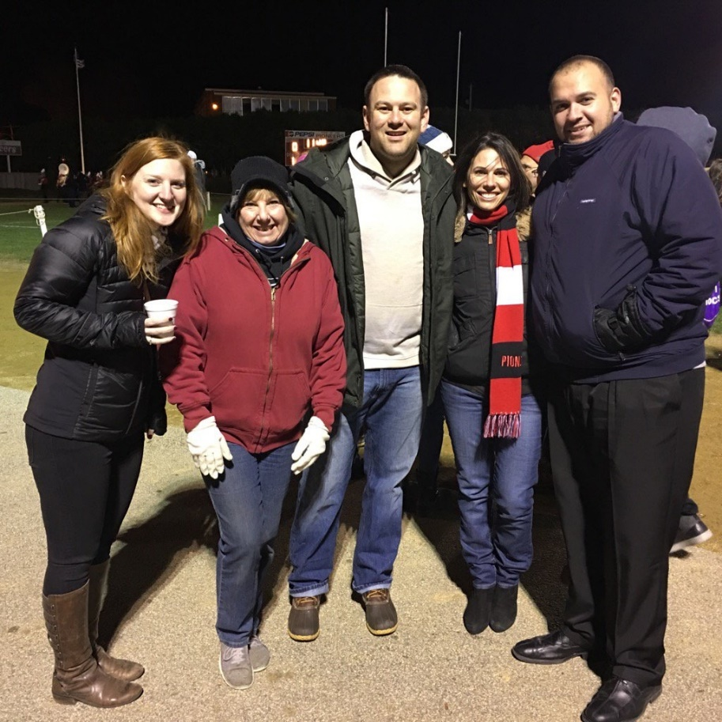
Just a friendly reminder that all Educator Plans were due this past Saturday, Oct. 30 to your evaluators. As of yesterday afternoon, we still had 79 staff members who had yet to complete this task. If you have not yet completed it, please submit it to your evaluator today. We will be following up on an individual basis as well.

Finally, the SEA and Administration have come up with agreed upon language regarding the dress code, and this will be updated in all staff handbooks. The language will read as follows: “All employees are expected to dress in a professional manner appropriate to their position.” This will be based on the discretion of the building administration.

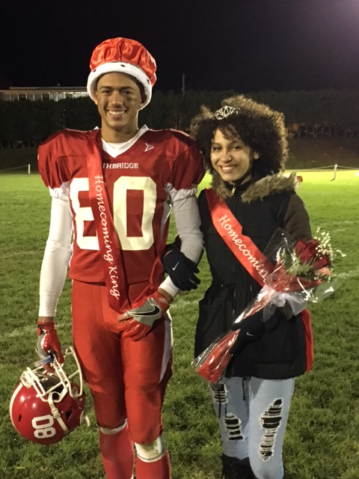
It’s hard to believe that school started just nine weeks ago – so much has happened. Thanks for your hard work and support and for always keeping Southbridge students first.

Dr. Jessica Huizenga

Tim Williamson & Paola Gonzalez
Homecoming King & Queen

