Vaulting Queensland State Championships 2018...
Mid July in South East Qld was embraced in crystal blue skies and glorious warm sunshine. The weekend was here.... the Vaulting community was descending on Veresdale, make-up was applying and bling was being ‘blung’!
As the bustle of activity began at Ballara Park, the atmosphere sparked.... the arena was almost set, music tested, horses were arriving and the aroma of BBQ sausages reminded everyone to keep their tank full for a high energy afternoon.
Clubs and Committee worked together to finalise arrangements, as two well dressed guests drove down the long tree lined driveway. The Judges had arrived! With Chris Wicks and Janet Leadbeater on site....VQ States 2018 was now set to go!
The afternoon moved along smoothly. The classes were efficient and the vaulting spectacular! With Official Classes rubbing shoulders with Recreational there was something for every vaulter on the first day of competition. Little ‘flyers’ stole attention, a Witch brewed up trouble and others put on quite a Show!

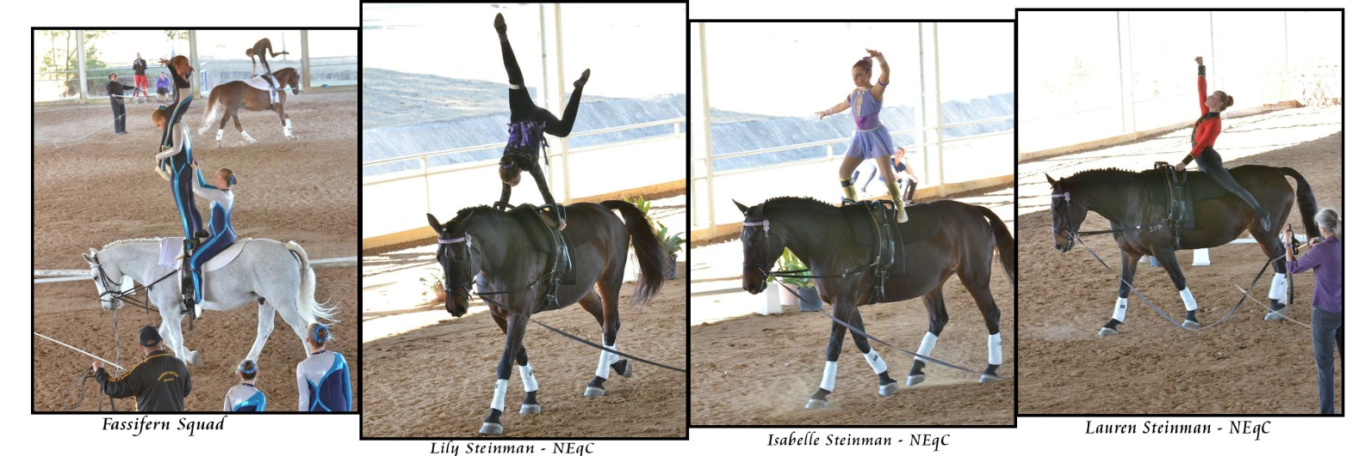

To end the day on a high, two senior vaulters were requested for a special judging role...... to award Fun Encouragement Awards to the Pre-Novice and Preliminary Barrel competitors! Assigned to this task were Lili Tamai and Alexandra Playfoot - and their judgement proved impeccable! Each young vaulter was recognised for the enjoyment and showmanship they bring to this wonderful sport!
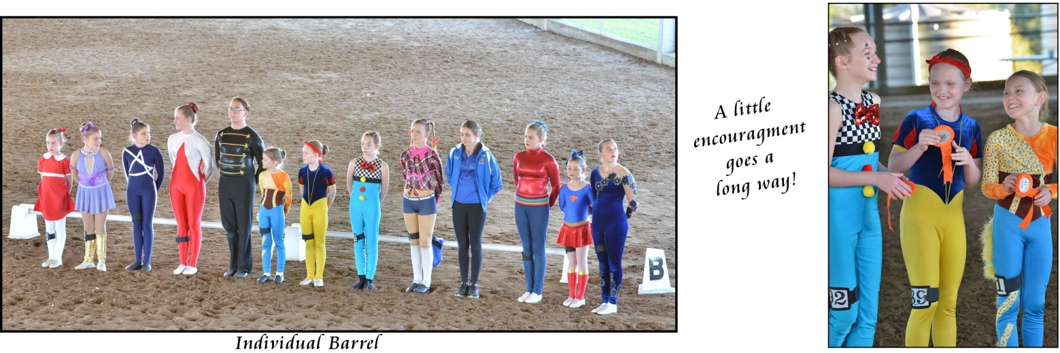

At the break of daylight Sunday, Hot Air balloons were lifting off to drift their way across the crisp, chilled terrain of Beaudesert Shire. Kangaroos were abundant, enjoying early morning dewy grass while a blanket of fog rolled over low hills ... inside it was all stations go for make-up, hair and costumes!
Competition kicked off with a Tech Test worthy of Gold, setting the pace for some outstanding vaulting and results. Vaulters strived for the roof in PDD, A Spider weaved her web and watch out for those Pirates!
The sun wasn’t the only thing warming up the day.... warm smiles were aplenty as Clubs and Spectators enjoyed the friendly and relaxed competition and Vaulters enjoyed performing and competing.

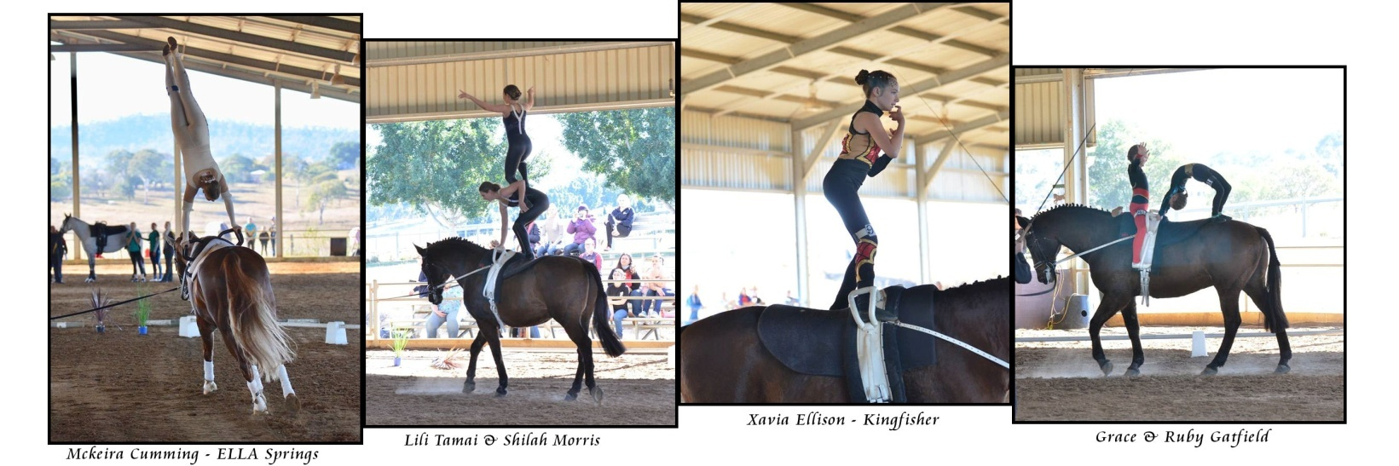
It was a big day but fun filled as the awesome raffle prizes were drawn and the Awards Ceremony drew near.

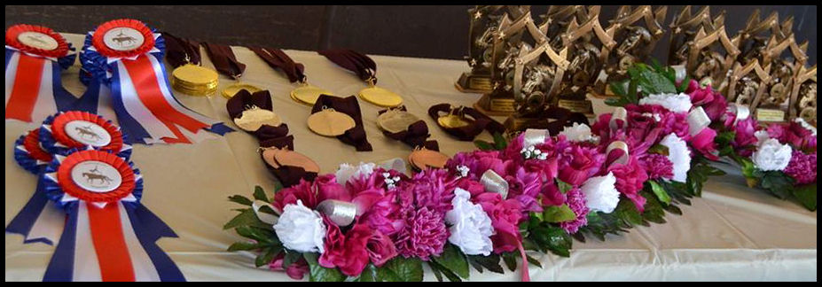

All competitors and their supporters worked tirelessly to be ready and give their best. Well done to all the competitors for an outstanding effort and their excellent sportsmanship.
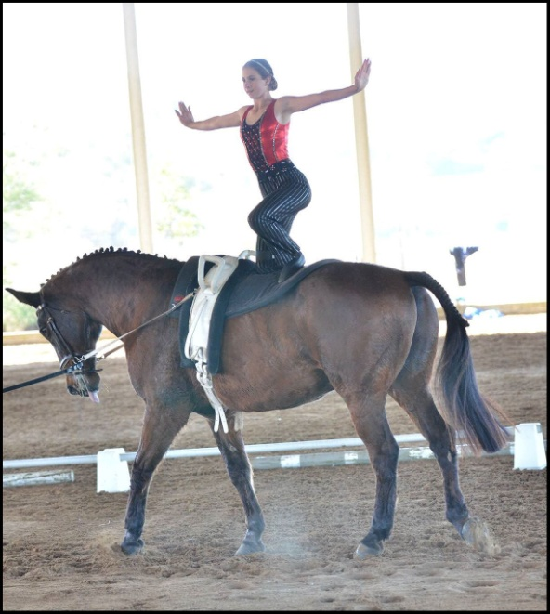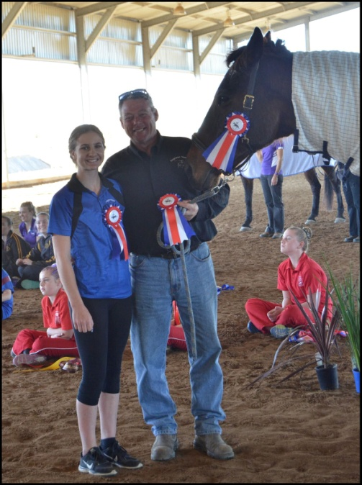
Congratulations to Champion Participant Shilah Morris, Lunger Mike Winwood and Brigadoon KF.

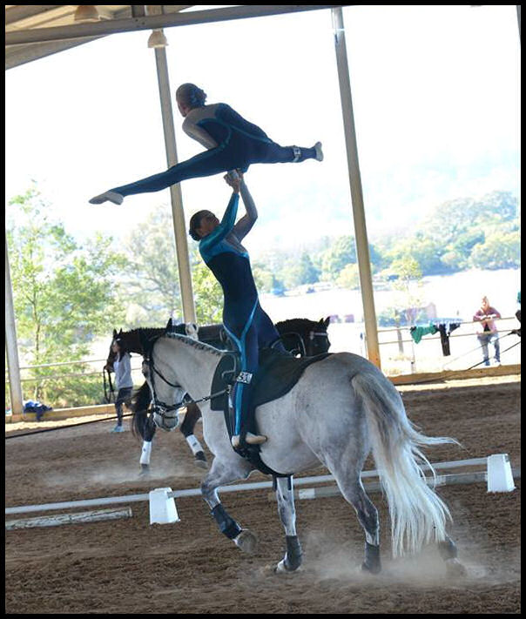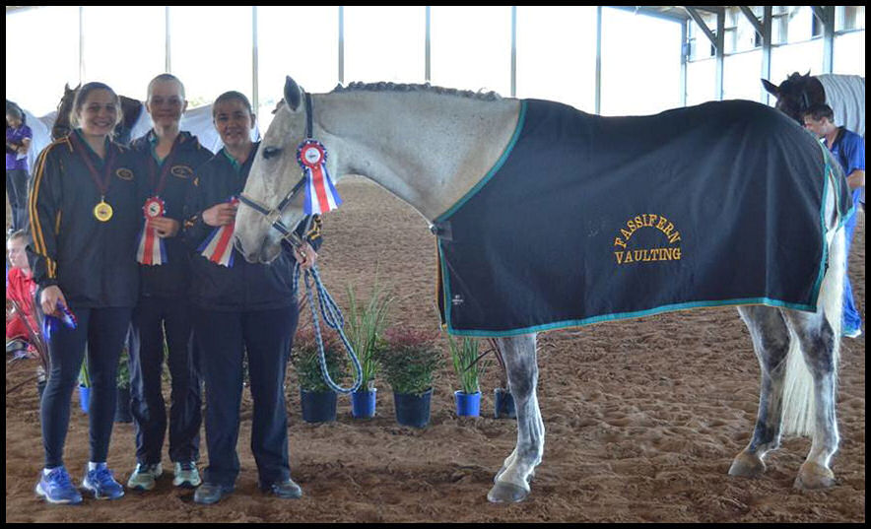
Congratulations to Champion Pas De Deux Jazz Heckeroth and Jean Betts, Lunger Melanie Fedrick and Kamilaroi Cavalier.

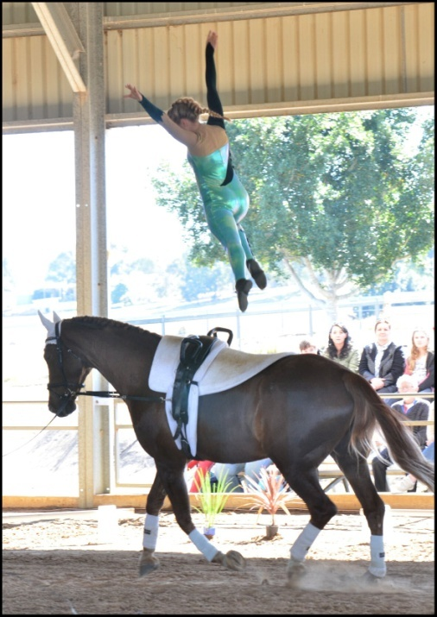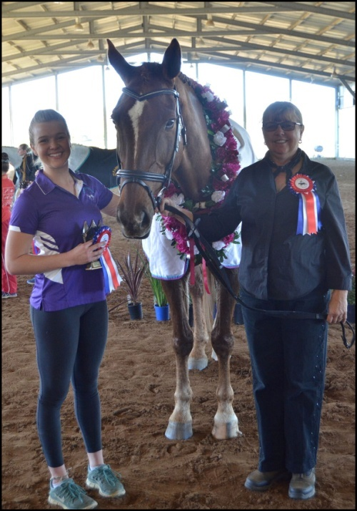
Congratulations to Champion Competitor Mckeira Cumming, Lunger Darani Cumming and Audouville Ludovic

As the early evening neared, horses were floated away and Veresdale drew quiet. A few stragglers packed up the last remaining items and marvelled in the successful weekend. All the hard work had paid off to give an enjoyable and professional State Championships to our wonderful vaulters and interstate guests!
Thank you to all those who helped make the Vaulting Qld State Championships the success that it was. We couldn’t have done it without you! Thank you to our sponsors for their support and generosity. Thank you to Alison Tamai for her terrific photography.
Special thanks to Chris Wicks and Janet Leadbeater for giving up their time and expertise to support Qld Vaulting.
We look forward to the next time when Vaulters......start your music!

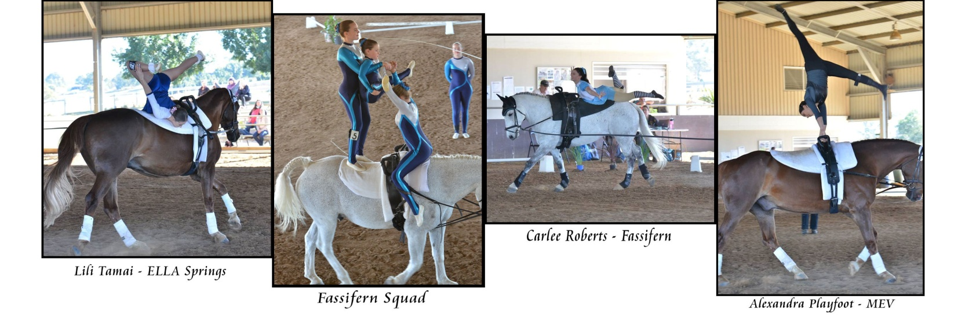

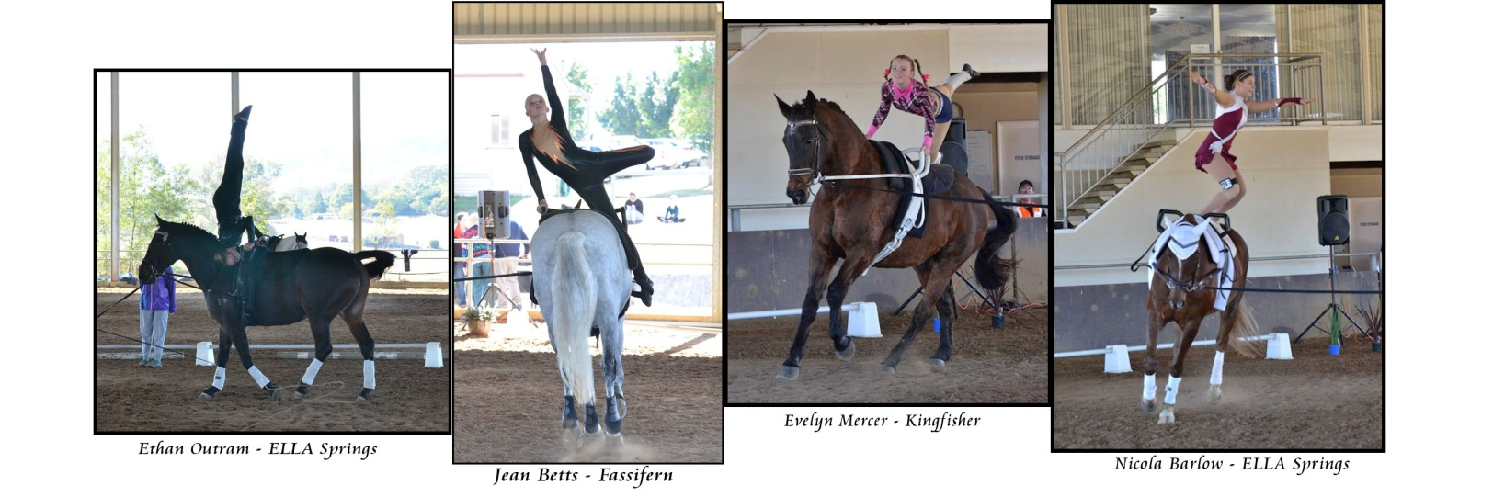

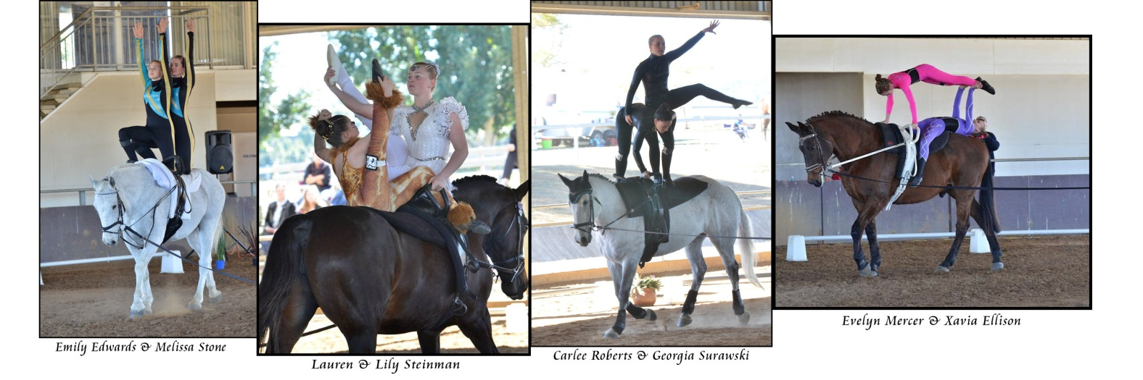

More photos
Tiziana Simonelli
Secretary Vaulting Queensland

