***Conference on Accounting for Surgeons***

A *Zoom* Conference May 14th, 2020 3:00pm Eastern Time

Speakers:

Lauren Warner, ACA

Assistant Manager at Grant Thornton, UK

Jon JP Warner, MD

Chief Shoulder Service

Acting Chief Sports Medicine Service

Chair for Quality and Safety for Orthopedics

Director of the Shoulder & Elbow Fellowship Program, at the Massachusetts General Hospital

Professor of Orthopaedic Surgery, Harvard Medical School

Program:

* Introduction (Jon JP Warner)
* Accounting for Surgeons (Lauren Warner)
  + Understanding Financial Statements
  + Understanding Cashflow vs Profit
  + Understanding Ratios
  + Practical applications of TDABC
* TDABC in Orthopedics (Jon JP Warner)

Lauren Warner is an ACA (Associate Chartered Accountant) with four years of experience. She graduated Magna Cum Laude from Brown University with a Bachelor of Arts in English in 2014 and then went on to obtain a Postgraduate Diploma in Accounting and Finance from the London School of Economics and Political Science, and a Master of Science in Innovation, Entrepreneurship, and Management from Imperial College London Business School, prior to becoming an ACA. She currently lives in London, United Kingdom, and works for Grant Thornton, having spent three years in Audit and the past year in the Special Projects team. She has also been involved with the Grant Thornton and Cranfield University MBA partnership, having taught a variety of Accounting topics to Executive MBA students. When she is not debiting and crediting, she enjoys running, traveling (especially with her father!), musical theatre, baking and meeting new people.

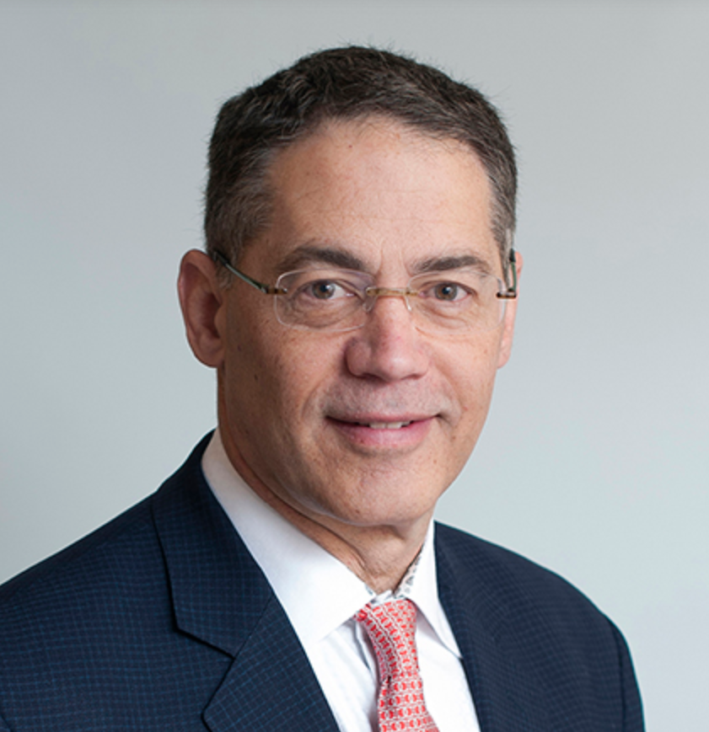Jon JP Warner was born in Wichita Falls, TX, USA and

graduated from Colgate University Hamilton, NY

with a BA (1978) and attended the University of Rochester

School of Medicine Rochester, NY (1982) for his Medical

Education. After 2 years of residency in surgery at Strong Memorial Hospital, University of Rochester, NY (1983) he spent 4 years in the Combined Harvard Orthopedic Surgery Residency (1987).

He subsequently participated in several clinical fellowships which included The Children’s Hospital Sports Medicine Fellowship,

in Boston (1988), The Cave Traveling Fellowship Award of the Massachusetts General Hospital (1989), and The A.O International Postgraduate Fellowship at the Inselspital, University of Berne Switzerland (1989). After his Swiss experience he went to France for a research fellowship at the Ecôle de Chirurgie Ampitheatre du Anatomie at the University of Paris, France (1989) and then to a clinical fellowship in Sports Medicine at Linkoeping University Hospital in Sweden (1989). In July 1989 he returned to the USA for the Shoulder and Sports Medicine Fellowship at the Hospital for Special Surgery in New York City (1990). From 1990 to 1998 he was an an Associate Professor of Orthopaedic Surgery and Director of the Shoulder Service, at the Department of Orthpedics at the University of Pittsburgh. Since 1998 he has been Chief of the Boston Shoulder Institute Program and remains at MGH as a Professor of Orthopedic Surgery.

He attended The Harvard Business School Executive Program and is a Graduate of HBS Class, 2019. He founded the New England Shoulder and Elbow Society ([www.neses.com](http://www.neses.com)), the Boston Shoulder Institute ([www.bosshin.com](http://www.bosshin.com) ) and the Codman Shoulder Society (www.codman-shoulder-society.com) .