Directions to Perkasie Municipal Authority If you need assistance contact Andrea 215-519-0108
150 Ridge Road
Sellersville PA 18960
From South
Take 309 North to exit PA-563/Perkasie. Turn left onto Lawn Avenue and then make a right on to PA-563/Rige Road. Continue approximately 1 mile and PRA building will be on the right side of the road. There are actually 2 entrances into the Authority and the first entrance is just beyond the Pennridge Regional Police building and the second entrance is actually the Comcast building entrance.
From North
Take 309 South to exit towards Sellersville (Bethlehem Pike). Continue approximately 2.5 miles to traffic light and turn right onto PA-563/Ridge Road. The building is approximately 1/10 of a mile ahead on the right. There are actually 2 entrances into the Authority and the first entrance is actually the Comcast building entrance and the second entrance is just before the Pennridge Regional Police building.
Parking
There are actually 2 entrances into the Authority and the first entrance is just beyond the Pennridge Regional Police building and the second entrance is actually the Comcast building entrance.
Once you arrive you will follow the signs for Perkasie Regional authority deliveries. Follow around the building to the back parking lot. You will park there. Use the steps closest to the dumpster. Ring the call button and you will be buzzed in. The training room is 1 floor up.
TURN IN HERE
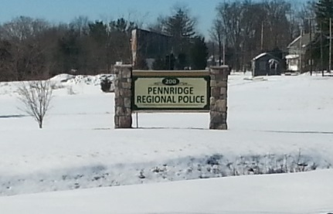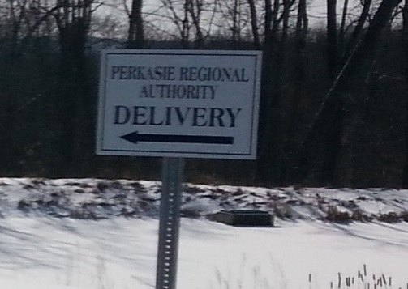
Follow Sign for Perkasie Regional Authority Parking
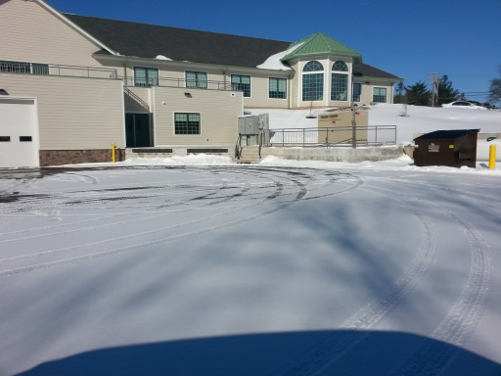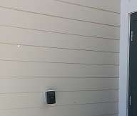
Ring Call Bell to be Buzzed In
PARK HERE

