# MAKING HISTORY WITH MULTICULTURAL TELEVISION PRODUCED BY LATINOS

# In a cozy atmosphere, with a knowledgeable and keen audience on television, Multicultural Television Sizzle Reel Upfronts, was held on September 30 in Manhattan. This event was the perfect opportunity to bring together dozens of recognized media executives, advertisers, celebrities and television insiders to preview a slate of innovative and quality sizzle reels, created for mainstream television and produced independently with multicultural talents. In its first edition, this event coincided with the celebration of Hispanic Heritage Month and the Advertising Week in New York.

# The promotional reels and pilots included original English-language content ranging from drama (Dark Prophet, Life Coach, and The Velvet Underground), sitcom (My Mother Married a Green-Go and Hail Mary), reality (Banquet Hall Drama, Million Dollar Off Sketch and The Real Miami Vice), interactive talk shows (#Buzzchat and The Kiki Show), comedy specials (Hot tamales Live and Fried Bananas) to children's programming (Tipitom).

# This event was produced by Kiki Melendez, renowned actress and executive producer of Latin Hollywood Films (www.lhfilms.tv), in partnership with Latin Heat Media Institute, a nonprofit organization. "We are making history" "Mlticulturalism is important" "Latinos are talented and creative." "We are breaking the rules." "It is about bridging the gap between buyers and the media", "We did it all together," said Melendez during the event.

# This event was a historic contribution to the future of multicultural talent in the United States by showing how do Latinos want to be portrayed on television with innovative and creative programming. In addition, it was an incredible opportunity for advertisers who are looking to expand their markets and learn about Latinos in front and behind the camera.

# An excellent work was done by all the team who bring "Multicultural Television Upfronts Sizzle Reel" to life. Congratulations on making history!

About the Author

Argelis Wesley has been writing about culture, movies, trips, politics, life style and a variety of other subjects since 2015.  She holds a Bachelor of Communication in Advertising and a Master of Business Administration in Marketing.  Email: avwesley17@gmail.com

Photo credit:

Argelis Wesley

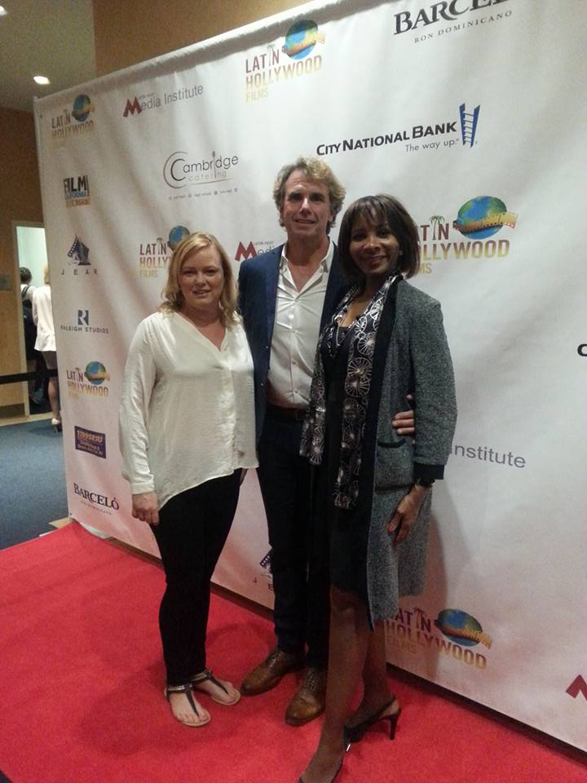

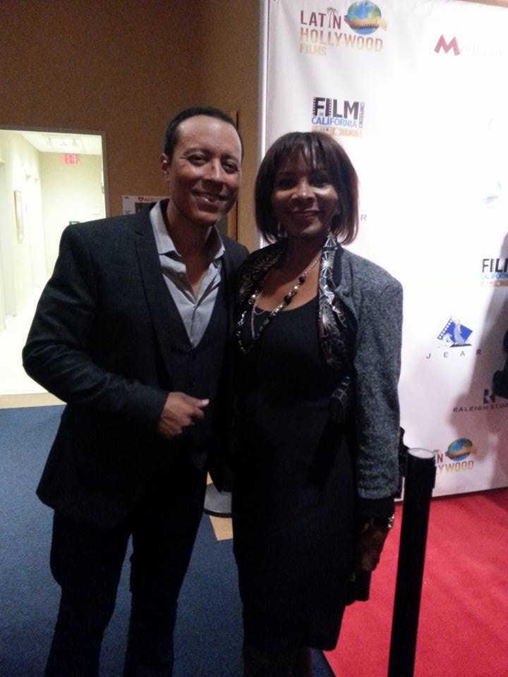

Email: [avwesley17@gmail.com](mailto:avwesley17@gmail.com)

With Rebecca Gouveia, COO Feast It Forward and Kevin Gouveia, Vice President and Co-Founder of United Village Transformation

With Hollywood actor Yancey Arias

With Hollywood actor Yancey Arias

With Hollywood actor Yancey Arias

With Rebecca Gouveia, COO, Feast It Forward and Kevin Gouveia, Vice President/Co-Founder United Village Transformation

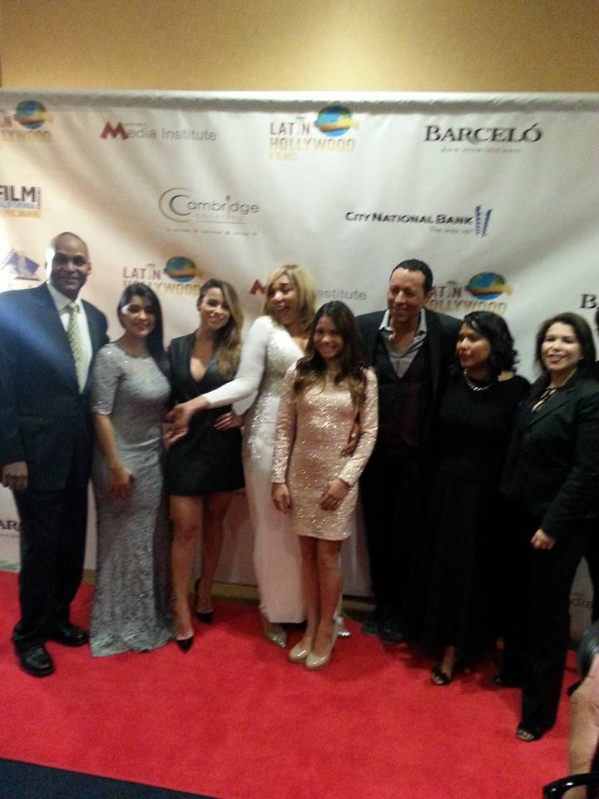

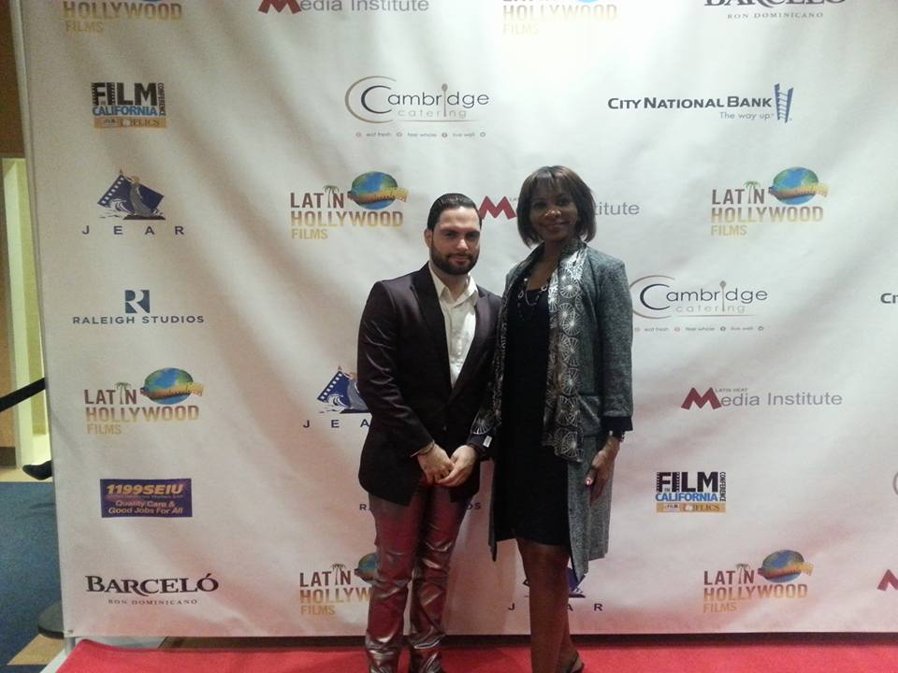

With Dominican actor Eddy Ramírez Photo featuring Chelsea Rendon, Kiki Meléndez

Yancey Arias, Julia Carias Linares, Evette Vargas