The Real Rocky

The expected release of the film Hands of Stone is around the corner.  I’m looking forward to be one of first movie goers. This biopic movie describes the evolution of one of the best boxing fighters of all times: Roberto Durán best known as “Hands of Stone”.

With a budget of around 20 million of dollars, Hands of Stone had a special screening at the Cannes Film Festival last May. The movie was directed and written by Venezuelan director Jonathan Jakubowicz. It features: Venezuelan actor Ėdgar Ramirez, Robert De Niro, Usher, John Tuturro, Ellen Barkin, Panamanian actor/singer Rubén Blades and the Spaniards Ana De Armas and Óscar Jaenada, among other celebrities.

## Why am I so interested in Hands of Stone? There are two reasons: the first reason is that this movie was filmed mostly on locations in my beloved Panama. My skin is bristling with fever whenever I see images of Panama. Due to financial incentives offered by Panamanian film industry allowing foreign producers to make their films in Panama, dozens of Panamanian extras and crew members took part of this movie.. The life of Durán has been inspiration for a TV mini-series and on stage play in Panama. Now, Hollywood pays tribute to Durán.

## Being a boxing aficionado is the second reason. Yes, I love good boxing matches. I particularly enjoy viewing Duran’s boxing matches during the past decades, especially, in '70s and ‘80s. At that time, the population in the country was only 1.7 million of habitants, however; we had 17 world boxing champions. The most famous and popular was, you guessed it -Roberto Durán.

## If you are a millennial, it is very probable you do not know who Roberto Durán was. According to boxing experts, he is considered as the 8th best boxer of all the times. In my opinion, he is, he was, and he will be the best of all times. One of my most satisfying child memories I had was watching his boxing matches. I am his loyal fan. He was my child hero. In addition, we share the same birth month. Roberto was born on June 16th, while my anniversary of life is on June 17th. (You can still send me a birthday gift).

Boxing has been a common theme in many movies. For instance, there are more than thirty films with boxing themes today like: Raging Bull, Million Dollar Baby, The Hurricane, and Champion, just to mention few. Now, Hands of Stone is part of this list. The most successful boxing film has been Rocky which went on to win three [Oscars](https://en.wikipedia.org/wiki/Academy_Awards), including [Best Picture](https://en.wikipedia.org/wiki/Academy_Award_for_Best_Picture) in 1976. Rocky has spawned [six sequels](https://en.wikipedia.org/wiki/Rocky_(film_series)) and one spin off. I am convinced that Roberto Duran provided an inspiration for the script of Rocky written by Sylvester Stallone. The life of Duran has all the ingredients we can see in the story of Rocky. Both characters have humble origins, success, love, defeat, challenges and a legacy. I had analyzed some data from both movies. Here are the similarities that I have found:

Name: The Panamanian fighter was baptized as Roberto Durán Samaniego, but when he became a professional fighter in 1969, his nickname was Rocky. Robert "Rocky" Balboa is the [title character](https://en.wikipedia.org/wiki/Title_character) of the Rocky films.

Origins: Rocky’s plot is a hard-living, but failing fighter who was able to get to the top, challenging everybody and everyone, including himself. His boxing career starts in 1975 and his legacy lasts until today.

Before his debut as professional fighter in 1967, Duran was a messenger, a shoe shiner, a waiter, a painter, and a mechanic. He was actively fighting until the year 2000.

Career: Rocky achieved the unthinkable by confronting a boxing champion thanks to his indomitable spirit, he lost the fight, but was left standing by his feet.

Duran took Latin American boxing at its highest levels, he faced the best boxers of his time on various boxing categories, making memorable bouts in which showed his remarkable punch and boxing knowledge.

Boxing style: Durán was not a runner, he simply drove forward, he was a knockout puncher with outstanding body movement. Rocky has the same boxing style. In fact, Duran trained Sylvester Stallone for his role in Rocky II.

Boxing trainer: Néstor Quiñónez, best known as "Plomo Espinosa", discovered Roberto Durán when he was a teenager. As his first trainer, he was a relevant role in Duran’s initial career. The fictional trainer character is nicknamed Mighty Mick. Both trainers have a vast experience in boxing.

First boxing championship: Duran won the World Lightweight Championship from Scottish champion Ken Buchanan at the Madison Square Garden in 1972. In contrast, fictional character Rocky won his first World Championship's heavy weight against then champion, Apollo Creed.

Love: Rocky’s love is Adriana. Like Rocky, the love life of Duran focuses on a single woman. Since he was 16 years old, Roberto shares his life with his wife Felicidad.

First-born son: Adriana delivered a baby and she suggested that the boy should be named after his dad; Robert Balboa, Jr. Durán’s first-born son is Roberto "Chavo" Durán Jr.

The next time that I will meet with Duran, I'll ask him if he is the real Rocky? What do you think would be his answer. Meanwhile, I'm content to state that Roberto Durán is the real Rocky.

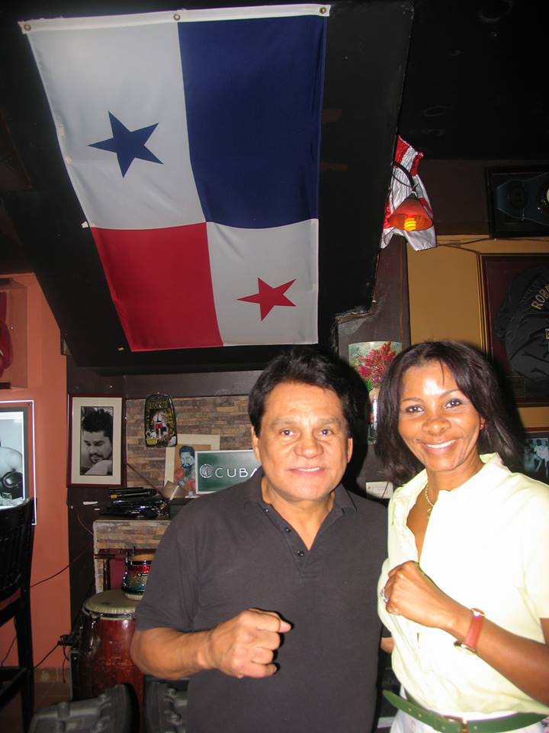

Roberto Durán and Argelis Wesley

About the Author

Argelis Wesley has been writing about culture, movies, trips, politics, life style and a variety of other subjects since 2015. She holds a Bachelor of Communication in Advertising and a Master of Business Administration in Marketing.

Email: avwesley17@gmail.com

Photo Credits

Mariusz Jankiewicz

* Kevork Djansezian/Getty Images News/Getty Images