EVERYTHING YOU SHOULD KNOW ABOUT FILM LAW IN PANAMA

Panama is becoming the place to make world-class cinema. How is it possible? Well, Panama has created legal provisions and incentives to make this Central American country the preferred site for film and television locations.

In 2012, Panama passed a law establishing a proper film industry. As a result, foreign productions come and shoot in Panama

BENEFITS FOR FOREIGN FILM MAKERS

* 15% cash back to foreign film and television projects
* Policy of tax-free temporary importation of all film equipment with no deposit required.
* Producers are tax exempt from duty, levies, fees, and charges for items  
  purchased and not resold or leased.
* Panama facilitates the paperwork for foreign employers
* Film and television companies travelling to Panama can be exempt from having to pay certain immigration service fees.
* Cost of visas and administration fees are also often offered at a reduced price.
* Panama offers an ease of mobility across a diversity of locations, including tropical rain forest, Caribbean beaches, volcanic areas, islands and a cosmopolitan skyline.

BENEFITS FOR PANAMA-BASED FILM COMPANIES

* $3m annual fund that supports domestic film production, with prizes awarded every year

BENEFITS FOR PANAMA

* Panama has received around $2–3 millions in foreign production since 2008
* A $3m annual fund that supporting domestic film production, with prizes awarded to 12 productions every year.

COMPETITION

[Panama](http://en.centralamericadata.com/en/search?q1=content_en_le:%22Panama%22&q2=mattersInCountry_es_le:%22Panama%22) competes with several countries in order to be chosen as a location for filming. Puerto Rico and the Dominican Republic are the main competitors, due to the similarity of their scenery.

FILMS SHOT IN PANAMA (SINCE 2007)

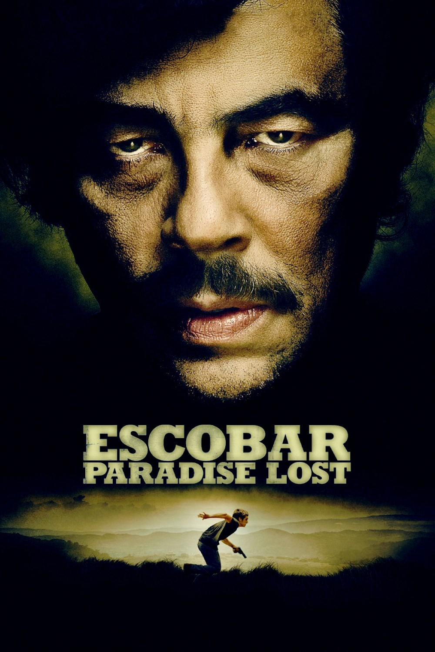

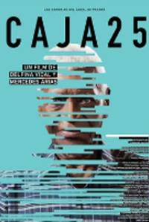

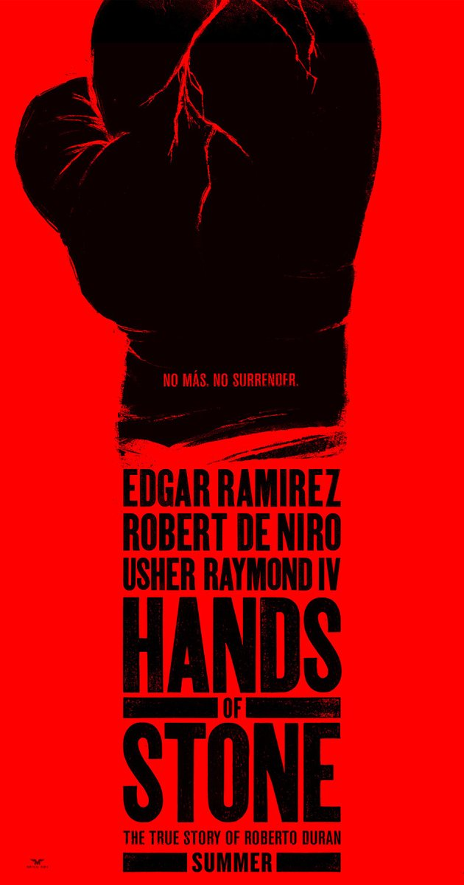

* Más que Hermanos (2016)
* Hands of Stone (2016)
* Historias del Canal (2014)
* [Escobar: Paradise Lost](https://en.wikipedia.org/wiki/Escobar:_Paradise_Lost) (2014)
* Caja 25 (2014)
* Indigenous (2014)
* Contraband (2012)

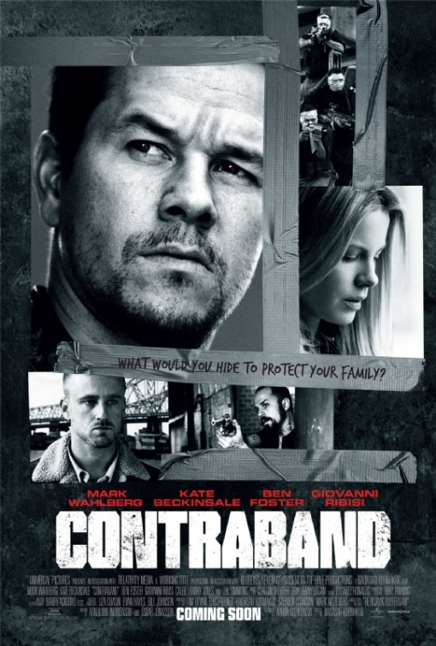

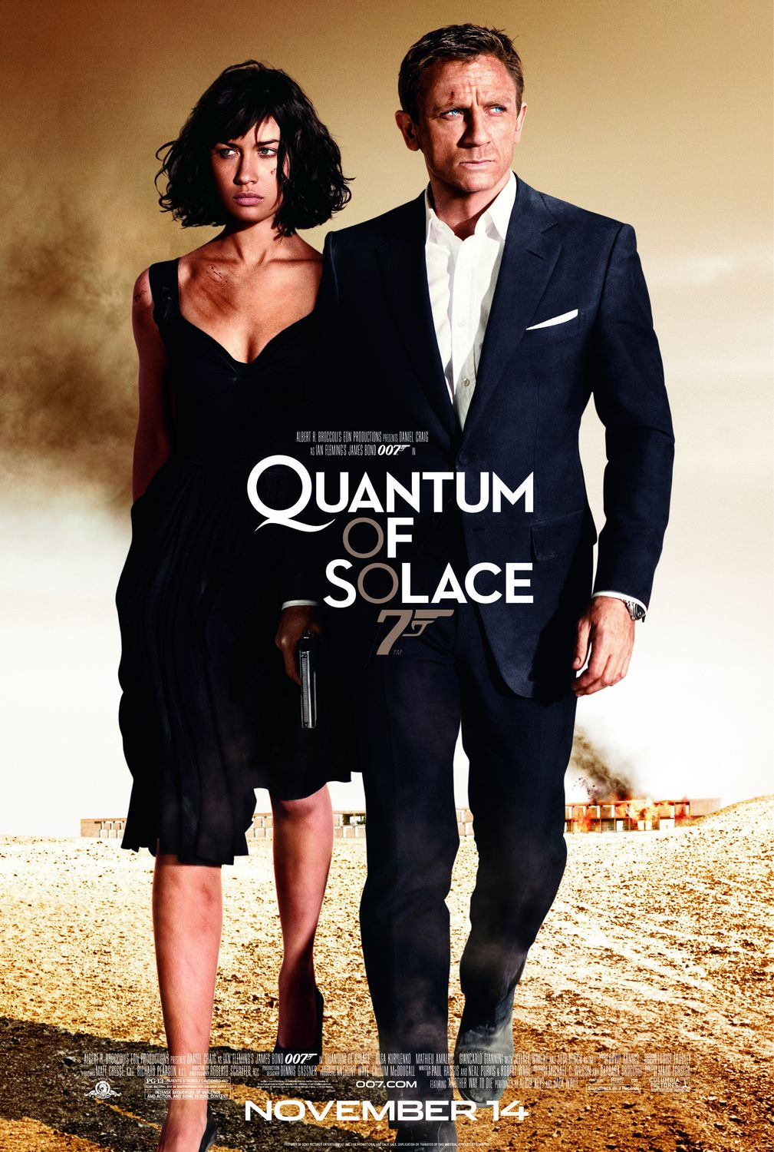

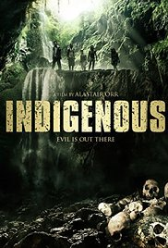

* Quantum of Solace (2008)

### RECENT PANAMANIAN FILMS

#### Kimura

#### [Salta (2016](http://dicine.gob.pa/%25fondocine%25/))

#### [El Cheque](http://dicine.gob.pa/%25fondocine%25/)

#### [A La Deriva](http://dicine.gob.pa/%25fondocine%25/)

#### [Salsipuedes](http://dicine.gob.pa/%25fondocine%25/)

#### [Sultan](http://dicine.gob.pa/%25fondocine%25/)

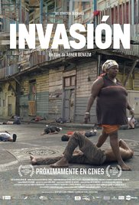

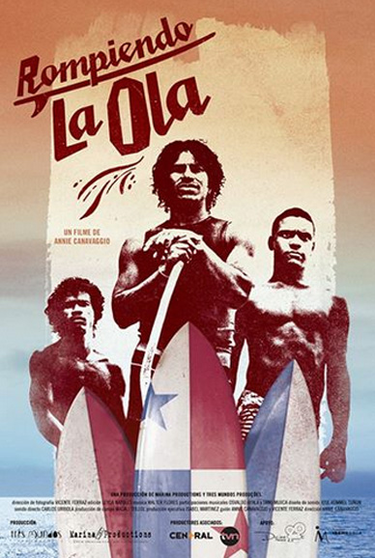

#### DOCUMENTARIES SHOT IN PANAMA

* Invasion (2014)
* Rompiendo la Ola (2014)

### PANAMANIAN SHORT FILMS

#### [El Amateur](http://dicine.gob.pa/%25fondocine%25/)

#### [La Cajita](http://dicine.gob.pa/%25fondocine%25/)

#### [Los Cuatro Reyes](http://dicine.gob.pa/%25fondocine%25/)

#### [Amalia y Rafa](http://dicine.gob.pa/%25fondocine%25/)

#### [Tita la Bruja](http://dicine.gob.pa/%25fondocine%25/)

#### [Mal Inmueble](http://dicine.gob.pa/%25fondocine%25/)

#### Photo credits:

REFEENCES:

**For more details, visit the following links:**

DICINE, “Ley de Cine del 16 de Septiembre de 2012”. dicine.gob.pa, 27 Apr. 2012. Web 16 Aug 2016.

# JUSTIA PANAMA. “Decreto Ejecutivo 34 De 2009. Panama.justia.com, 2 Jul 2009, Web 16 Aug 2016.

DICINE, “Ley de Cine del 16 de Septiembre de 2012”. dicine.gob.pa, 27 Apr. 2012. Web 16 Aug 2016.

# JUSTIA PANAMA. “Decreto Ejecutivo 34 De 2009. Panama.justia.com, 2 Jul 2009, Web 16 Aug 2016.

# DICINE, “Bases y Requisitos para Participar en el Concurso Fondo Cine 2016”, dicine.gob.pa, 16 dic 2015, Web 16 Aug 2016.

# LATAMCINEMA.” La onda de las coproducciones internacionales y los incentivos en América Latina”, latamcinema.com, 18 Jan 2011, Web 16 Aug 2016.

# [PROINVEXPANAMA](https://www.youtube.com/channel/UCEv-8Az_QyshnJahsRrQGvA), 2 Sep 2010. “Incentivos para la Industria del Cine en Panamá”. Retrieved from <https://www.youtube.com/watch?v=ZNV8Fquc6pk>, Web 16 Aug 2016