Research that says not to give anti-psychotic dopamine antagonist medications
Like Risperdal (risperidone), Haldol
The Diagnosis and Treatment of Autoimmune Encephalitis
Eric Lancaster
https://synapse.koreamed.org/search.php?where=aview&id=10.3988/jcn.2016.12.1.1&code=0145JCN&vmode=FULL
“Intoxications such a neuroleptic malignant syndrome and serotonin syndrome may often present with similarities to autoimmune encephalitis. Conversely, patients with anti-NMDAR encephalitis may develop psychosis as an initial symptom and be treated with neuroleptics, then later show catatonia, rigidity, autonomic instability and altered level of consciousness; this pattern of findings may be mistaken for neuroleptic malignant syndrome. Autoimmune encephalitis therefore should enter into the differential diagnosis of any case of suspected neuroleptic malignant syndrome (Patients with anti-NMDAR encephalitis may be particularly sensitive to strong dopamine antagonists, and our group attempts to avoid using these medications).”

Clinical experience and laboratory investigations in patients with anti-NMDAR encephalitis
Prof Josep Dalmau, MD, Eric Lancaster, MD, Eugenia Martinez-Hernandez, MD, Prof Myrna R Rosenfeld, MD, and Prof Rita Balice-Gordon, PhD
https://www.ncbi.nlm.nih.gov/pmc/articles/PMC3158385/
“Studies investigating the effects of phencyclidine and ketamine (non-competitive antagonists of NMDARs) in human beings show that these drugs induce behaviours that are much the same as the positive and negative symptoms of schizophrenia, along with repetitive orofacial and limb movements, autonomic instability, and seizures”
“The profile of symptoms caused by antagonists of NMDAR is dose dependent and varies in much the same way as the multistage clinical course of anti-NMDAR encephalitis does (figure 5). At low doses, NMDAR antagonists cause psychosis, agitation, memory disturbance, and decreased responsiveness to pain, and at higher doses they cause dissociative anaesthesia, a state of profound unresponsiveness with catatonic features, and coma”
Neuronal surface autoantibodies, encephalitis, and psychosis: from neurology to psychiatry page 6-9
http://www.acnr.co.uk/wp-content/uploads/2017/11/ACNR-N-J18-low-rez-2.pdf
“In terms of psychiatric treatment, there is mounting evidence that patients with NMDARantibody encephalitis may respond poorly to antipsychotic treatment, with high rates of rhabdomyolysis and even development of a neuroleptic malignant syndrome (NMS)-type picture.22,23 For this reason, benzodiazepines are preferred for initial management of behavioral disturbance and catatonia. If antipsychotics are required, sedating atypical antipsychotics such as olanzapine may be preferable.”
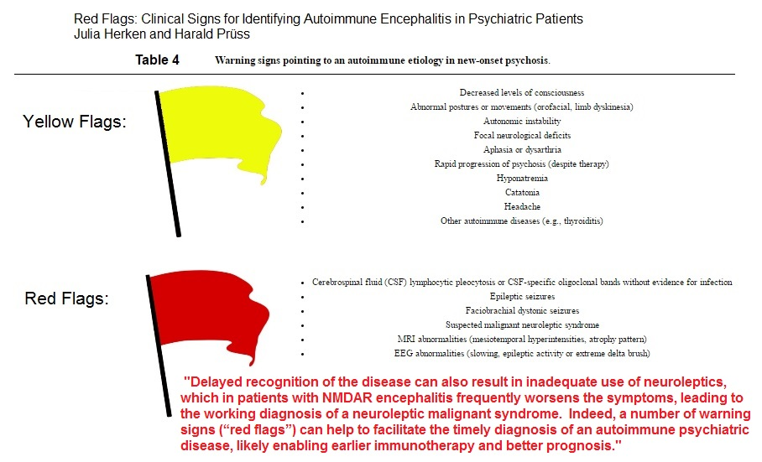
https://www.ncbi.nlm.nih.gov/pmc/articles/PMC5311041/
The development of extrapyramidal symptoms (EPS) when placed on antipsychotics should alert the team to consider this diagnosis. Of course, EPS is a known side effect of antipsychotics, but is just another reminder to consider the possibility of Autoimmune Encephalitis.
Delayed recognition of the disease can result in inadequate use of neuroleptics. Patients who develop psychosis as an initial symptom may be treated with neuroleptics, then later show catatonia, rigidity, autonomic instability and altered level of consciousness and possible coma; this pattern of findings may be mistaken for neuroleptic malignant syndrome. Patients with anti-NMDAR encephalitis may be particularly sensitive to strong dopamine antagonist medications such as Risperdal (risperidone), Haldol and these should be avoided. For this reason, benzodiazepines are preferred for initial management of behavioral disturbance and catatonia in suspected autoimmune encephalitis.
Autoimmune encephalitis therefore should enter into the differential diagnosis of any case of suspected/new onset of possible Neuroleptic Malignant Syndrome (especially if the Creatine Kinase (CK) is normal, or CK normalizes after treatment, but without improvement.)

Clinical experience and laboratory investigations in patients with anti-NMDAR encephalitis Prof Josep Dalmau, MD, Eric Lancaster
https://www.ncbi.nlm.nih.gov/pmc/articles/PMC3158385/ “The profile of symptoms caused by antagonists of NMDAR is dose dependent and varies in much the same way as the multistage clinical course of anti-NMDAR encephalitis does. At low doses, NMDAR antagonists cause psychosis, agitation, memory disturbance, and decreased responsiveness to pain, and at higher doses they cause dissociative anaesthesia, a state of profound unresponsiveness with catatonic features, and coma”
Treatments should not hide disease evolution neither worsen symptoms.22 They advised to choose atypical and more sedative antipsychotics rather than typical antipsychotics as dopamine antagonists that aggravate agitation, in order to treat psychotic symptoms. To treat mood symptoms, valproic acid was advised for sedation, sleep, and seizure benefits and thanks to the availability of an intravenous form. Uses of lithium and benzodiazepines are also reported in the literature but do not cause significant changes.112,113 ----https://www.ncbi.nlm.nih.gov/pmc/articles/PMC5089825/

