6 Thinking Hats

 | White Hat  - Neutral hat  - Focuses only on the facts and information given.
 | Black Hat  - Judgement hat  - Plays devil's advocate and sees where there might be problems or difficulties.
 | Blue Hat  - Metacognition hat  - Manages the thinking and timing of the group, and keeps in mind the big picture.
 | Yellow Hat  - Optimistic hat.  - Only considers the positive benefits and keeps a very happy attitude.
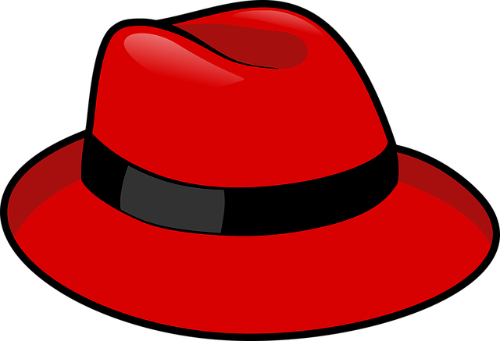 | Red Hat  - Intuitive hat  - Only pays attention to the feelings and emotions of the problem or situation.
 | Green Hat  - Creative hat  - Examines the possibilities, options, and new ideas.

