

**221 Petersburg Road, Carlisle**

**717-245-0561**

**Cumberlandgymnastics.org**

[**info@cumberlandgymnastics.org**](mailto:info@cumberlandgymnastics.org)

**Like Us on Facebook & Instagram**

**Lik**

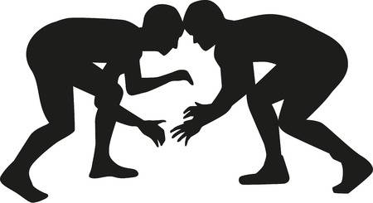

6 week program:

**March 22nd – May 3rd**

**No class on April 12th**

**Sunday**

**5:00 – 6:00**

**Cost: $72 per person**

**Cash or Check Only**

**Stop by the office to sign up!**

**Ages 4 & Up!**

**WRESTLING**

**AGILITY, STRENGTH & TUMBLING**

**Student Information Form**

Name: ______________________________________ DOB: ______________

Parents Names: ________________________________________________

Address: _____________________________________________________________________

Phone Number: H: _____________________ C: _____________________

Email: ________________________________________

Emergency Contact for if parents cannot be reached:

Name: ______________________________ Phone Number: _____________________

Any injuries or concerns staff of CG should know: (fears, ADHD, etc.)

______________________________________________________________________________________

Any medications your child is NOT permitted in an emergency?

______________________________________________________________________________________

Can child be in pictures posted on our website/social media? **YES** or **NO**

I hereby authorize the staff at Cumberland Gymnastics, Inc. to act for me according to their best judgment in an emergency requiring medical attention, and I hereby waive any and all claims for personal injury that I may have against Cumberland Gymnastics, Inc. and its directors, officers, agents, employees, representatives, and any volunteers in any way associated with Cumberland Gymnastics, Inc. I understand that participation in gymnastics and tumbling carry with them the risk of injury. All medical expenses incurred will be the responsibility of the student or the student’s family.

**Parent signature: ________________________________________ Date: _________________**