Collecting and Curiosity Cabinets Lesson Plan
REVISED from “Look Into My Cabinet of Natural Curiosities lesson plan” and
“From Curiosity Cabinet to Museum Collection lesson plan”

This lesson for 5th to 7th graders integrates biology, history, art, and math through a series of collecting, classifying, and cataloguing activities. The lesson introduces students to binomial nomenclature and museum-based research. Students discover the development of museums from their origins as curiosity cabinets to today’s virtual museums, providing online access to collections and specimen databases. Students create a curiosity box, label the objects in their curiosity box (possibly using Latin binomials for plant and animal specimens when appropriate), develop a classification scheme for the objects, and create a database of all objects collected by the class.

Goals:
- Learn history of collecting, classifying, and exhibiting
- Explore systems of classification
- Create systems of classification
- Classify objects using skills in observing, identifying, and comparing
- Communicate systems of classification

Objectives:
- Stimulate and strengthen problem-solving and critical thinking skills
- Encourage collaboration and teamwork
- Enhance student motivation
- Provide hands-on opportunities to students
- Inspire inquisitiveness and logical inquiry
- Encourage recognition of connections across disciplines and between learning and real life
- Expand notions of how learning can be communicated

Key Terms (definitions from Dictionary.com)
- Case: protective container used to display objects
- Classify: to arrange or organize by specific characteristics
- Collection: a group of objects or an amount of material collected in one location, especially for some purpose or as a result of some process
- Curation: to pull together, sift through, and select for presentation (collect-analyze and research-exhibit)
- Exhibition: a public display, as of the work of artists or artisans, the skills of performers, or objects of general interest
- Gallery: rooms or series of rooms used to display art or other kinds of objects
- Label: card, usually placed on the wall next to the object, that provides information about the object
- Museum: a building or place where works of art, scientific specimens, or other objects of permanent value are kept and displayed
- Taxonomy: the science or technique of classification
  - In biology, the science dealing with the description, identification, naming, and classification of organisms

Background
Before museums existed, objects of natural history, art, and technology were held in private collections. Curiosity cabinets (also known as cabinets of wonders or chambers of curiosities) of the 16th and 17th century included all sorts of attractive or interesting objects. Rare items were especially prized. Aristocrats and other wealthy collectors amazed their visitors with never-before-seen shells, bones, medicinal plants, minerals, paintings, cannons, and clocks. The objects were usually displayed together. But they were categorized as:
- naturalia (products of nature),
- artificialia (products of man including textiles, coins, weapons, furniture, prints),
- and scientifica (scientific instruments).

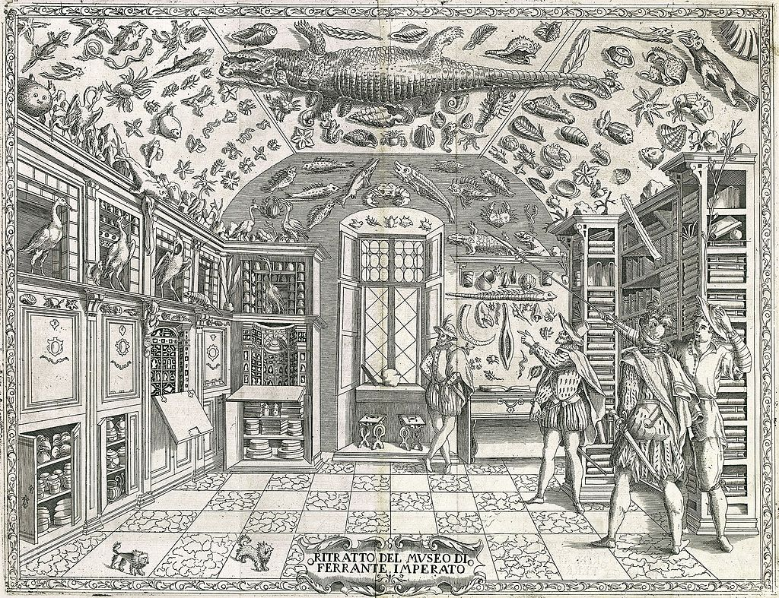

The term cabinet originally described a room rather than a piece of furniture. The first of the cabinets of curiosities were assembled in the mid-sixteenth century. The earlies pictorial record of a natural history cabinet is the engraving in Ferrante Imperato’s Dell’Historia Naturale (Naples, 1599). It serves to authenticate its author’s credibility as a source of natural history information, in which many of the volumes in the bookcases most probably represent his plant specimens collection. Every surface of the vaulted ceiling is occupied with preserved fishes, stuffed mammals and curious shells, even a stuffed crocodile is suspended in the center.

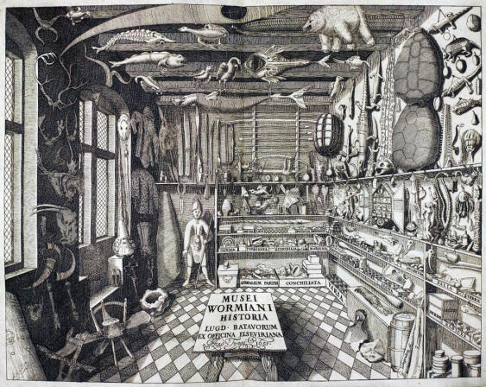

One of the most famously described 17th-century cabinets was that of Olaus Wormius (1588-1654). His cabinet was filled with preserved animals, horns, tusks, skeletons, minerals, as well as other types of equally fascinating man-made objects: a mix of fact and fiction, including mythical creatures. The specimens displayed were often collected during exploring expeditions from unfamiliar locations and trading voyages.

Private collections eventually became natural history museums, anthropology museums, art museums, science museums, etc.

Classification/Taxonomy
As collectors traveled the world, many new organisms became known to science. There was a great need to organize this new information. In 1735, Carolus Linnaeus outlined his scheme to classify plants, animals, and rocks. By 1753, he formalized the two-word system to name organisms. Thus, he established his role as father of classification and binomial nomenclature.

Activities and Worksheets
- Field Trip to explore collections, classification systems, and presentation (Worksheet 1)
- Creating a curiosity box
- Classifying and labeling (Worksheet 2)
- Creating a database of your class museum (Worksheet 3)

Time frame
Five class periods. In the first period, introduce museum terms. Second period, take field trip (historic house, natural history museum, art museum, etc.). Students create a curiosity box as a homework assignment. The third period, have students bring curiosity boxes to school. Begin class by describing the history of museums and introduce naturalia, artificialia, and scientifica as one way of classifying objects. Introduce and discuss remaining key terms—classification, curation, and taxonomy. Have students take a tour through the classroom to see all the curiosity boxes. Fourth period, complete curiosity box class activity. Fifth period, complete datasheet class activity.

Materials for Creating a Curiosity Box

- observation report (Worksheet 1)
- containers that could be used to create a cabinet (cardboard boxes, jars, CD jewel boxes, paper, etc.)
- pencil or pen
- collector labels (~ six per student—photocopy/print Worksheet 2)
- datasheet (provided in Worksheet 3) or transfer table columns to chalkboard
- computer with web access (for optional enhancement activities)

Procedures

Period 1:
- Introduce key terms (case, collection, exhibition, gallery, museum):
  - Create brainstorming map about collecting on the chalkboard/whiteboard.
Period 2:
- Take field trip and complete observation report (Worksheet 1).
- Describe the homework activity and provide a handout with instructions.
  - Ask students to collect a variety of natural objects, man-made objects, and scientific instruments and record information about their collections.
  - About six objects per student is reasonable, although the number can be altered depending on class size.
  - Within the category of natural objects, ask students to include some leaves, flowers, seeds, or nuts from their home (e.g., rice, beans, dried herbs from the pantry) or backyard or nearby park. Please ask students to collect only fallen plant parts if collecting beyond their backyard. (Collecting plants and animals in state or national parks requires an official permit.)
  - The man-made objects and scientific instruments should be items from the students’ homes. Scientific instruments may be any items used to measure, document, or understand the world: ruler, compass, watch, calculator, magnifying lens, battery, scale.
  - Accept any reasonable item.
  - While collecting, students should record on a piece of paper when and where they collect each object.
  - Give students one week to collect the items and arrange the items in their box in whatever fashion they choose.
Period 3:
- Introduce background information on curiosity cabinets as precursors to museums. Introduce naturalia, artificialia, and scientifica as kinds of objects that were collected for curiosity cabinets.
- Introduce key terms (classify, curation, taxonomy).
  - Discuss classification systems. Explore different types. For example, you could introduce current classification scheme for living organisms and some of the general characteristics of each kingdom. Ask students to consider ways they classify everyday objects.
  - Introduce activities of curation: collect, analyze, research, select, exhibit.
  - Discuss presentation of collections, including display and the methods used to communicate information.
- Allow a few minutes for students to look at each other’s boxes. Ask them to look closely at the kinds of objects that have been collected and their characteristics.
Period 4:
- Curiosity Box Class Activity
  - Break the class into three museum staffs: one for the natural objects, one for the man-made objects, and one for the scientific instruments.
  - Give students 20 minutes to brainstorm ways to classify the non-living objects and discuss the classification of their plant, animal, fungus collections.
  - Ask students to diagram a classification scheme for their objects, noting the major characteristics for each subgroup of objects.
  - A spokesperson from each museum staff should then present to the class their classification schemes and the characteristics they used to separate the objects into groups and subgroups.

- Using the agreed classification schemes, ask students to complete a label for each object in their curiosity box (Worksheet 2).
Period 5:
- Ask students to pool their individual label data to create a database recording all objects collected by the class. Fill in the columns on the datasheet provided (or tally on the board).

- Each student should analyze the class database.

- Discuss the class’s data and experience. Which objects did the class most commonly collect? Are these commonly collected object commonly found in the environment? Which item was difficult to classify? Why? What characteristics did you use to group objects? How many groups did you recognize? Can you think of alternative ways to classify the set of objects? Referring to your experience in classifying objects, discuss the statement: Classification systems are human inventions.

Applying and Extending
- If you collected something new to science, how would you identify and name it?
- How many species have been named worldwide; how many do you think have yet to be discovered and named?
- Why is it important that museum labels include information about where the specimen/object was collected? What kinds of research do you think takes place behind-the-scene at a museum?
- Create a classroom herbarium for teaching and learning purposes. As a group project collect, press, dry, mount, and label specimens of locally common herbs, shrubs, and trees.

Create a field guide for the plants in your classroom herbarium. Prepare a page for each species, include an image of the plant (a sketch, an image cut out of a magazine, a photograph, any medium will work), a map of the plant’s range, the plant’s scientific and common names, a description of the plant (its life form, its size, leaves, flowers, and other identifying features), when to find the plant flowering (or producing cones or spores, if not a flowering plant), and a list of the plant’s habitats. For each plant genus in your classroom herbarium with two or more species, prepare a key that identifies each species.
A guide to plant collecting geared for middle school students is available from the University of Arizona’s General Biology Lesson Plans.
http://biology.Arizona.edu/sciconn/lessons2/lessons.html/
The Canadian Botanical Conservation Network provides instructions for collecting plants and creating a herbarium accessible to elementary school students.
http://www.rbg.ca/ca/cbcn/en/kids/kids_what2.htm

Explore and do more!
How does your label data compare with labels of museum specimens/objects? Many museums and herbaria have images and databases of their specimens online.
Check out images of art online
Spencer Museum of Art
https://www.spencerart.ku.edu/collection
Check out images of plant specimens online

Missouri Botanical Garden
http://mobot.mobot.org/W3T/Search/image/imagefr.html/

New York Botanical Garden
http://www.nybg.org/bsci/hcol/

Digital Flora of Texas
http://www.texasflora.org/dftimagebase.htm/

Fairchild Tropical Garden Research Center
http://virtualherbarium.org/
Plant Information Center of University of North Carolina-Chapel Hill, School of Information and Library Science, North Carolina Botanical Garden, and UNC Herbarium
http://www.ibiblio.org/pic/
Look at some animal specimens available online

The WorldWide Museum of Natural History
http://www.wmnh.com/

Virtual Insectarium
http://www.insectariumvirtual.com/

Virtual Tour of the University of Kansas Natural History Museum
http://www.digitaljayhawk.org/Projects/DJProjects/KUNaturalHistoryMuseum/index.html

How do the early museums compare to modern museums? Learn more about the history of museums and view some curiosity cabinets.
http://www.kunstkammer.at [Although not in English, this site has spectacular images] http://www.ashmol.ox.ac.uk/ash/amulets/tradescant/tradescant00.html

Suggested Readings
Purcell, R. 2004. A room revisited (A contemporary artist is inspired by a “cabinet of curiosities” collected by a naturalist of another era) Natural History 113(7): 46–48.
Suarez, A. V. and Tsutsui, N. D. 2004. The value of museum collections for research and society.
BioScience 54(1): 66–74.
Tangley, L. 1998. A flowering of finds for American botanists. U.S. News and World Report 125: 64.
NRC Content Standards: Unifying Concepts & Processes 1.1; Science as Inquiry 2.1; Life Science 4.3; History and Nature of Science 8.2, 8.3
Grades and Levels: middle school
Evaluation: Students should be evaluated on their individual work and their ability to work together, how they completed their labels, and whether they could record data in the database, and whether they could calculate percentages.

Classroom Worksheet 1: Labeling and classifying specimens
Collector’s name
Place collected
Specimen number
Date collected
Common name/description The object is a natural object / man-made object / scientific instrument (circle one).
Was the natural object once living?
If so, what kingdom does it belong to? What is its scientific name?
If not, how would you classify the object?

Collector’s name
Place collected
Specimen number
Date collected
Common name/description The object is a natural object / man-made object / scientific instrument (circle one).
Was the natural object once living?
If so, what kingdom does it belong to? What is its scientific name?
If not, how would you classify the object?

Collector’s name
Place collected
Specimen number
Date collected
Common name/description The object is a natural object / man-made object / scientific instrument (circle one).
Was the natural object once living?
If so, what kingdom does it belong to? What is its scientific name?
If not, how would you classify the object?

Worksheet 2: Creating a database of your class specimen collection

Use this table or write headers on the board.

Specimen number | Common name of object | Kind of object (natural/artificial/scientific) | Biological kingdom or classification | Scientific name

Use your class database to calculate:

What percentage of specimens collected by the class are natural objects? What percentage of specimens collected by the class are man-made objects? What percentage of specimens collected by the class are scientific instruments? What percentage of the natural objects are plants?
What was the most common object collected?

The private collections of naturalia eventually became natural history museums. Ashmole’s collection, owned by Oxford University, opened in 1683 as the first public museum. Natural history museums quickly grew into impressive research collections. Today, natural history museums around the world hold about three billion specimens. The Smithsonian Institution’s National Museum of Natural History, established in 1850, has over 126 million specimens of plants, animals, minerals, rocks, fossils, and human artifacts.

Specialized collections such as fossil specimens are often housed in paleontology museums and plant specimens are housed in herbaria (singular: herbarium). The three largest U.S. herbaria are New York Botanical Garden, Missouri Botanical Garden, and Harvard University Herbaria (with 6.5, 5.2, and 5 million specimens, respectively).

The mission of natural history museums is to identify and research Earth’s biodiversity, and to share their knowledge with the public. In response to increased threats to species and their habitats, researchers have stepped up efforts to catalogue Earth’s biodiversity. New species continue to be discovered around the world, including North America. Between 1975 and 1995, over 1,190 vascular plant taxa (including some 600 new species) were described in North America.

