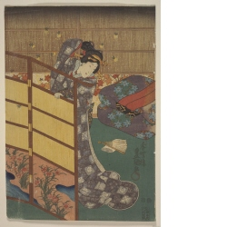
- Utagawa Kunisada
1786–1864
born: Katsushika, Musashi province (present-day Tokyo prefecture), Japan ; died: Edo (present-day Tokyo), Japan
- Woman with fireflies, circa 1847–1852, Edo period (1600–1868)
- Where object was made: Japan
- color woodcut
- Image Dimensions Height/Width: 358 x 252 mm
Image Dimensions Height/Width: 14 1/8 x 9 7/8 in
Sheet/Paper Dimensions: 361 x 253 mm
Sheet/Paper Dimensions: 14 3/16 x 9 15/16 in
Mat Dimensions: 19 x 14 in
- Gift of Fina C. Ott
- Not on display
- 1979.0169
Archive Label date unknown:
Kunisada was the most famous and prolific print designer of figures in the nineteenth century. The woman surrounded by fireflies is a courtesan. In the upper right corner of the print are several layers of bedding, called futon. A gift of expensive bedding from a patron enhanced a courtesan's prestige and the bedding was prominently displayed in her room. The seasonal motifs in this print, the fireflies lighting up the room, the nadeshiko flowers growing by a stream on the screen to the left, and the wallpaper decorated wtih maple leaves in the back of the room all imply late summer or early fall.
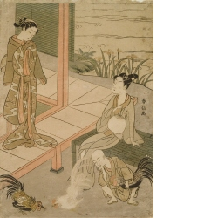
Suzuki Harunobu
circa 1725–1770
born: Edo (present-day Tokyo), Japan ; died: Edo (present-day Tokyo), Japan
- • young couple and child watching cock fight, late 1760s, Edo period (1600–1868)
- • Where object was made: Japan
- • color woodcut
- • Image Dimensions Height/Width: 279 x 201 mm
Image Dimensions Height/Width: 11 x 7 7/8 in
Sheet/Paper Dimensions: 284 x 201 mm
Sheet/Paper Dimensions: 11 1/8 x 7 7/8 in
Mat Dimensions: 19 x 14 in
- • William Bridges Thayer Memorial
- • Not on display
- • 1928.7573
Archive Label date unknown:
Harunobu is known for his depictions of elegantly posed slender young men and women. The viewer can tell from the imagery in this print that the season must be late May or early June, when it is frequently hot and humid in Japan. The sudare bamboo blind hangs down at the back of the porch to keep out the afternoon sun and the irises are blooming in the garden. The figure to the right is a young man, as evidenced by his hairstyle with the center of his head shaved but not the forelock. His garment is refreshingly thin, his upper body visible beneath the lightweight material. He is also holding an uchiwa, round fan, to cool himself.

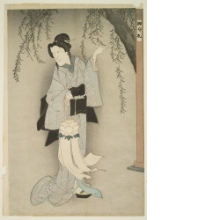
- Toyohara Kunichika
1835–1900
born: Edo (present-day Tokyo), Japan ; active: Japan
- Otsuyu holding peony lantern, 1892, Meiji period (1868–1912)
- Where object was made: Japan
- color woodcut
- Image Dimensions Height/Width: 362 x 240 mm
Sheet/Paper Dimensions: 372 x 250 mm
Image Dimensions Height/Width: 14 1/4 x 9 7/16 in
Sheet/Paper Dimensions: 14 5/8 x 9 13/16 in
Mat Dimensions: 19 x 14 in
- Anonymous gift
- Not on display
- 1982.0394
unichika primarily designed prints of Kabuki theater subjects; one of his most famous works is a series of ōkubi-e (bust portraits) of actors.
This print depicts the heroine, Ostuyu, of the gruesome play, Kaidan Botan Dōrō (The Ghost Story of the Peony Lantern) performed in 1892 at the Kabuki-za theater. To advertise the production of this play, shops in Edo (Tokyo) hung out peony shaped lanterns and 2,000 such lanterns were floated down the Sumida River.
Otsuyu, played by Onoe Eisaburō IV, died of unrequited love for Hagiwara Shinzaburō. After her death, she visited Shinzaburō for six nights. When his friend saw Shinzaburō embraced by a skeleton, he tried to stop the visits by placing Buddhist charms around the house. (On this print, a charm can be seen posted on the pillar to the right.) Unfortunately, the ghost bribed a third party to remove the charms and that night's embrace killed Shinzaburō.
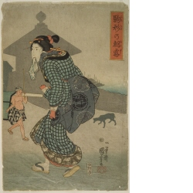
- Utagawa Kuniyoshi
1797–1861
born: Edo (present-day Tokyo), Japan ; died: Edo (present-day Tokyo), Japan
- 駒形の朝霧 Komagata no asagiri (Morning Mist at Komagata), early-mid 1800s
- Where object was made: Japan
- color woodcut
- Image Dimensions Height/Width: 374 x 251 mm
Image Dimensions Height/Width: 14 3/4 x 9 7/8 in
Sheet/Paper Dimensions: 378 x 255 mm
Sheet/Paper Dimensions: 14 7/8 x 10 1/16 in
Mat Dimensions: 19 x 14 in
- William Bridges Thayer Memorial
- Not on display
- 1928.7658
Archive Label date unknown:
Kuniyoshi was famous for his prints of actors, animals, and illustrations of historical tales. His few landscapes were on par with those of Hiroshige. Like his follower Yoshitoshi (1839-1892), Kuniyoshi had a taste for the bizarre and unusual. His prints were so popular that young men often had his designs tattooed onto their bodies.
Here, a woman of dubious reputation tightens her sash as she wends her way home in th early hours of the morning. One person, the rider in the palanquin, has already arisen and set off for the day. The woman holds her tenugui, similar to a modern day hand towel or handkerchief, in her mouth. Holding objects in the mouth was considered extremely uncouth, but such depictions were often included in prints for their sexual innuendo.
Archive Label Sept-May 1993:
As woodblock prints became increasingly popular in the Edo period (1600-1868), artists used more expensive materials and created larger, costlier prints. Because government officials, who tightly controlled many aaspects of daily life, felt taht people were spending too much money on the more expensive prints, they passed laws regulating production that included restrictions on the sizes. To circumvent the law, some artists worked in diptych (two part), triptych (three part) or larger multiple formats so that they could technically comply with the smaller size limitations. This print was designed to be the right panel of a triptych.
Earlier Japanese prints of women tended to idealize feminine beauty. In Kuniyoshi's work, as well as that of other artists of the nineteenth century, such idealization in minimized. This less romantic view of women, as well as the simplification and interest in contours and silhouettes present in the background of this print, is also evident in some French art.
Irregularity
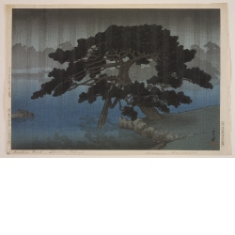
Kawase Hasui
1883–1957
born: Tokyo, Japan ; died: Tokyo, Japan ; active: Japan
• Shiba Onshi Koen (Onshi Park, Shiba, Tokyo), 1937, 12th month, Showa period (1926–1989)
• Where object was made: Japan
• color woodcut
• Image Dimensions Height/Width: 257 x 376 mm
Sheet/Paper Dimensions: 275 x 406 mm
Image Dimensions Height/Width: 10 1/8 x 14 3/4 in
Sheet/Paper Dimensions: 10 13/16 x 16 in
Mat Dimensions: 14 x 19 in
• Museum purchase: Lucy Shaw Schultz Fund
• Not on display
• 1996.0057
Exhibition Label:
"Selections for the Summer," Jun-2006, Mary Dusenbury
Kawase Hasui, a painter turned printmaker, traveled extensively to visit almost every well-known scenic spot in Japan. His beautifully executed images of famous scenic places make him one of the most widely known and beloved Shin hanga (“New Print“) artists throughout the world. He was named a Living National Treasure by the Japanese government in 1956, a year before his death.
Though the venerable pine tree illustrated here is in a public park in Tokyo, Hasui’s interpretation makes an obvious reference to Hiroshige’s well-known rendition of the famous pine at Karasaki on Lake Biwa near Kyoto, created a century earlier.

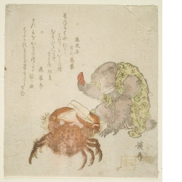
- Keisai Eisen
1790–1848
born: Edo (present-day Tokyo), Japan
- monkey and crab, 1824, Edo period (1600–1868)
- Where object was made: Japan
- color woodcut
- Mat Dimensions: 19 x 14 in
- William Bridges Thayer Memorial
- Not on display
- 0000.1505
Monkey offers a crab dried persimmon seed. Poems by Shinratei and Shin'eitei Kokin Manyō.

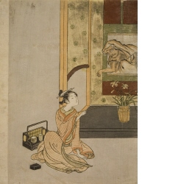
- Suzuki Harunobu
circa 1725–1770
born: Edo (present-day Tokyo), Japan ; died: Edo (present-day Tokyo), Japan
- courtesan offering a pipe to Bodhidharma, 1765, Edo period (1600–1868)
- Where object was made: Japan
- color woodcut
- Image Dimensions Height/Width: 275 x 195 mm
Image Dimensions Height/Width: 10 13/16 x 7 5/8 in
Sheet/Paper Dimensions: 275 x 207 mm
Sheet/Paper Dimensions: 10 13/16 x 8 1/8 in
Mat Dimensions: 19 x 14 in
- William Bridges Thayer Memorial
- Not on display
- 1928.7580
- Exhibition Label:
"Nature/Natural", 20-May-2011
The hairy figure with wide-eyes that emerges from the hanging scroll in this print is Bodhidharma, also known as Daruma in Japanese, the legendary founder of Zen Buddhism. Many folk beliefs are associated with Daruma, who meditated in a cave in central China for many years. According to legend, Daruma pulled off his eyelids so he would not fall asleep while meditating, thus the large appearance of his eyes in prints and paintings. Although not the case here, in other imagery he is shown with no arms or legs, as many people believe that they fell off from lack of use during his extensive periods of meditation. Daruma, an Indian monk who lived in China around the year 500 C.E., hands a pipe to a courtesan in surroundings of Japan in the 1700s, when the image was made. The artist Suzuki Harunobu was well known for his images of courtesans, as well as his use of humor, both exemplified in this image. While Daruma may be an important Buddhist icon, here we see him depicted in an amusing fashion, a possible reminder of the humanity of this legendary figure.

- Teaching Gallery Label:
“Eyes on Icons: Exploring Japanese Buddhism at the Spencer Museum of Art,” Apr-2008, Alison Miller
The hairy figure with wide-eyes that emerges from the hanging scroll in this print is Bodhidharma, also known as Daruma in Japanese, the legendary founder of Zen Buddhism. Many folk beliefs are associated with Daruma, who meditated in a cave in central China for many years. According to legend, Daruma pulled off his eyelids so he would not fall asleep while meditating, thus the large appearance of his eyes in prints and paintings. Although not the case here, in other imagery he is shown with no arms or legs, as many people believe that they fell off from lack of use during his extensive periods of meditation. Daruma, an Indian monk who lived in China around the year 500 C.E., hands a pipe to a courtesan in surroundings of Japan in the 1700s, when the image was made. The artist Suzuki Harunobu was well known for his images of courtesans, as well as his use of humor, both exemplified in this image. While Daruma may be an important Buddhist icon, here we see him depicted in an amusing fashion, a possible reminder of the humanity of this legendary figure.
Exhibition Label:
“The Sacred and the Secular: Buddhist Imagery in Religious and Popular Contexts,” Oct-2005, Hillary Pedersen
In this print, the artist has depicted a courtesan in lavish dress seated in front of a recessed alcove, or tokonoma. Hanging in the tokonoma is a painting of the Zen (Chan) Buddhist patriarch Bodhidarma who has come to life as he reaches out to take the pipe the courtesan has offered him. The use of Bodhidarma, known in Japan as Daruma, as a somewhat humorous subject is typical in Zen Buddhist imagery, and represents the freedom from convention emphasized in this school of Buddhism. See the related Daruma imagery on display in the museum’s tokonoma.

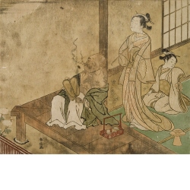
Suzuki Harunobu
circa 1725–1770
born: Edo (present-day Tokyo), Japan ; died: Edo (present-day Tokyo), Japan
• Hotei and courtesan viewing autumn moon, 1765, Edo period (1600–1868)
• Where object was made: Japan
• color woodcut
• Image Dimensions Height/Width: 211 x 258 mm
Image Dimensions Height/Width: 8 1/4 x 10 1/8 in
Sheet/Paper Dimensions: 211 x 258 mm
Sheet/Paper Dimensions: 8 1/4 x 10 1/8 in
Mat Dimensions: 14 x 19 in
• William Bridges Thayer Memorial
• Not on display
• 1928.7574
Hotei smoking with tabakobon by him. Courtesan also with pipe and with attendant.

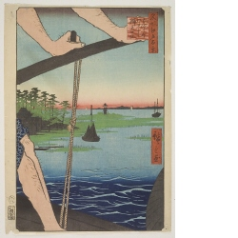
- Utagawa Hiroshige
1797–1858
born: Edo (present-day Tokyo), Japan ; died: Edo (present-day Tokyo), Japan ; active: Japan
- #72 Haneda no watashi Benten no yashira (Benten Shrine from the Ferry at Haneda), 1858, 8th month, Edo period (1600–1868)
- 名所江戸百景 Meisho Edo Hyekkei (One-hundred Views of Famous Places in Edo)
- Where object was made: Japan
- color woodcut
- Source unknown
- Not on display
- 0000.2858
- Exhibition Label:
Installation related to "Tokyo: The Imperial Capital Woodblock prints by Koizumi Kishio, 1928-1940," Feb-2005, Hillary Pedersen
Hiroshige has proven his compositional ingenuity with this print. Framed by the boatman’s arms, legs, and the boat’s rowing mechanism, the viewer shares the same vantage point as the passenger in the lower right corner, indicated by a black parasol. The scene is of a spit of land that was home to a lighthouse and a Shinto shrine dedicated to Benten, the goddess of water. The spit is now connected to the mainland by Benten Bridge, the entryway to Haneda Airport. As compensation for removal of the shrine from its original location during construction of the airport, two red torii (gates demarkating sacred Shinto sites) were erected at the airport entrances.
Archive Label Sept-May 1993:
In this series of prints, Hiroshige depicts famous places in the large and bustling capital city of Edo, now Tokyo. Such sets of prints, also made of other cities, such as Kyoto, were popular souvenirs for tourists and also purchased by armchair travelers.
This print is a good example of a compositional formula Japanese artists frequently used: a partial view of cropped image in the foreground set against a more distant landscape backgound. ...French artists emulated this compositional formula. For example, the incomplete but realistically hairy, sinewy legs of the ferryman in Hiroshige's print can be compared with the half figure of a non-idealized washerwoman in the work of Lepere (on exhibit).

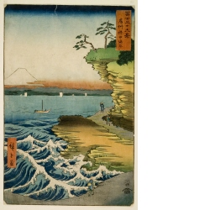
- Utagawa Hiroshige
1797–1858
born: Edo (present-day Tokyo), Japan ; died: Edo (present-day Tokyo), Japan ; active: Japan
- Boshu hoda no kaigan (The Hoda Coast in Awa Province), 1858, 4th month, Edo period (1600–1868)
- 富士三十六景 Fuji sanjūrokkei (Thirty-six Views of Mt. Fuji)
- Where object was made: Japan
- color woodcut
- Image Dimensions Height/Width: 336 x 219 mm
Image Dimensions Height/Width: 13 1/4 x 8 5/8 in
Sheet/Paper Dimensions: 339 x 223 mm
Sheet/Paper Dimensions: 13 3/8 x 8 3/4 in
Mat Dimensions: 19 x 14 in
- William Bridges Thayer Memorial
- Not on display
- 1928.7497
Raging waves at coastline, travellers on coastal path. Ships in bay. Long-away view of Mt. Fuji enveloped in red clouds. Dramatic composition.
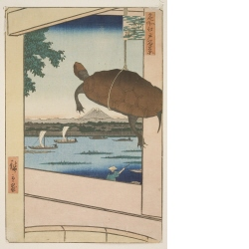
Utagawa Hiroshige
1797–1858
born: Edo (present-day Tokyo), Japan ; died: Edo (present-day Tokyo), Japan ; active: Japan
• #51 深川万年橋 Fukagawa mannenbashi (Mannen Bridge in Fukagawa), 1857, Edo period (1600–1868)
• 名所江戸百景 Meisho Edo Hyekkei (One-hundred Views of Famous Places in Edo)
• Where object was made: Japan
• color woodcut
• Mat Dimensions: 19 x 14 in
• William Bridges Thayer Memorial
• Not on display
• 1928.7278

Exhibition Label:
"Nature/Natural", 20-May-2011
In his One Hundred Famous Views of Edo series, Hiroshige introduced a new technique of composition with an enlarged framing element against a distant background. Here we see a turtle dangling from the handle of a wooden bucket. Through the beams of the bridge and the bucket we glimpse a busy canal.
Mannen Bridge lay at the entrance to the canal in Fukagawa district where turtles were bred for sale for food or as pets. It was custom for the breeders of these turtles to offer their wares along well-traveled bridges where people could buy and release the turtles into the nearby river or canal on the hope of building up Buddhist merit. The turtle is also a symbol of longevity. By using the image of the turtle, Hiroshige creates a verbal play with the name of the bridge, Mannen, which means "10,000 years."

Archive Label date unknown:
In his One Hundred Famous Views of Edo series, Hiroshige introduced a new technique of composition with an enlarged framing element against a distant background. Here we see a turtle dangling from the handle of a wooden bucket. Through the beams of the bridge and the bucket we glimpse a busy canal.
Mannen Bridge lay at the entrance to the canal in Fukagawa district where turtles were bred for sale for food or as pets. It was custom for the breeders of these turtles to offer their wares along well-traveled bridges where people could buy and release the turtles into the nearby river or canal on the hope of building up Buddhist merit. The turtle is also a symbol of longevity. By using the image of the turtle, Hiroshige creates a verbal play with the name of the bridge, Mannen, which means "10,000 years."

Perishability

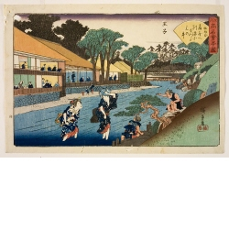
- Utagawa Hiroshige
1797–1858
born: Edo (present-day Tokyo), Japan ; died: Edo (present-day Tokyo), Japan ; active: Japan
- 扇屋王子 (Ōgiya Restaurant at Ōji), circa 1835–1842, Edo period (1600–1868)
- 江戸高名会亭尽 Edo kōmei kaitei zukushi (Famous Restaurants in Edo)
- Where object was made: Japan
- color woodcut
- Sheet/Paper Dimensions: 254 x 374.7 mm
Sheet/Paper Dimensions: 10 x 14 3/4 in
Mat Dimensions: 14 x 19 in
- Gift of H. Lee Turner
- Not on display
- 1968.0001.120

Archive Label date unknown:
Here, on a hot summer evening, waitresses from the restaurant hold up their kimono to wade across a stream while a young boy also plays in the water. Hiroshige was most famous for his prints of the Tōkaidō, but also produced many other print series of famous places. Each print in this series includes a fan-shaped cartouche with a satirical seventeen syllable kyōku poem that mentions the name of the restaurant depicted. Restaurants were important places in the Edo period (1615-1868) that allowed different social classes to mix and form private coteries, often for the production of satirical prose (kibyōshi) and poetry.

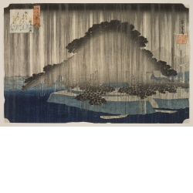
Utagawa Hiroshige
1797–1858
born: Edo (present-day Tokyo), Japan ; died: Edo (present-day Tokyo), Japan ; active: Japan
• Karasaki no Yan (Night Rain on Karasaki Pine), circa 1834, Edo period (1600–1868)
• Ōmi Hakkei no Uchi (Eight Views of Ōmi), popularly known as Eight Views of Lake Biwa
• Where object was made: Japan
• color woodcut, mica
• Image Dimensions Height/Width: 224 x 346 mm
Image Dimensions Height/Width: 8 13/16 x 13 5/8 in
Sheet/Paper Dimensions: 224 x 346 mm
Sheet/Paper Dimensions: 8 13/16 x 13 5/8 in
Mat Dimensions: 14 x 19 in
• William Bridges Thayer Memorial
• Not on display
• 1928.7287

Archive Label 1999:
The ancient pine tree of Karasaki stands brooding in the heavy night rain. The single venerable pine spreads out, as large as an entire forest, dominating the space. The absence of any human presence and the utter stillness of the scene emphasize the timelessness of the image. A poem referring to the famous pine appears in the upper left:
Elsewhere will they talk of the music of the evening breeze that has made the pine of Karasaki famous. The voice of the wind is not heard through the sound of the rain in the night.
In the nineteenth century, depictions of scenic spots on Lake Biwa in the district of Omi, east of Kyoto, had been part of the artistic vocabulary for several centuries. Hiroshige was not introducing new scenery, but reinterpreting a well-known view that would have evoked other images and poetic allusions in the viewer's mind. The Omi series shows the influence of the Japanese literati tradition with its predilection for monochrome landscapes and sparse description. Here Hiroshige uses subdued colors, the black and grey of the pine, blue and deep indigo of the water and silver of the long vertical lines of the mica rain

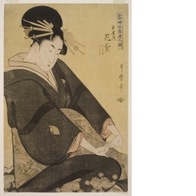
- Kitagawa Utamaro
1754–1806
active: Japan
- Tamaya uchi Hanamurasaki Sekiya, Teriha [Hana-murasaki of the Tamaya], 1794, Edo period (1600–1868)
- Tōji zensei bijin zoroe (Array of Supreme Beauties of the Present Day)
- Where object was made: Japan
- color woodcut
- Image Dimensions Height/Width: 384 x 253 mm
Image Dimensions Height/Width: 15 1/8 x 9 15/16 in
Sheet/Paper Dimensions: 384 x 253 mm
Sheet/Paper Dimensions: 15 1/8 x 9 15/16 in
Mat Dimensions: 19 x 14 in
- William Bridges Thayer Memorial
- Not on display
- 1928.7879

Archive Label date unknown:
Hana-murasaki was the most prestigious courtesan name at the Tamaya ("Jewel House") brothel in the Yoshiwara pleasure district of Edo. The name remained a constant, and courtesans who were brought into the house as children aspired to earn the right to take on the name as they progressed in their careers. In this print, the 1794 Hana-muraski's child apprentices (kamurō) Sekiya and Teriha, are noted but not pictured.
Archive Label 1988:
The art of portraying bijin (beautiful women) has had a long tradition in Japan, with courtesans as the most common subject. Often highly trained and educated, these women wielded considerable power within their limited world of the pleasure quarters. Since they also represented the height of fashion, print designers focused on the courtesans' elaborate hairstyles and gorgeous robes.
The woodblock prints here depict three different views of idealized womanhood dictated by the changing tastes of the day. Harunobu's courtesan composing a letter is a frail, childlike woman who kneels before a writing box containing ink brushes and an inkstone. Utamaro's haughty courtesan is the antithesis of Harunobu's sweet maiden. The monumental, full-scale figure fills the entire space of the picture as she lazily stretches in total self-absorption. Her hairstyle is more complex, and her robe is rendered in bold, sweeping lines that create an elegant design. Kunisada's beauties strolling beneath plum trees in the third print assume less idealized proportions, but wear by far the most elaborate costumes. The use of intense colors with silver and gold accents contributes to the suptuousness of the kimono and headdresses.

Kate
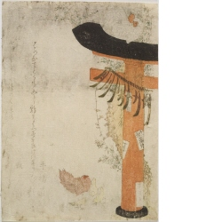
- Japan
- chickens by gate to shrine, 1813, Edo period (1600–1868)
- Where object was made: Japan
- color woodcut
- William Bridges Thayer Memorial
- Not on display
- 0000.1391
Half of a red and black torii gate is visible on the right. The top bar and base of the column of the gate are black and the rest is red. A rope is attached to the gate and the numbers for the long months of 1813 are attached to the rope on this calendar print. There are white fliers with black lettering around the column. There is a white rooster on the top. There is a pink chicken with three yellow chicks to the left of the base of the column. There is a plant behind the column. There is calligraphy on the left side.

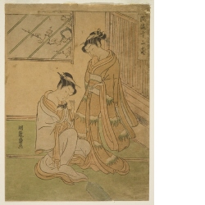
- Isoda Koryūsai
1735–1790
active: Japan
- two women with a black rat, early 1770s, Edo period (1600–1868)
- Fūryū Jūnishi (Elegant 12 Zodiac Animals)
- Where object was made: Japan
- color woodcut
- Image Dimensions Height/Width: 263 x 191 mm
Image Dimensions Height/Width: 10 3/8 x 7 1/2 in
Sheet/Paper Dimensions: 263 x 193 mm
Sheet/Paper Dimensions: 10 3/8 x 7 5/8 in
Mat Dimensions: 19 x 14 in
- William Bridges Thayer Memorial
- Not on display
- 1928.7862

Archive Label date unknown:
In each of these prints elegant figures appear with one of the twelve zodiac animals, which have been used by the Chinese and the Japanese to designate different years of the cyclical calendar. Koryūsai has cleverly represented the boar as a painted motif on the screen behind the two figures in the left print. In the center print, the dragon is portrayed as a spout out of which water flows, and in the right print the rat is shown as a live animal being petted by one of the women. The branch of plum blossoms seen through the window and the snow-covered bamboo leaf motifs on the kimono allude to winter and the coming of a new year.

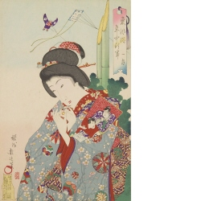
- Toyohara Chikanobu
1838–1912
born: Takada, Echigo province (present-day Niigata prefecture), Japan ; active: Japan
- ichigatsu (The First Month), 1890, Meiji period (1868–1912)
- Nenju gyoji (Calendar of Eastern Customs)
- Where object was made: Japan
- color woodcut
- Image Dimensions Height/Width: 360 x 234 mm
Image Dimensions Height/Width: 14 1/8 x 9 3/16 in
Sheet/Paper Dimensions: 360 x 234 mm
Sheet/Paper Dimensions: 14 1/8 x 9 3/16 in
Mat Dimensions: 19 x 14 in
- Museum purchase: Lucy Shaw Schultz Fund
- Not on display
- 2007.0062.01

Exhibition Label:
"Time/Frame," Jun-2008, Robert Fucci, Shuyun Ho, Lauren Kernes, Lara Kuykendall, Ellen C. Raimond, and Stephanie Teasley
The theme of “annual customs” in Japanese art depicts rituals, customs, and festivals in different times of a year. Each of these prints describes an important custom of a month. As a part of a larger agenda of modernizing the country, the Meiji government changed the calendar system from lunar to the solar-based Gregorian calendar in 1873. However, when Chikanobu created this set in 1890, the depicted customs still followed the lunar system. For example, the Gion festival is depicted in the sixth month instead of July, as it is held today. It was not until after 1945 that Japan completed converting the dates for traditional customs according to the solar calendar. This lengthy transition period of the two systems exemplifies the notion that calendars are not just systems of dates, but embody cultural and social values. To read the prints in order, start at the top right corner and proceed top to bottom from right to left.

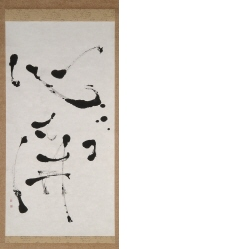
- Stephen Addiss
active: United States
- Heart Opens
- Where object was made: Lawrence, Kansas, United States
- ink, on paper
- Object Height/Width: 126.7 x 49.1 cm
Object Height/Width: 49 7/8 x 19 5/16 in
- Not on display
- C2003.011

