Metamorphoses

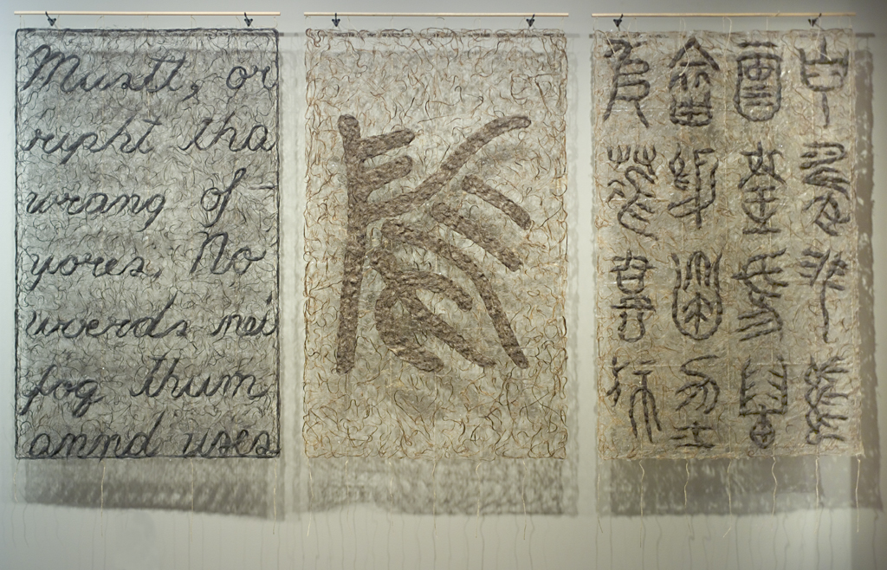

Wenda Gu (born 1955)
Metamorphoses, 2004
hair, glue, twine
Museum purchase: Gift of William T. Kemper Foundation and David Woods Kemper Memorial Foundation in honor of Dr. Chu-tsing Li
2006.0162.a,b,c

Panel a: Seven lines of English text in cursive style made of human hair compressed in glue. The hair is mostly black.
Panel b: A single large character made of human hair compressed in glue. The character is a combination of English and Chinese. The hair is of various shades of brown.
Panel c: Four horizontal lines of pseudo Chinese characters in seal script style made of human hair compressed in glue. Each line contains four characters. The hair is of various shades of brown.

Interpretive Text:
- 3 panels create one work of art
- Wenda Gu lives in NYC and keeps a home in China
- Made of hair, glue, and twine
  - Human hair
    - Unusual material
    - Cultural signifier across history and cultures (color, amount, texture, length, hairstyle, cutting/shaving, saving)
      - Stage of life
        - First hair cut, lock of babies hair
        - Puberty rituals
        - Marital status
        - Elder
      - Associations
        - Membership, status, allegiance, fan, etc.
      - Identity
        - Personally identity through color, length, style, amount
      - Cultural translations
        - Different meanings/interpretations
        - Possible miscommunication
- Universal
- Relationship to script/drawing
      - Lines, curls of hair like script
      - Brushes for calligraphy
- Hair transformed into language—language into illegible signs—metamorphoses
- Artwork made of symbols of language
  - Alphabet
    - Characters—ancient Chinese seal script
    - Illegible—pseudo script—can’t actually be read
      - Draws you in to find it’s not what you thought it was.
      - Faking: lead one way and then go the other
      - Want to read the words and understand, but you can’t.
      - Need to look closely and carefully to see things accurately and to even begin to make sense of what you are looking at.
    - Language as something that exists universally, but not understood universally
    - Language mode of communication, but can be a barrier to communication if you do not speak the same language
    - Even when you learn another language, culture can still be a barrier to understanding: for example—slang, proverbs, value systems, social practices, etc.
- Metamorphosis
  - To change/transform
  - Caterpillar to a butterfly
  - Growth
  - Maybe move to something better/more beautiful
  - How do people change over time?
    - Physically
    - Socially
    - Intellectually
  - Hair as an indicator of change
    - Change in amount of hair
    - Change in style
    - Change in color
    - Change in texture
- More Characteristics of Artwork:
  - Color
  - Texture
  - Transparent vs. thick opaque areas
  - order on alphabet piece random. Not intended as one work of art when each panel was created. Gu selected the three panels to go together in one work of art.
  - Repetition (material, hair, thickness, texture, letters, characters)
  - Scale of words
  - Scale of work of art
  - Shadow
  - Tryptich
  - Hanging
  - Vertical panels placed in horizontal format
  - Do you read from left to right or right to left? Alphabet on left panel. Characters on right panel
  - Letters, characters, pictographs
  - Seal script: can kind of see house, cat, flower; just like you can sort of see words in the alphabet panel.
  - Strips of twine create matrix that hair is glued to.
  - Feelings or response to the use of human hair—cultural implications
  - Language as transformed through human activity
  - Use of twine gives sense of delicacy, airy suspension – reinforced by glistening glue
  - Relationship of suspended panels to hanging scrolls

Wenda Gu Biography
- Lives in NYC and keeps a home in China
- Married to an American artist
- Has had same hairstyle since the 1970’s: shaved on top with a ponytail in back. Hairstyle has a particular meaning and is interpreted as an ongoing performance piece by Wenda Gu
- Home/Communication/Identity
  - Considers himself a global nomad. Identity a part of two different countries. Does not feel at home in either.
  - Where is your home? Is it where you are from or where you are living?
  - Did not know English when he moved to U.S. This was a challenging barrier for him to overcome. Words are very important to Gu
  - It’s possible to travel easily and quickly, but that doesn’t mean that you will be able to successfully communicate once you arrive—culture, language.
  - Sees words as a barrier that has to be broken.
  - Work may communicate Gu’s Utopian vision of a world where there aren’t barriers—universal language/signs being symbolic of this transformed world. Center panel with large character. Conglomoration of symbols/letters/colors. Metamorphoses
    - Tryptich: climactic scene in center panel. Often proof of Christ saving humanity through his sacrifice. Center panel vision of a utopian future for humanity

Portable/ textile / nomadic culture—home is where your heart is / your work of art, etc.
  - No frame; hung like a textile or tapestry
  - Do Sung Hung (Korean)
    - Silk mint green tapestry with replica of his home
    - Title: Seoul Home
    - As tapestry travels from one exhibition to the next, each city added to the title:
      - L.A. Home; Seattle Home

- Surge of globalism in 20th/21st C. Trend among 20th/21st Century international artists to connect to personal roots, yet create works with huge, global themes. (global nomads)
- Wu has had calligraphic training.
- Uses abject art materials (hair, bodily fluids, etc.)
- Interested in contemporary bioscientific research
- Thought America was the “land of the free.” You could do anything in America. First show in 70’s was an installation of used feminine hygiene products. Met with very negative reviews. Very shocking to Gu. Had to really rethink his assumptions.

